

Administrative Domains User Guide

Version 2.0
April 10, 2010

Table of Contents

Table of Figures 3
Introduction 4
What are Administrative Domains? 4
Setup 4
Granting Permission to Manage Administrative Domains 4
Accessing Administrative Domains 5
How do Administrative Domains Work? 6
Administrative Domains Rules 7
Super Administrators 8
Method One: SuccessFactors Creates a New Super Administrator 8
Method Two: Promote a Domain Restricted Administrator to Become a Super Administrator 8
Reporting on Administrative Domains 8
Finding Super Administrators 10
Defining Administrative Domains 10
Example 1: Domain Restriction Based on One Filter 10
Example 2: Domain Restriction Based on Multiple Filters 14
Example 3: Avoiding Mistake of Zero User Domain 17
Granting Target Permissions with Domains 17
Granting Target Permissions with Overlapping Domains 21
Hierarchies in Compensation and Variable Pay 23
Administrative Privileges and Administrative Domain Privileges 24
Frequently Asked Questions 24
When assigning reporting permissions to an individual, can an Administrator grant access to other dept/div/loc outside of their domain? 24
What happens if my admin domain privileges are revoked after I’ve already assigned permissions? 26
Admin Links Restricted by Administrative Domains 26
How Are Actions Restricted by the Admin Domain? 28
1 Action on Individual User 28
2 Action on Group of Users 29
3 Employee Import 31
4 Employee Export 32
5 Create New User Interface 33
6 Manage Documents 33
7 Granting Target Permissions 34
8 Compensation Administration 35
Manage Compensation Forms 35
Create New Form 35
Mass Create Forms 36
Add/Delete/Move Members in a Form 36
Compensation Groups 37
9 Variable Pay Administration 37
List Variable Pay Program 37
Configure Variable Pay Program 38
Administrative Features NOT Restricted to the Administrative Domain 38

Table of Figures

Figure 1 What are Administrative Domains? 4
Figure 4 Administrative Domain Privileges link 6
Figure 5 Administrative Domain Privilege page 6
Figure 6 The domain controls the user filter values seen throughout admin pages 7
Figure 7 Security Permissions Reports link 9
Figure 8 Permissions Reports page 9
Figure 9 Administrative Domain Privileges link 11
Figure 10 Domain for dadmin1 based on Division filter 12
Figure 11 Search for user3 outside of dadmin1 domain 13
Figure 12 Search for user1 within dadmin1 domain 14
Figure 13 Administrative Domain Privilege link 15
Figure 14 Domain for dadmin2 based on multiple filters 15
Figure 15 Search for user3 who is in dadmin2's domain 16
Figure 16 Search for user4 outside dadmin2's domain 16
Figure 17 Zero User Domain Mistake 17
Figure 18 Permissions Management Screens that use Target Populations 18
Figure 19 The domain controls the user filter values seen throughout admin pages 19
Figure 20 Domain for dadmin1 where Division = "ACE Healthcare" 19
Figure 21 Detailed Reporting Privileges for user1 as seen by dadmin1 domain 20
Figure 22 Administrators cannot increase their domain 21
Figure 23 Superadmin sets overlapping domains for dadmin1 and dadmin2 22
Figure 24 Super Admin sets Detailed Reporting Rights for user2 25
Figure 25 Manage Human Resources Privileges page 28
Figure 26 Example of admin function that applies to a group of users 30
Figure 27 Employee Import Page 31
Figure 28 Employee Export Page 32
Figure 29 Add New User Page 33
Figure 30 Modify Document Route Map page 34
Figure 31 Create Compensation Form Error (Compensation group has users outside of your domain) 36
Figure 32 Manage Variable Pay Programs Page 37
Figure 33 Configure Variable Pay Program Page 38

Introduction

What are Administrative Domains?
Administrative Domains allows you to restrict an Admin user to perform administrative tasks on a subset of people in the organization. The restriction applies only to user centric tasks. For example, resetting a user’s password is an action that can be restricted.
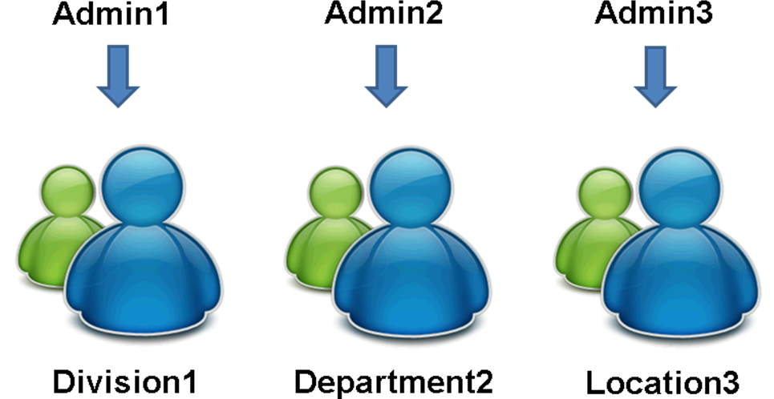
Figure 1 What are Administrative Domains?

There are some administrative actions that are not functions on a user. For example, importing a competency library, or importing a Form Template. These actions are not able to be restricted, and are considered global to the enterprise.

Setup

Granting Permission to Manage Administrative Domains
The Administrative Domain Privilege link will be available by default for any admin user that has access to ALL manage security links. Permission to this link can be revoked in Admin→Manage Security→Administrative Privileges
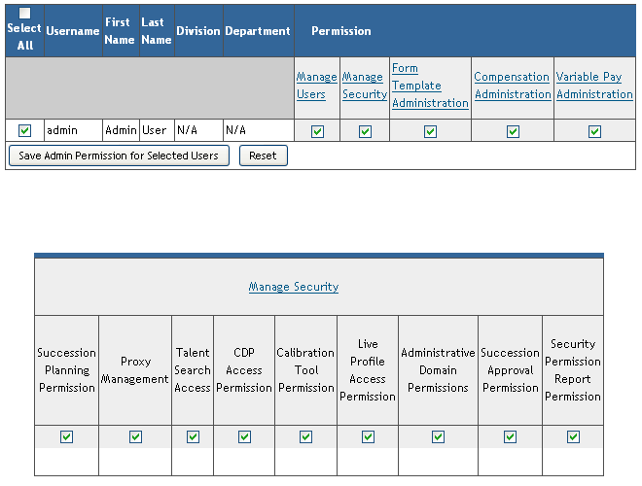

Accessing Administrative Domains

Administrative Domains are defined in the Administrative Domain Privileges page. This page can be accessed in Admin→Manage Security→Administrative Domain Privileges as seen below.
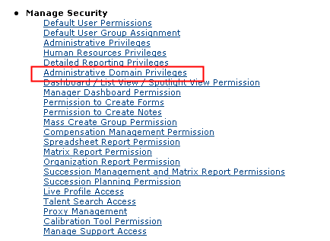
Figure 2 Administrative Domain Privileges link

Selecting the Administrative Domain Privilege link will bring you to the Administrative Domain Privilege page seen below. This page is the heart of Administrative Domains and will be used to specify the target populations for administrators.

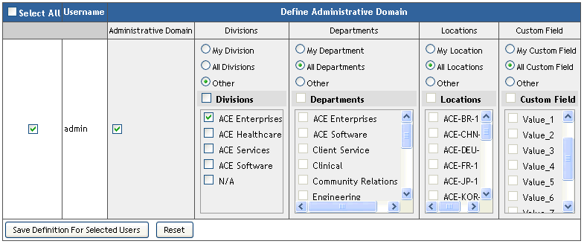
Figure 3 Administrative Domain Privilege page

How do Administrative Domains Work?
Administrative domains can be defined using department, division, location and your organization’s custom filters. This is accomplished as seen Figure 5 Administrative Domain Privilege page above.

The values set in the domain as seen in Figure 5 will control the user filter values available to an administrator throughout the admin pages. This is described in the diagram below.
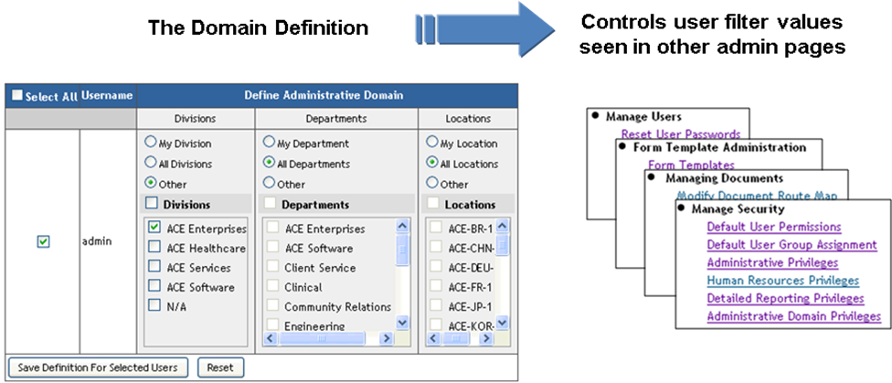
Figure 4 The domain controls the user filter values seen throughout admin pages

When Administrative Domains is enabled for your SuccessFactors instance, you will need to log in as a super administrator to begin setting up domains for any administrators you wish to restrict.

A super administrator is any administrator in your system that is not restricted by a domain. See sections below on how to create super administrators, and how to report on existing super administrators in your system.

Administrative Domains Rules
The key to understanding how administrative domains work is summarized in the list of rules below. The rest of this document gives examples and details of these rules.
- Domains control what user filter and permission values are available to an administrator.
- Administrators cannot see filter values outside of their domain.
- Administrators cannot increase their own domain, nor grant others with domains larger than their own. They can only narrow.
- Only super administrators can disable domains for a user. But any administrator may enable a domain for another administrator within their domain.
- When multiple administrators set permissions for the same user, the last save wins and it is a complete over-write.
- Like rule 3 above, administrators cannot increase the administrative privileges they own, nor grant others with more administrative privileges than they own. They can only narrow. (An administrative privilege is any permission under Admin Tools → Manage Security → Administrative Privilege. For example, the ability to import users is an administrative privilege).
- In Compensation and Variable Pay, when dealing with hierarchical administrative tasks, access is controlled by head of hierarchy.

Super Administrators
A super administrator is any administrator in your system that is not restricted by a domain. Super administrators have access to all users in the enterprise. They also have the special ability to promote others to become super administrators.

You can create super administrators in one of two ways listed below.

Method One: SuccessFactors Creates a New Super Administrator
SuccessFactors can create a new administrative account for you at any time. The new administrative account will be a super administrator by default. Just open a support ticket to request a new administrative account for your system.

Method Two: Promote a Domain Restricted Administrator to Become a Super Administrator
If you have a domain restricted administrator, you can promote them to become a super administrator. This can only be done by an existing super administrator. To accomplish this, log in as an existing super administrator, go to Admin → Manage Security → Administrative Domain Privileges, and find the domain restricted administrator you wish to promote. Once you have found the user, unselect the checkbox labeled “Administrative Domains” and save the permission. The administrator has now been promoted to a super administrator.

Reporting on Administrative Domains
You can audit your domain configurations to view the domains for all administrators in your system. This report can be run through Admin → Manage Security → Security Permissions Reports → Administrative Domains Privileges, per the steps below.

- Log in as a super administrator who has access to the “Security Permissions Report” feature.
- Go to Admin → Manage Security and select the “Security Permissions Reports” link seen below.
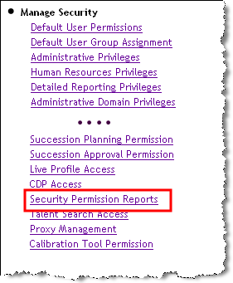
Figure 5 Security Permissions Reports link

- On the Permissions Report page, select the checkbox for “Administrative Domains Privileges” and run the report. The report will be scheduled and available for download as a CSV file. And example report appears below.

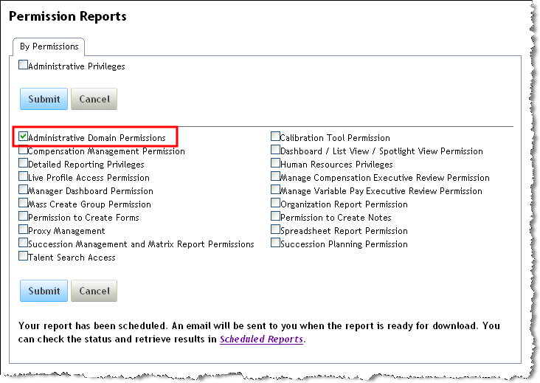
Figure 6 Permissions Reports page

The output of this report will be a CSV file as seen in the example below.

Note that domains are applied to this feature, which is why we suggest logging in as a known super administrator in step one. This ensures you have a full audit of all users in the enterprise. Though it is fine to run the report as a domain restricted administrator, the output will include only the users within the domain of the person who invoked the report.

Finding Super Administrators
The above report will list all administrators that are domain restricted. If an administrator does not appear on this report, then they are not restricted by a domain, meaning they have super administrator privileges. They can access all users in the enterprise for any administrative tasks they own.

To find out all administrators in your system, you must run the “Administrative Privileges” report. This will list anyone who has administrative privileges in the system. By cross referencing the output of this report with the users found on the “Administrative Domains Privileges” report, you can discover which administrators do not have domains and are therefore super administrators.

Defining Administrative Domains
Defining an administrative domain for an admin user is done through the Administrative Domain Privileges page available at Admin → Manage Security → Administrative Domain Privileges.

Domains can be defined by specifying values of department, division, location and your organization’s custom fields. This allows an administrator to access users that match the domain definition. Target users must meet ALL the criteria specified. For instance, if we set a target population of Division 2 and Department 2, a user must be in BOTH Division 2 and Department 2 to be in that specified Administrator’s target population.

There is only one domain definition for a single administrative user. The one domain is applied to all administrative functions granted to the user, where applicable. (See the separate section on what admin links / functionality are supported).

If you would like to give multiple domains to an administrator, this can be achieved by giving the user multiple accounts, where each account has a different domain. You can also define different administrative features that each account may access. For example, you can give account1 the ability to export users from domain1, and account2 can manage Detailed Reporting Privileges for domain2.

Example 1: Domain Restriction Based on One Filter
For this example, consider the following user data.

USERNAME | DIVISION | DEPARTMENT | LOCATION
superadmin | ACE Enterprises | Talent Management | ACE_HQ_HQ
dadmin1 | ACE Healthcare | Talent Management | ACE-DEU-1
user1 | ACE Healthcare | Clinical | ACE-FR-1
user2 | ACE Healthcare | Finance | ACE-UK-1
dadmin2 | ACE Software | Talent Management | Central
user3 | ACE Software | Engineering | East
user4 | ACE Software | Sales | West

1) Login as an admin (i.e. superadmin)

2) Navigate to Admin→Manage Security→Admin Domain Privileges.
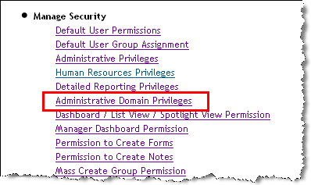
Figure 7 Administrative Domain Privileges link

3) Search and select another admin user you wish to restrict. In this example, we will restrict dadmin1

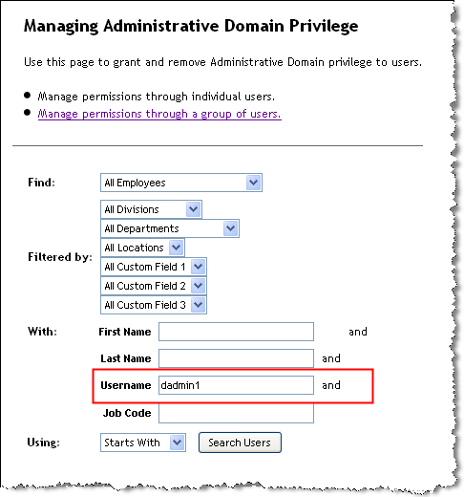

4) You can use Divisions, Departments, Locations and your custom field filters as criteria for a target population. In this example, we will enable domains for this user by selecting the “Administrative Domain” checkbox. We will restrict dadmin1 to users in Division
”ACE Healthcare”. We will give admin1 access to all values for the other filters.

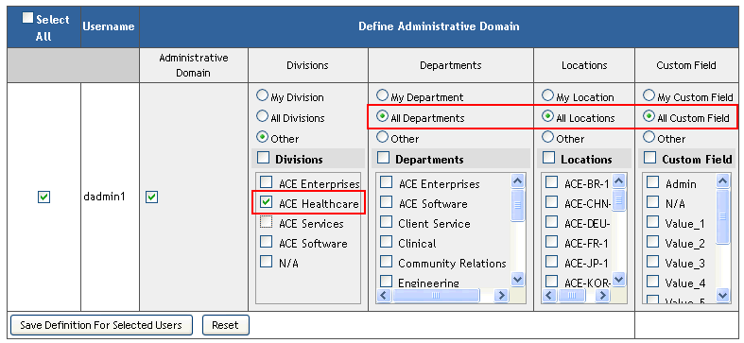
Figure 8 Domain for dadmin1 based on Division filter

Note: Only super administrators have the ability to enable/disable domains for a user through the “Administrative Domain” checkbox seen above. A super admin is any administrator who is not restricted by a domain, and therefore has access to the entire enterprise. Domain restricted administrators will not have access to the Administrative Domains checkbox and therefore can not enable/disable domains for a user.

To find out who are super administrators in your organization, run the Security Report for Administrative Domain Privileges. Any user that does not appear on the Security Report for Administrative Domain Privileges is a super admin – they are not restricted by a domain, and have access to the entire enterprise.

5) Login as dadmin1 and try to Reset User Password for somebody outside of division “ACE Healthcare”. For example, we will try user3 from the example employee file above.

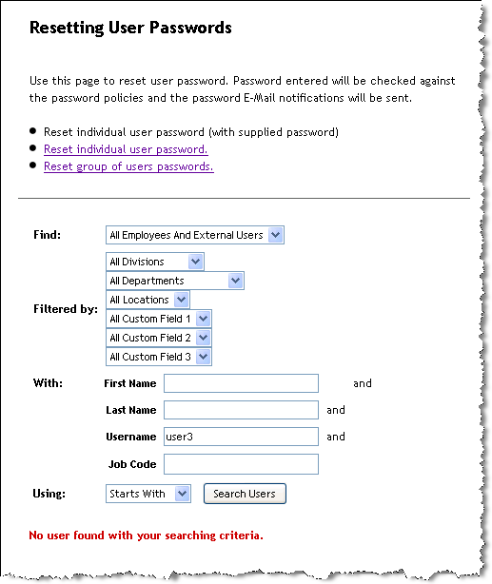
Figure 9 Search for user3 outside of dadmin1 domain

You can see that the user cannot find a user outside of their target population. Here is an example of searching for a user within the target population: (user1):

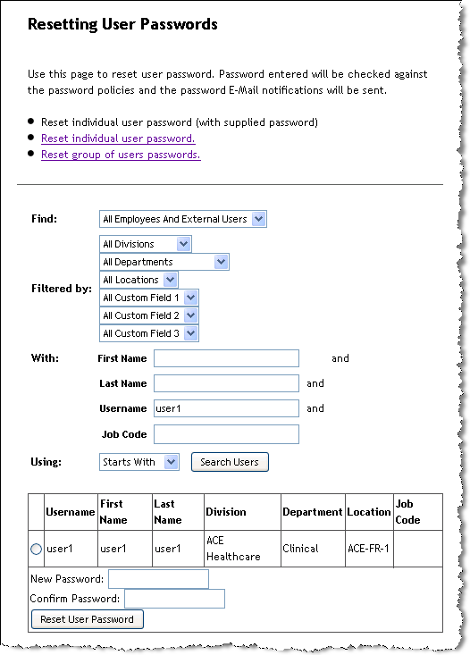
Figure 10 Search for user1 within dadmin1 domain
Dadmin1 is able to reset user password for user1, but not user3.

Example 2: Domain Restriction Based on Multiple Filters
For this example, we will set the domain for dadmin2 using division and department with values of “ACE Software” and “Engineering”. Recall that the employee data is as follows:

USERNAME | DIVISION | DEPARTMENT | LOCATION
superadmin | ACE Enterprises | Talent Management | ACE_HQ_HQ
dadmin1 | ACE Healthcare | Talent Management | ACE-DEU-1
user1 | ACE Healthcare | Clinical | ACE-FR-1
user2 | ACE Healthcare | Finance | ACE-UK-1
dadmin2 | ACE Software | Talent Management | Central
user3 | ACE Software | Engineering | East
user4 | ACE Software | Sales | West

1) Login as an admin (i.e. superadmin)

2) Navigate to Admin→Manage Security→Admin Domain Privileges.

Figure 11 Administrative Domain Privilege link

3) Search and select another admin user you wish to restrict. In this example, we will search for dadmin2. We will enable domains for this user by selecting the “Administrative Domain” checkbox. Then we specify division of “ACE Software” and department of “Engineering”. Finally we will select all values for the remaining filters. This will allow dadmin2 to administer all users in the “Engineering” department of the “ACE Software” division.

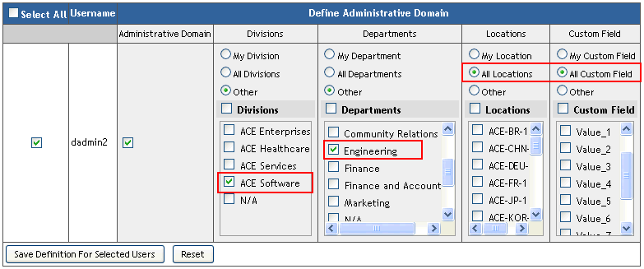
Figure 12 Domain for dadmin2 based on multiple filters

5) Login as dadmin2 and go to Admin→Reset User Password. Search for user3 whose division and department match the domain of “ACE Software” and “Engineering”.

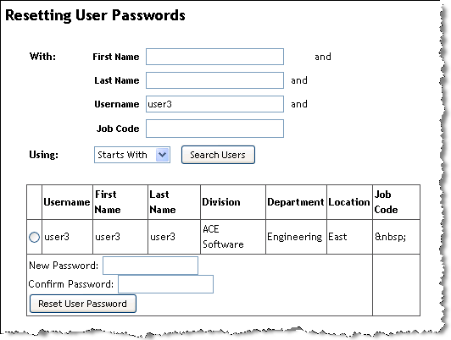
Figure 13 Search for user3 who is in dadmin2's domain

We can access user3 because they meet ALL of the set criteria for dadmin2’s target population.

6) Search for user4 whose division (ACE Software) is in dadmin2’s domain, but whose department (Sales) is not in dadmin2’s domain.

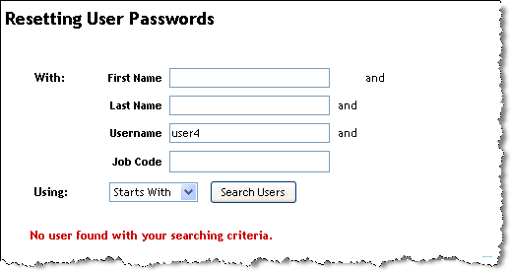
Figure 14 Search for user4 outside dadmin2's domain

We cannot find user4 they do not meet ALL of the set criteria for dadmin2’s target population. Or more simply stated, user4 is not in the domain defined for dadmin2.

Example 3: Avoiding Mistake of Zero User Domain
When defining an administrative domain for a user, you must select at least one value for each of the domain filters. Clearly you can select more than one value. But you cannot leave a filter blank. This will prevent the user for accessing anyone. In other words, the domain size will be zero users.
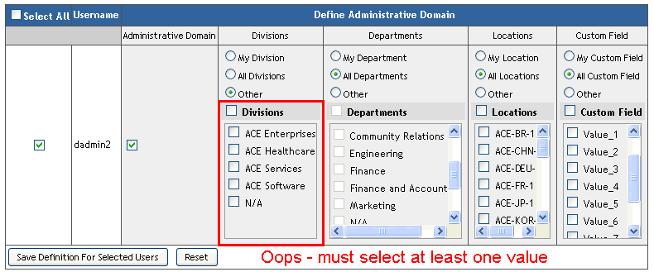
Figure 15 Zero User Domain Mistake

Granting Target Permissions with Domains
When managing security, there are several permissions management pages that require the specification of a target population to which the permission applies. These include the following pages:
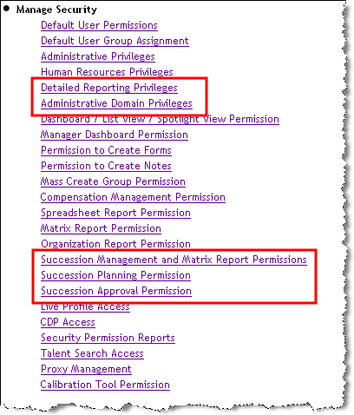
Figure 16 Permissions Management Screens that use Target Populations

The permissions that can be granted on these pages are restricted to the values set in your administrative domain. Recall from the section on How Domains Work that an administrator’s domain controls the user filter values seen in other admin pages:

Figure 17 The domain controls the user filter values seen throughout admin pages

For example consider the domain for dadmin1 where we restrict dadmin1 to users in the
”ACE Healthcare” division. The domain appears as follows

Figure 18 Domain for dadmin1 where Division = "ACE Healthcare"

When dadmin1 logs in and wants to grant “Detailed Reporting Privileges” to another user, dadmin1 will only have access to the above values. This will appear as seen below:

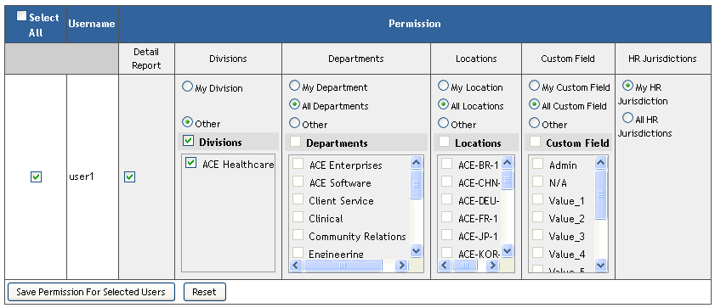
Figure 19 Detailed Reporting Privileges for user1 as seen by dadmin1 domain

Notice that for the Divisions field, dadmin1 can access only the “ACE Healthcare” division. We do not see any Divisions which are not in dadmin1’s domain. Also we cannot select “All Divisions”. We can only select either “ACE Healthcare” as the explicit division, or we can select “My Division” which means user1 can report on their division, regardless of which division they belong to in the future, should that change for user1.

Note that the Administrative Domain Privileges link also appears in the list shown in Figure 16: Permissions Management Screens that use Target Populations. This is recursive in nature. It simply means that if you have already been restricted to a domain, then you cannot grant others with domains larger than your own. Recall that this is rule 3 from the section on Administrative Domain Rules. Namely, rule 3 states the following

Administrators cannot increase their own domain, nor grant others with domains larger than their own.

Visually this can be described best in a tree structure diagram seen in Figure 20 below. In this diagram assume that Admin1 has a domain with access to divisions Div1 through Div4. Admin1 then defines domains for Admin2 with access to divisions Div3 and Div4, and Admin3 with access to Div1, Div2 and Div3. This can continue, where Admin3 can grant others with access to the divisions available to Admin3, namely Div1, Div2, and Div3. But Admin3 cannot give access to Div4, since Admin3 does not have access to Div3 in their domain definition.
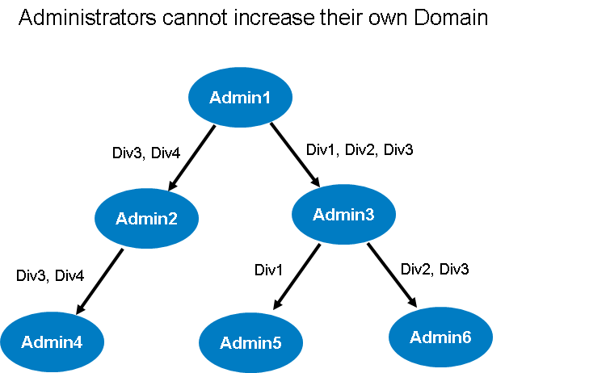
Figure 20 Administrators cannot increase their domain

This rule applies whether you are granting domains for others, or whether you are trying to modify your own domain definition.

Granting Target Permissions with Overlapping Domains
Multiple administrators can have domain definitions that allow them to access the same set of users. The domains for each administrator may not be equal and they can overlap on subsets of the domain. For example, consider the following domain definitions:
- dadmin1 → Division = “ACE Services, ACE Healthcare”.
- dadmin2 → Division = “ACE Services, ACE Software”.

Here the domains overlap on division “ACE Services”. This means that both dadmin1 and dadmin2 can access users in the “ACE Services” division. This appears as follows to the superadmin when setting their domain in the “Administrative Domain Privileges page.
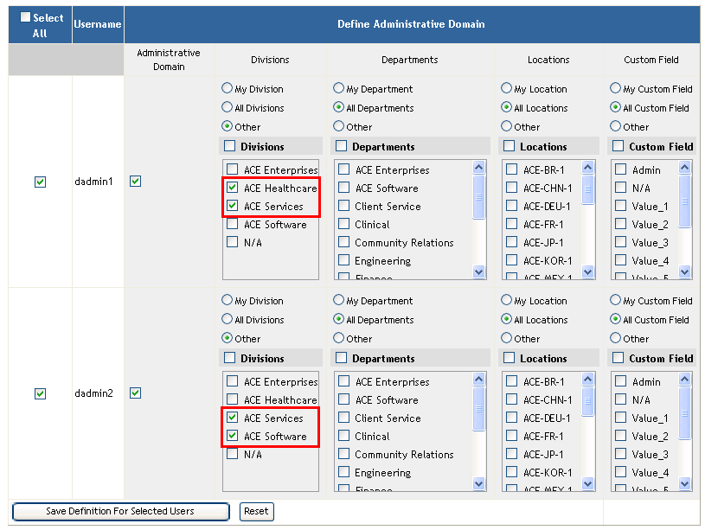
Figure 21 Superadmin sets overlapping domains for dadmin1 and dadmin2

Referring to the rules summarized in the Administrative Domain Rules section, recall rules 2 and 6, specifically:
- Administrators cannot see filter values outside of their domain
- When multiple administrators set permissions for the same user, the last save wins and it is a complete over-write.

The following steps will show these rules in action. Assume that user1 is now in division “ACE Services”. This means that user1 can be accessed by both dadmin1 and dadmin2.

- Log in as dadmin1
- Go to Admin → Manage Security → Detailed Reporting Privileges.
- Find user1 and set their permissions so they can access both the “ACE Healthcare” and “ACE Services” divisions. Select all values for the remaining filters, per the screen below. (The screenshot is hiding the custom filters for brevity) 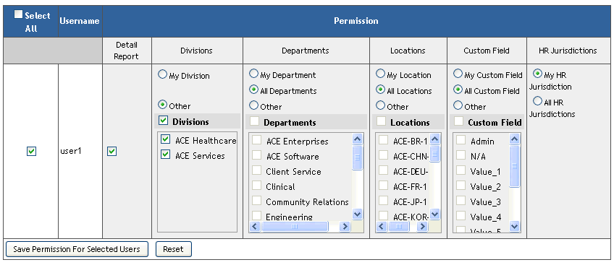
- Log out and log in as dadmin2.
- Go to Admin → Manage Security → Detailed Reporting Privileges.
- Find user1 and view their permissions. Notice that dadmin2 cannot see the “ACE Healthcare” division. Instead dadmin2 can see the values in their domain, namely the “ACE Services” and “ACE Software” divisions. Also notice that “ACE Services” is selected, while “ACE Software” is not. 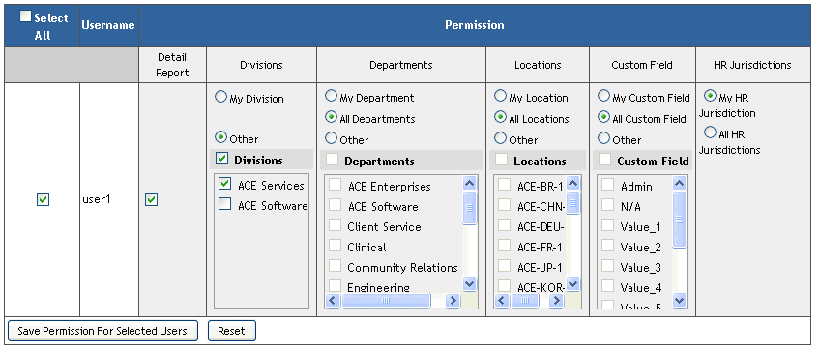
- Select the “ACE Software” division and save the permissions.

Step 7 resulted in a complete over-write of the permissions. Now user1 can report on the values set by dadmin2, namely the “ACE Services” and “ACE Software” divisions. The values set by dadmin1 are gone, and no longer exist. Last save wins and it is a complete over-write.

Hierarchies in Compensation and Variable Pay
Some administrative tasks in the Compensation and Variable Pay modules perform actions that are driven by employee hierarchies. Domain restrictions are enforced at the head of hierarchy only.

For example, the Compensation Administration → Mass Create New Form feature allows compensation forms to be mass created for a hierarchy of users. Every manager in the compensation hierarchy will get a form with their direct reports in the compensation form.

The administrative domains restriction on this feature will control which head of hierarchies an administrator may access. But once the Compensation Mass Create Forms feature is invoked, domains will follow the compensation hierarchy regardless of any domain consideration. Everyone in the hierarchy will get a form. The only domain check is for accessing the root head of hierarchy for where to start the mass create.

Another hierarchical example is the Compensation Administration → Manage Compensation Forms. Here the domain restriction is applied to accessing forms where the form planner is in your domain. However the plan members whose compensation is being managed by this form are not restricted against the administrative domain. Only the form planner is filtered against the administrative domain.

The hierarchical based administrative tasks for Compensation and Variable Pay administration include the following:

Administrative Privileges and Administrative Domain Privileges
Administrative Privileges refers to which administrative actions you can perform. Administrative Domains refer to the target user population to which your administrative actions are restricted.

Both your administrative domain and your administrative privileges are controlled such that you cannot grant others with access to more than you own. For example, suppose dadmin1 has administrative privilege to import and export employees, and also has access to Administrative Privileges management. In this scenario dadmin1 can grant others the ability to Import and Export employees. But even though dadmin1 has access to the Administrative Privileges link, they cannot grant others with access to privileges they do not own. For example, dadmin1 cannot grant any Form Template Administration privileges since dadmin1 does not have these privileges for themselves.

Frequently Asked Questions
The following are frequently asked questions about administrative domains

When assigning reporting permissions to an individual, can an Administrator grant access to other dept/div/loc outside of their domain?
No, the administrator is restricted to viewing their dept/div/loc specified in their domain. Even if the target user has permissions larger than the administrator’s domain (maybe super admin gave these permissions to the user), the administrator cannot view those permissions.

For example, assume that superadmin has granted Detailed Reporting Rights for user2 with access to all divisions, departments and locations in the enterprise, as seen below.

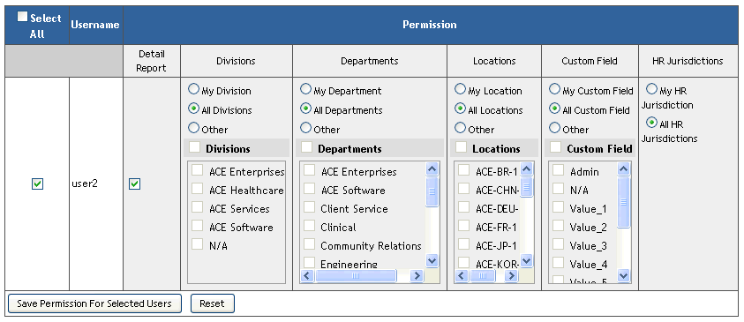
Figure 22 Super Admin sets Detailed Reporting Rights for user2

You can see that Super Admin has access to all divisions, departments and locations in the enterprise and can revoke/enable all values within user2 permissions. If we login as dadmin1 whose domain is restricted to divisions of “ACE Healthcare” and “ACE Services” below is the view of user2’s detailed reporting rights.

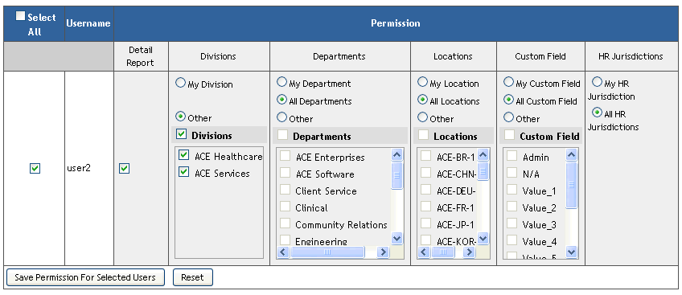

Dadmin2 can only see the divisions in their domain as seen above. User2 still has access to all divisions in the enterprise as set by the superadmin, but dadmin2 does not know this and can only see the values in their domain.

If dadmin2 saves the permissions now, user2 will lose the permissions set by superadmin in the previous step. In other words, last save wins and the new permissions are a complete over-write of what dadmin2 sets for user2.

What happens if my admin domain privileges are revoked after I’ve already assigned permissions?

If an administrator’s domain privileges are revoked or reduced in scope, any permission given prior to the change will be intact, however the admin will not be able to act on any of the areas in which permissions have been revoked. Below is a sample scenario:

- Super Admin gives dadmin1 domain privileges with divisions “ACE Healthcare” and “ACE Services”
- User1 is in division “ACE Healthcare”
- Admin dadmin1 logs in and gives detailed reporting rights to User1 for “ACE Healthcare”.
- Super Admin removes “ACE Healthcare” from dadmin1’s domain.

User1 will still have detailed reporting rights to “ACE Healthcare”, however dadmin1 can no longer access User1, nor can dadmin1 grant others with access to “ACE Healthcare” since it is no longer in dadmin1’s domain.

Admin Links Restricted by Administrative Domains
Below is a full list of the links which are restricted by Administrative Domains. Note that the terminology may vary in your installation using our text replacement feature. For example, the last link in this table is “Manage Goals → Export User and Goal Plan Permission Association”, but Goals could be text replaced to another value like “Objective”.

Admin Section | Admin Link
Manage Users | Reset User Password
Manage Users | Employee Import
Manage Users | Employee Export
Manage Users | Documents Transfer
Manage Users | Goal Transfer
Manage Users | Send System E-Mail Notification
Manage Users | Reset User Account
Manage Users | Change Email Notification Setting
Manage Users | Change User Information
Manage Users | Manage User
Manage Security | Default User Group Assignment
Manage Security | Administrative Privileges
Manage Security | Human Resource Privileges
Manage Security | Detailed Reporting Privileges
Manage Security | Dashboard/List View/Spotlight View Permission
Manage Security | Manage Dashboard Permissions
Manage Security | Permission To Create Forms
Manage Security | Permission To Create Notes
Manage Security | Managing Mass Create Group Privilege
Manage Security | Compensation Management Permission
Manage Security | Spreadsheet Report Permission
Manage Security | Manage Organizational Chart Privileges
Manage Security | Succession Management and Matrix Report Privileges
Manage Security | Succession Planning Permissions
Manage Security | Live Profile Access
Manage Security | Talent Search Access
Manage Security | Proxy Management
Manage Security | Manage Support Access
Form Template Administration | Mass Create Form Instances
Manage Documents | Modify Document Route Map
Manage Documents | Delete Documents
Manage Documents | Restore Deleted Documents
Manage Documents | Approve Document
Manage Documents | Sign Document
Manage Documents | Route Document
Manage Documents | Route Signature Stage Document
Manage Documents | Route Complete Documents
Manage Documents | Complete/Decline 360 Document
Managing Recruiting | Recruiting Reports Permission
Managing Recruiting | Grant Job Postings Permission
System Properties | Import Extended User Information
System Properties | Export User Information (Data and Template)
System Properties | Import Nomination Transfers
Compensation Administration | Compensation Group Management
Compensation Administration | Compensation Group Assignment
Compensation Administration | Compensation Group Import
Compensation Administration | Compensation Group Export
Compensation Administration | Manage Compensation Executive Review Permission
Compensation Administration | Manage Compensation Forms
Compensation Administration | Create New Form
Compensation Administration | Mass Create Forms
Compensation Administration | Update Compensation Forms for Template
Compensation Administration | Update Compensation Forms
Compensation Administration | Move Members Between Forms
Compensation Administration | Add Members To Forms
Compensation Administration | Delete Members From Forms
Compensation Administration | Compensation Rollup
Compensation Administration | Compensation Aggregate Export
Compensation Administration | Budget Assignment
Compensation Administration | Store Compensation Data in Live Profile
Compensation Administration | Generate Personal Compensation Statement
Variable Pay | Manage Variable Pay Forms
Variable Pay | Manage Variable Pay Executive Review Permission
Variable Pay | List Variable Pay Programs → Configure Variable Pay Program. See details in section 9, Configure Variable Pay Program below.
Variable Pay | Manage Personal Variable Pay Statement Templates
Variable Pay | Generate Personal Variable Pay Statement
Manage Goals | Export User and Goal Plan Permission Association

How Are Actions Restricted by the Admin Domain?
Below is a full list of the types of actions that are restricted and details on how they are restricted by an administrative domain.

1 Action on Individual User
In Admin, there are areas where the administrator can perform an action on an individual user through a search. With Administrative Domains enabled, administrators can only find and perform actions on users within their domain.

Sample Page:

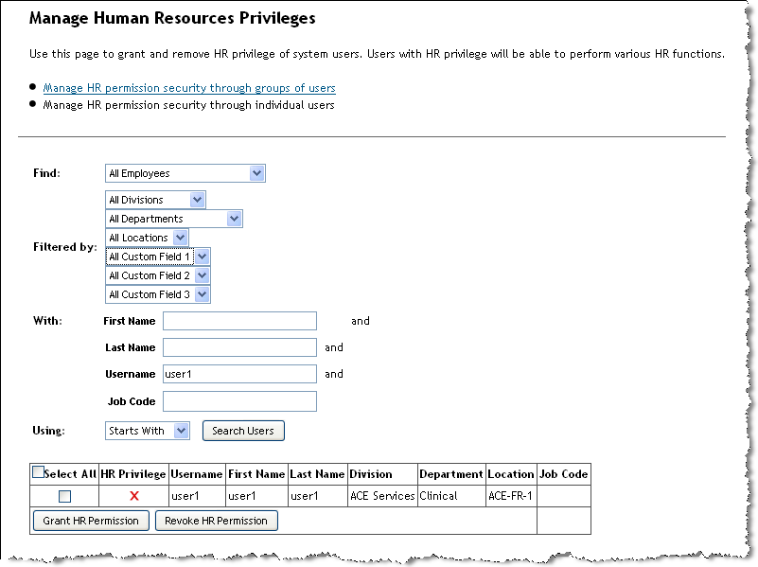
Figure 23 Manage Human Resources Privileges page

You can find this type of action in the following Admin Links:

Admin Section | Admin Link
Manage Users | Reset User Password
Manage Users | Documents Transfer
Manage Users | Goal Transfer
Manage Users | Send System E-Mail Notification
Manage Users | Reset User Account
Manage Users | Change Email Notification Setting
Manage Users | Change User Information
Manage Users | Manage User
Manage Security | Default User Group Assignment
Manage Security | Administrative Privileges
Manage Security | Human Resource Privileges
Manage Security | Detailed Reporting Privileges
Manage Security | Dashboard/List View/Spotlight View Permission
Manage Security | Manage Dashboard Permissions
Manage Security | Permission To Create Forms
Manage Security | Permission To Create Notes
Manage Security | Managing Mass Create Group Privilege
Manage Security | Compensation Management Permission
Manage Security | Spreadsheet Report Permission
Manage Security | Manage Organizational Chart Privileges
Manage Security | Succession Management and Matrix Report Privileges
Manage Security | Succession Planning Permissions
Manage Security | Live Profile Access
Manage Security | Talent Search Access
Manage Security | Proxy Management
Manage Security | Manage Support Access
Form Template Administration | Mass Create Form Instances
Managing Recruiting | Recruiting Reports Permission
Managing Recruiting | Grant Job Postings Permission
Compensation Administration | Compensation Group Assignment

2 Action on Group of Users
In Admin, there are areas where the administrator can perform an action on a group of users through filtering. With Administrative Domains enabled, administrators can only find and perform actions on groups that contain users within their domain. If a group is used as a filter for actions, an Admin will only be able to select a group if all members within that group are within their target population.

Sample Page:

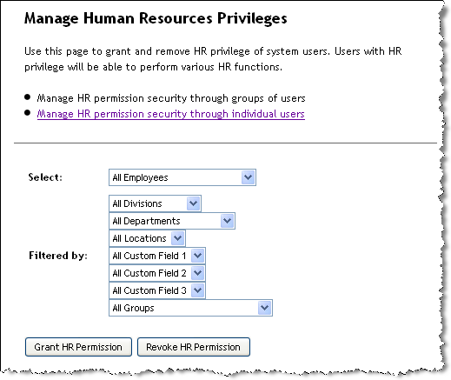
Figure 24 Example of admin function that applies to a group of users

The phrase “All Employees” should implicitly imply that the target is “All Employees within their Target Population.” We will have to think of a better way to express that.

You can find this type of action in the following Admin links:

Admin Section | Admin Link
Manage Users | Reset User Password
Manage Users | Send System E-Mail Notification
Manage Security | Default User Group Assignment
Manage Security | Administrative Privileges
Manage Security | Human Resource Privileges
Manage Security | Detailed Reporting Privileges
Manage Security | Dashboard/List View/Spotlight View Permission
Manage Security | Manage Dashboard Permissions
Manage Security | Permission To Create Forms
Manage Security | Permission To Create Notes
Manage Security | Managing Mass Create Group Privilege
Manage Security | Compensation Management Permission
Manage Security | Spreadsheet Report Permission
Manage Security | Manage Organizational Chart Privileges
Manage Security | Succession Management and Matrix Report Privileges
Manage Security | Succession Planning Permissions
Manage Security | Live Profile Access
Manage Security | Talent Search Access
Form Template Administration | Mass Create Form Instances
Managing Recruiting | Recruiting Reports Permission
Managing Recruiting | Grant Job Postings Permission

3 Employee Import
In Admin, there are areas where the administrator can perform an employee import. With Administrative Domains enabled, administrators can only import users within their domain. For instance, if an administrator had a target population of Dept=A, that administrator could only import employees with the attribute Dept=A.

Sample Page:
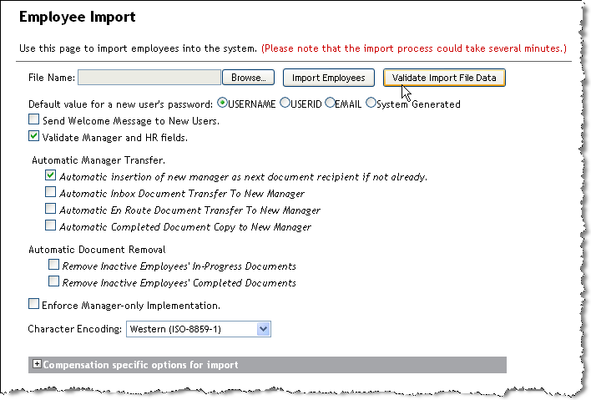
Figure 25 Employee Import Page

Imports with Employee information can be found in the following Admin Links:

Admin Section | Admin Link
Manage Users | Employee Import
System Properties → Live Profile | Import Extended User Information
System Properties → Succession Data Management | Import Nomination Transfers

Notification Error Message:
The E-mail notification for Employee Import should include a list of users that were not imported due to administrative restrictions. “The following users were not imported/update because they are not within your administrative target population:
{list users}

Example:
“The following users were not imported/updated because they are not within your administrative target populations:
cgrant
athompson
lhadley
”

4 Employee Export
In Admin, there are areas where the administrator can perform an employee export. With Administrative Domains enabled, administrators can only export users within their target domain. For instance, if an administrator had a target population of Dept=A, that administrator could only export employees with the attribute Dept=A.

Sample Page:
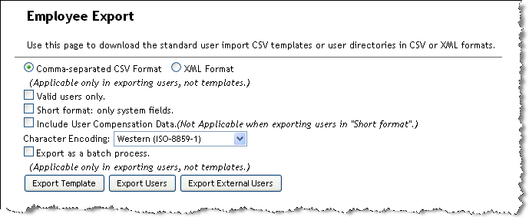
Figure 26 Employee Export Page

Exports with Employee information can be found in the following Admin Links:

Admin Section | Admin Link
Manage Users | Employee Export
System Properties → Live Profile | Export User Information (Data and Template)
Manage Goals | Export User and Goal Plan Permission Association

5 Create New User Interface
In admin, there is one link where you can create a new user. Similar to the employee import, the admin will only be able to create a new user in their specified target domain.

Sample Page:
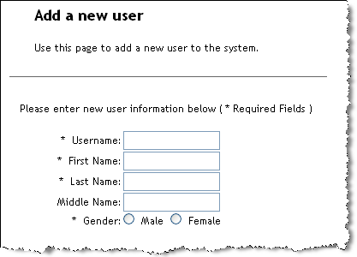
Figure 27 Add New User Page

Error Message
If an admin tries to create a new user that is not within the admin’s target population, the following error message should appear: “Your data has not been saved. Please check to make sure the user is within your Admin target population”

6 Manage Documents
In the Manage Documents section of Admin, when Administrative Domains are enabled administrators can only find and perform actions on documents that have a subject within their target domain.. For instance, if there is a PM form created for Cgrant, the administrator needs to have access to Cgrant in order to perform any actions on this document.

Sample Page:
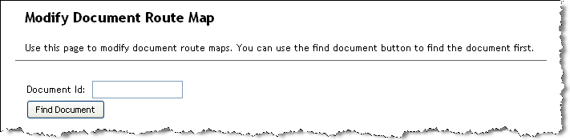
Figure 28 Modify Document Route Map page

Documents with Employee Data can be found in the following Admin Links:

Admin Section | Admin Link
Manage Documents | Modify Document Route Map
Manage Documents | Delete Documents
Manage Documents | Restore Deleted Documents
Manage Documents | Approve Document
Manage Documents | Sign Document
Manage Documents | Route Document
Manage Documents | Route Signature Stage Document
Manage Documents | Route Complete Documents
Manage Documents | Complete/Decline 360 Document

Error Message
If an admin tries to search for a document and the subject of that document is not within the admin’s target population, the following error message should appear : “You do not have access to document {Form Name}. User {subject username} is not within your admin target population”

Example:
“You do not have access to the document Annual Review for Charles Grant. User cgrant is not within your admin target population.”

7 Granting Target Permissions
An administrator can have the rights to assign target permissions in the Admin Links listed below. The details of granting target permissions are covered .

Target Permissions can be found in the following Admin Links:

Admin Section | Admin Link
Manage Security | Administrative Domain Permissions
Manage Security | Detailed Reporting Privileges
Manage Security | Succession Management and Matrix Report Privileges
Manage Security | Succession Planning Permissions
Manage Security | Succession Approval Permissions

8 Compensation Administration

Manage Compensation Forms
You can manage any compensation form where the form planner is in your domain. You will not be able to see any forms for planners outside of your domain. Note that the members on the form are not filtered by your domain. You will be able to see all members on the form regardless of your domain. However when assigning or removing members from compensation form, you can only assign or remove members from your domain.

Create New Form
When creating a new compensation form an administrator can only specify a group planner for a user within their target domain. Additionally, when specifying a compensation group, all members of the compensation group must be in your domain. Note that you will see all groups in the enterprise, but you will not be able to create the form if a member is outside of your domain.

Example: Create compensation form using a compensation group with members outside of your administrative domain:

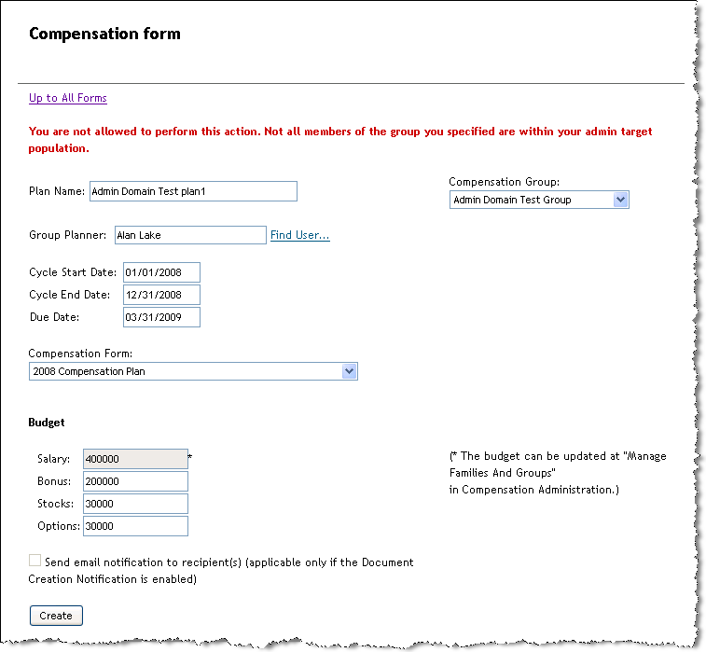
Figure 29 Create Compensation Form Error (Compensation group has users outside of your domain)

Mass Create Forms
Administrators can mass create compensation forms by specifying a head of hierarchy. The administrator can only specify a head of hierarchy that is within their target domain. Once the head of hierarchy is specified, the mass create will follow the hierarchy regardless of domains.

Add/Delete/Move Members in a Form
Compensation Administrators can add, delete or move members to a form using the following links:

Administrators can only select a source or target form that has a form owner within their administrative domain. Additionally, when the admin has selected a form, they may only be able to add/move/delete users within the admin target population.

Compensation Groups
Compensation groups are shared globally across the enterprise. Domain restrictions are applied in the following ways:
- When creating a new form, you may only use a compensation group where all members are within your domain.
- When editing a compensation group, you can only add or remove members who are within your domain.
- When exporting a compensation group, only members from your domain will be exported. Members who are not in your domain will not be exported.
- When importing a compensation group, you may only import members within your domain.

Compensation groups are used in the following ways:
- In Compensation Administration → Create New Form
- In Compensation Administration → Manage Families and Groups (used to specify budget rules).
- When a compensation form is configured, a compensation group can be specified in a compensation formula to specify budget rules.

9 Variable Pay Administration

List Variable Pay Program
Variable Pay Programs are shared globally in the enterprise. You can list the variable pay programs from the link in Variable Pay Administration → List Variable Pay Programs. This will present a screen similar to the following:
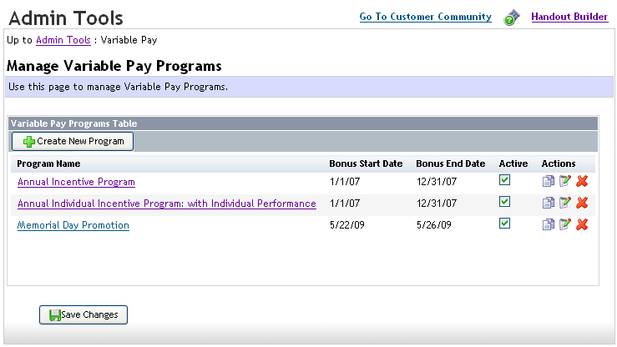
Figure 30 Manage Variable Pay Programs Page

Configure Variable Pay Program
Selecting a program name in the Manage Variable Pay Programs screen above will bring up the Configure Variable Pay Program page seen below. Though the variable pay program itself is shared globally, the links highlighted in yellow are restricted by your administrative domain.

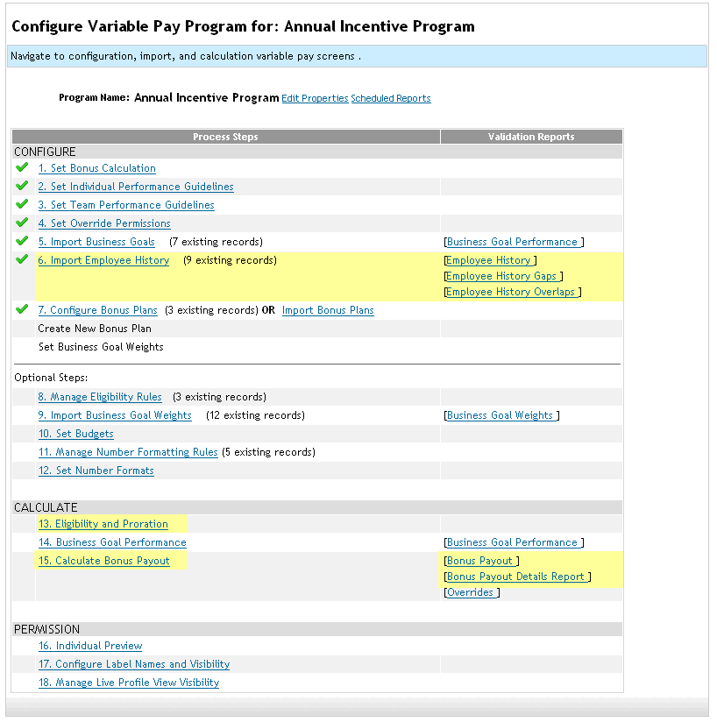
Figure 31 Configure Variable Pay Program Page

Administrative Features NOT Restricted to the Administrative Domain
Below is a list of links that are NOT included in the Administrative Domains release. Domain restrictions do not apply to these links. Mostly these are administrative actions that work on data, and are not directly associated to any particular user. The data (like Skills Libraries or Form Templates) are global to the enterprise and shared by the entire organization.

However there are some Compensation and Variable Pay features that are related to users and are NOT restricted to the Administrative Domain. These features will be able to operate on the entire enterprise of users in the system.

Admin Section | Admin Link
Form Template Administration | Form Templates
Form Template Administration | Routing Maps
Form Template Administration | Rating Scales
Form Template Administration | Set Corporate Goals
Form Template Administration | Schedule Mass Form Creation
Form Template Administration | Template Creator
Managing Competencies and Skills | Competency Libraries
Managing Competencies and Skills | Skills Libraries
Managing Competencies and Skills | Calculate 360 Benchmark Ratings
Managing Competencies and Skills | Families and Roles
Managing Competencies and Skills | Import Competency Library
Managing Competencies and Skills | Import New Skills Libraries
Managing Competencies and Skills | Import Skill and Role Mapping
Managing Competencies and Skills | Import Responsibility and Competency Mapping
Managing Competencies and Skills | Mapping Job Responsibility Skills to Competencies
Managing Competencies and Skills | Mapping Skills to Roles
Managing Competencies and Skills | Legal Scan Library
Managing Competencies and Skills | Legal Scan Library Import
Managing Question Library | Question Libraries
Managing Question Library | Import New Question Library
Managing Recruiting | Managing Recruiting Site
Managing Recruiting | Recruiting Reports Permission
Managing Recruiting | Edit Applicant Status Configuration
Managing Recruiting | Grant Job Posting Permission
Managing Recruiting | Setup Company Information
Managing Recruiting | Setup Job Board Options
System Properties | Company Process
System Properties | Data Privacy Consent Statement
System Properties | Bulletin Board Message Settings
System Properties | Password Policy Settings
System Properties | E-mail Notification Template Settings
System Properties | Process Guide Setting
System Properties | Help Link Settings
System Properties | Text Replacement
System Properties | Quick Link
System Properties | Matrix Grid Rating Scales
System Properties | Company Dictionary
System Properties | Change Engine Configuration
System Properties | Performance vs Potential
System Properties | How Vs What
System Properties | Retirement Eligibility Settings
System Properties | Picklists
System Properties | Data Category Configuration
System Properties | Configure Scorecard
System Properties | Portlet Permissions
Compensation Administration | Manage Salary Pay Matrices
Compensation Administration | Manage Job Code and Pay Grade Map
Compensation Administration | Manage Currency Conversion Rate Tables
Compensation Administration | Manage Stock Value Tables
Compensation Administration | Manage Stock Factors Tables
Compensation Administration | Manage Families And Groups
Compensation Administration | Manage Merit Matrices
Compensation Administration | Manage Personal Compensation Statement Templates
Dashboards/Reports | Process and Forms
Dashboards/Reports | Rating Scales
Dashboards/Reports | Performance Management Date Range
Dashboards/Reports | Thresholds
Dashboards/Reports | Trending
Dashboards/Reports | Filtering Options
Dashboards/Reports | Individual Portlets
Dashboards/Reports | Dashboards
Dashboards/Reports | Portlet Permissions
Dashboards/Reports | List Views
Manage Goals | Import Goals
Variable Pay Administration | Manage Personal Goal Statement Templates
Variable Pay Administration | Generate Personal Goal Statement
Variable Pay Administration | Manage Currency Conversion Rate Tables

