Part-1: Deployment Location

There are many ways to upload a Content to the iContent/self-hosted servers. One common way of doing it via the Deployment Location. This is where we configure the iContent server account (if we have an iContent account purchased) via which we can import contents.

Admin->Content->Deployment Locations->Add New
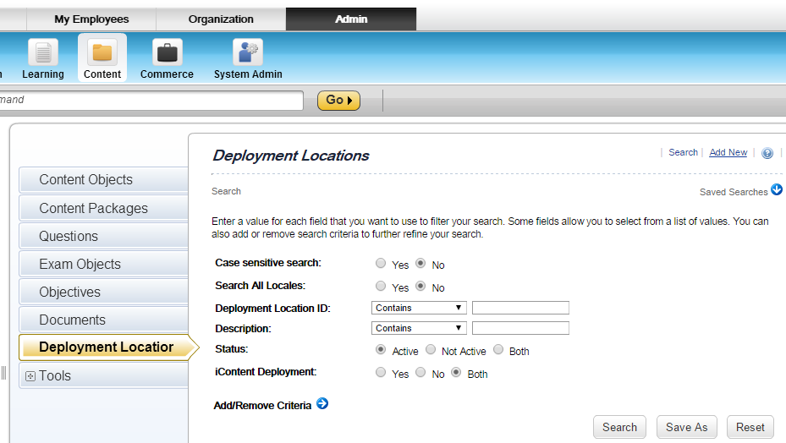
Pic-1

Certain details like
- Hostname - server location (it can be an IP also if it is self-hosted)
- Port number
- Username
- Password
- URL Prefix
are provided by SuccessFactors upon purchasing the iContent server space.

Provide a name for the Deployment Location ID and fill out all the necessary details as displayed in the picture below. URL-Prefix is a combination of a “url space”+”folder in the server space”. In this case the url space is: /icontent/CUSTOM/username/ and “Vish” is the folder present in the root directory of the server space. The same has to be updated for the “Directory” field.
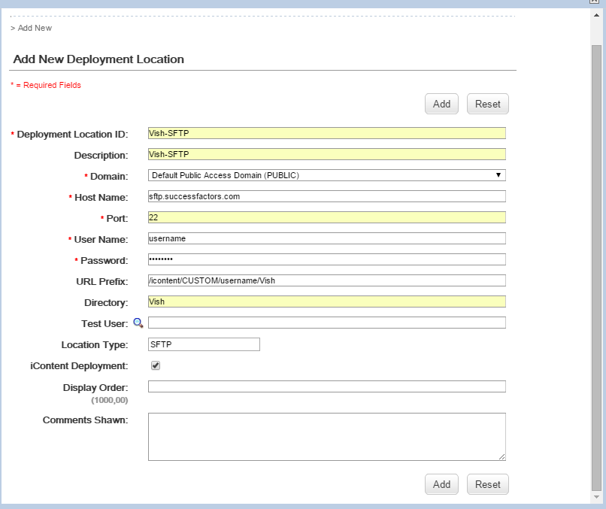
Pic-2

Click on “Add” button

Part-2: Content Creation
Go to Admin->Content->Tools->Import Content->Browse->Choose the file that we want to import to the FTP server space (in this case-iContent)
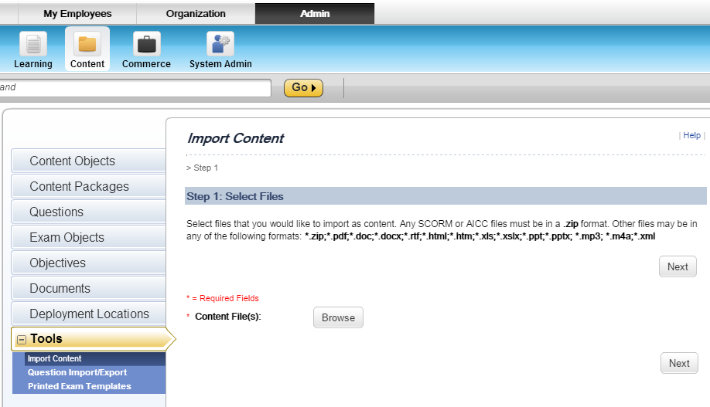
Pic-3
We can view all the supported file formats mentioned in bold in the above picture. After choosing the file, click on Next. After this we can create a new Content that will be associated with the PDF file that I chose by browsing for the file “in Pic-3” by clicking on Import Files and associate this content to an existing item or we can create a new item for this.
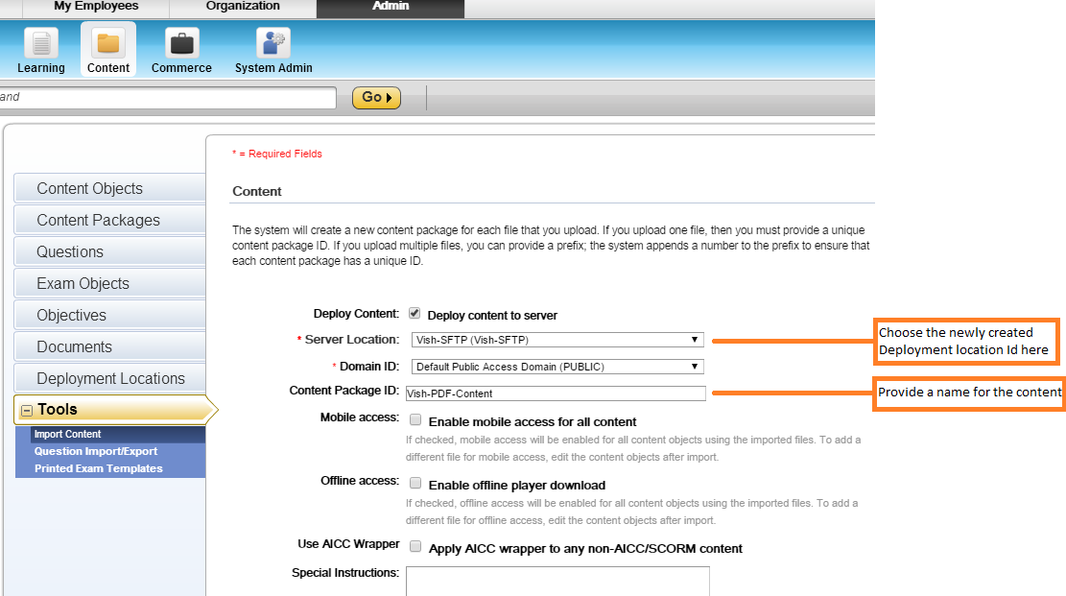
Pic-4

There are two ways we can associate the content to the items:
- To a new item
- To an existing item
To a new item (In the same window of the Pic-4):
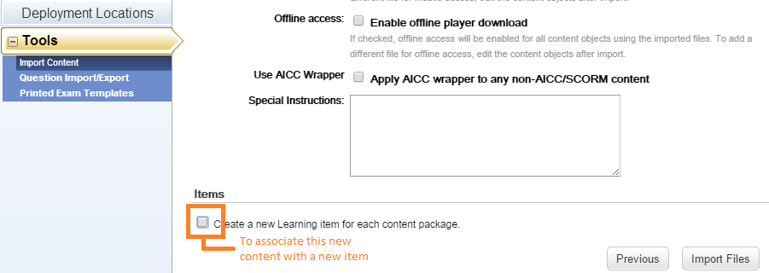
Pic-5
Check the checkbox shown in the pic-5, which will open a frame in the same window
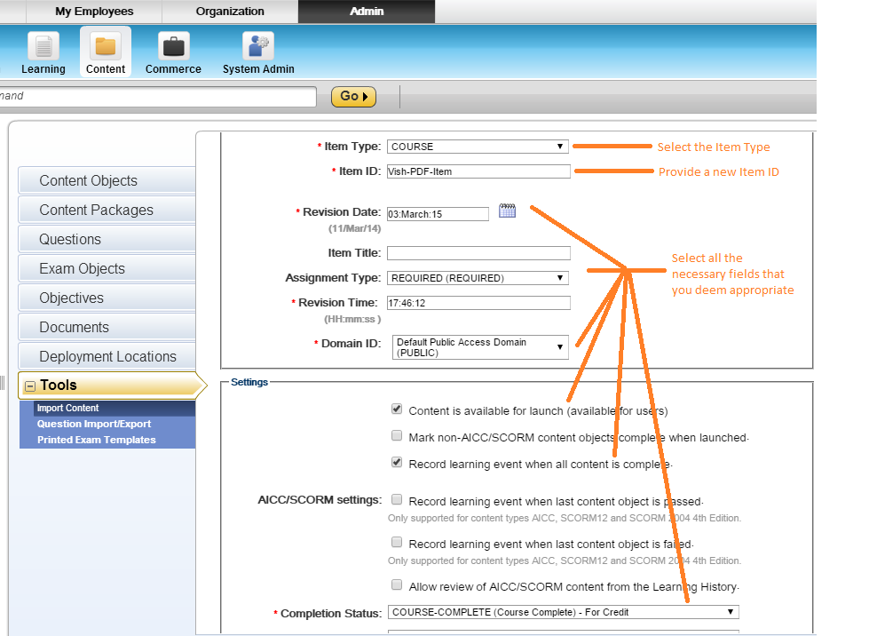
Pic-6

And then click on “Import Files”
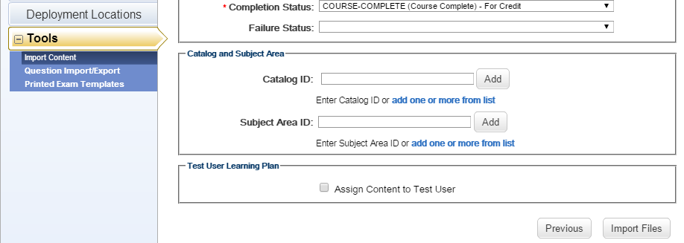
Pic-7

The window explaining the validation status of the upload will be shown as follows:
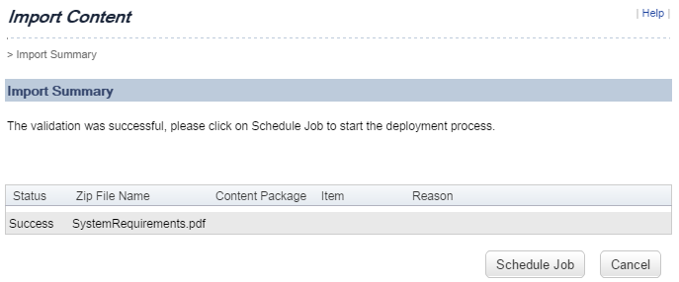
Pic-8

Click on “Schedule Job” to schedule the import for now or later.
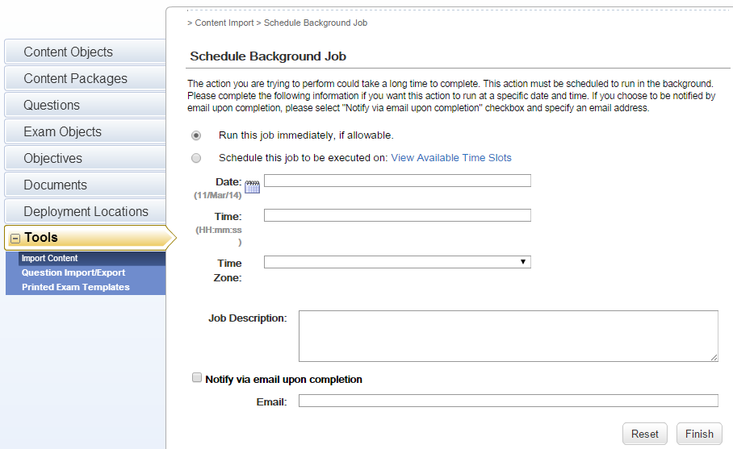
Pic-9
If we want to have this imported immediately, choose “Run this job immediately” and click on “Finish”.
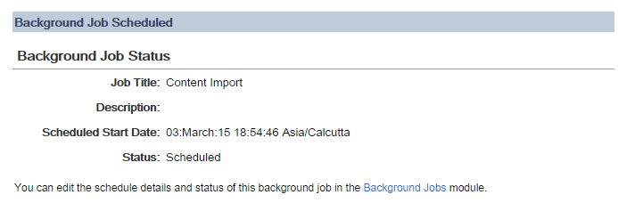
Pic-10

The status of the upload will be “Scheduled” when the new frame (window) loads and then it will change to “Succeeded” after it is uploaded successfully (time depends on the server availability and the file size) as shown below:

Pic-11
The item was created successfully and we can check for the same at Admin->Learning->Items->Search (Item ID: Vish-PDF-Content-Item)

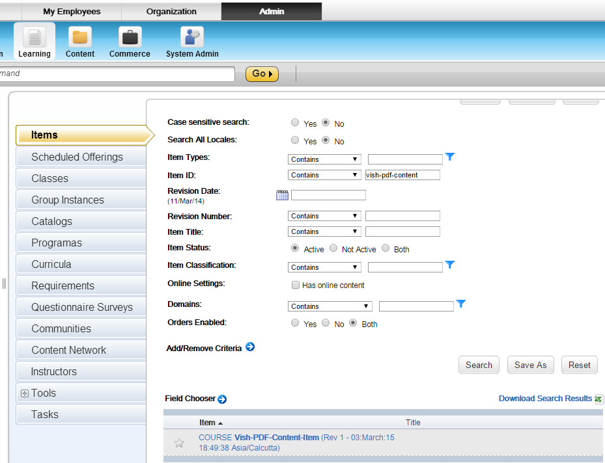
Pic-12

Open this item, and assign it to the users as per the requirement as shown in the following images:
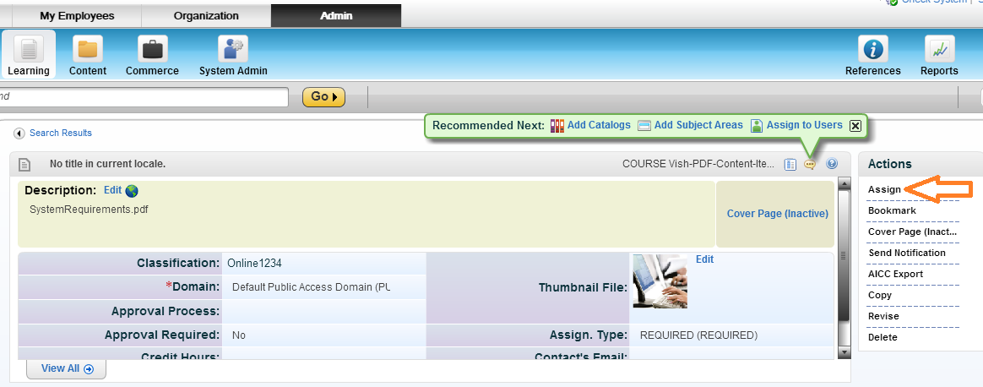
Pic-13
And then choose the users
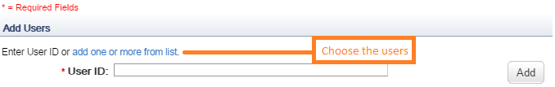
Pic-14
After choosing the user click on Next
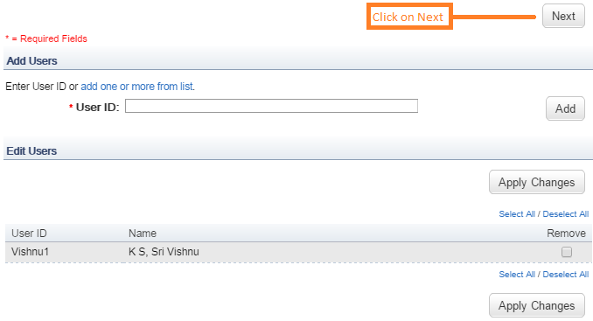
Pic-15

After that choose the appropriate values in the following screens and proceed forward by clicking on “Next” and in the last screen click on “Run Job now” to have it assigned immediately or click on “Schedule Job” to have it scheduled.
And there we go!!!! The item has been assigned to the user
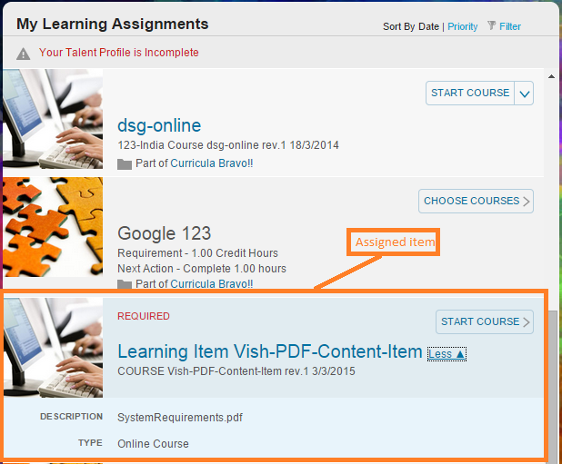
Pic-16
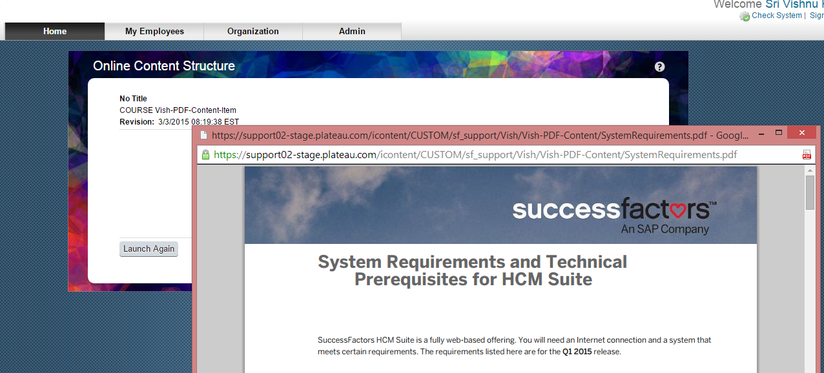
Pic-17

To an existing item
Follow the procedure from Page 7 to Page 9(Pic-12 to Pic-17)

