Personal Compensation Statement Development in Comp Admin 2.0
With the October 2012 Release, customers adopting Comp Admin 2.0 have new options for creating and distributing compensation statements. Statement templates may be either loaded or created from the SuccessStore, outside of all compensation plans via the Actions for all Plans setting. Once templates have been loaded or created, they may then be associated with a compensation plan from the “Reward Statements” menu, which is part of Complete Compensation Cycle. This feature is available for all SuccessFactors Compensation editions but at present supports compensation statements only. VarPay and Combined Statement permissioning will be available with a future release.
Actions for all Plans
From Comp Admin 2.0 > Compensation Home, browse to Manage Compensation Statements. The system brings you to the Manage Statement Templates landing page. On the top section of this page, you can import an XSL template, or create a new template by selecting Add from SuccessStore.
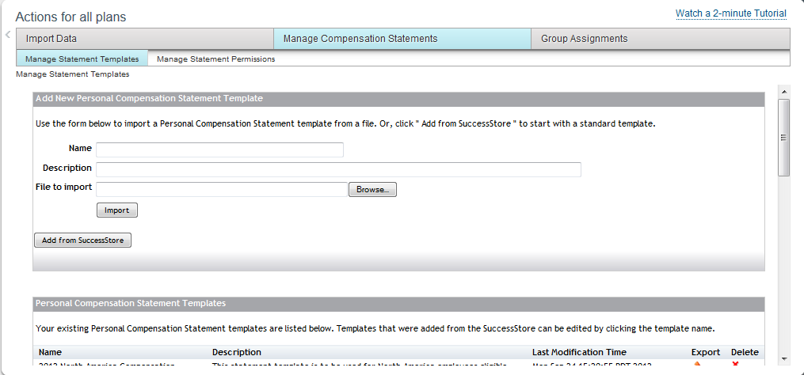
Manage Statement Templates
There is a compensation template available in the SuccessStore which has been pre-configured with standard compensation statement fields.
- Create a new statement template by selecting “Add to my instance”, and giving it a name and description.
- The statement template has section names and field names. These names can be edited by selecting the “edit” icon on the right side of each row.
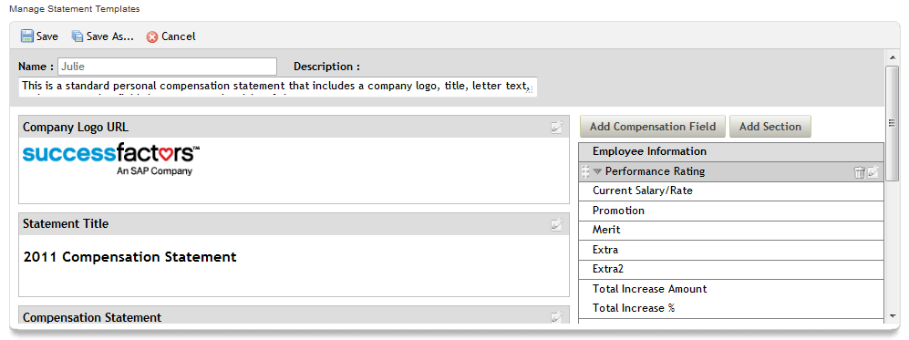
- The visibility of each section and field name is managed by setting conditions. For instance, for the Promotion amount field, you might want to hide the field if no promotion is being given. The operator can be set as follows:
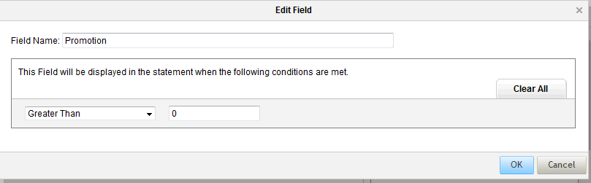
- The display order of the fields can be changed by selecting the grid arrow on each row. You may select the plus icon to view the condition that has been set.
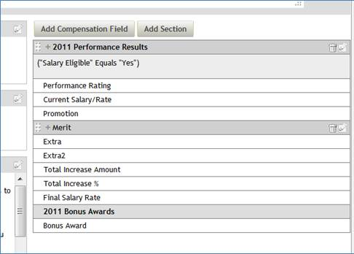
Once all statement templates have been either loaded or created, you are ready to assign the templates to a compensation plan.
Manage Statement Permissions
Manage Statement Permissions allows you to set the default statement viewing permissions for the instance. This setting is optional. It can be used to manage the visibility of legacy statements created prior to the October 2012 Release. However, once default permissions are set, all statements associated with a compensation plan will inherit the default permissions, unless they are updated from within a compensation plan.
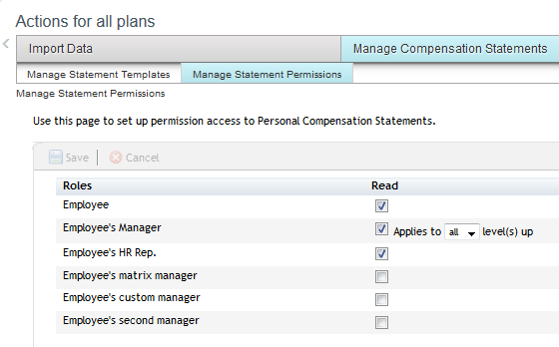
Complete Compensation Cycle
The Complete Compensation Cycle > Reward Statements setting within a compensation plan is used to assign statement templates to users, set visibility permissions for each template/user group, and generate/recall statements.
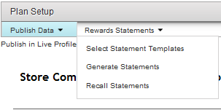
Select Statement Templates
Select Statement Templates allows you to associate templates created or loaded from Actions for all Plans with a specific compensation plan. Once the templates are selected, dynamic groups may be used to assign users to each template and set visibility permissions by role.
When you first visit the page, it will indicate that no templates have been selected.
- Select the statement template(s) you wish to use for the compensation plan. In our example, there will be one template for the medical device business unit, one template for the biotech business unit, and one template for all executives, defined as business unit vice president and above. In addition, select a statement as the default template that will be assigned to any user not meeting the above attributes.
- Select “Save and Refresh”. Note that all users have been assigned to the default template, which is always located in the last row of the landing page.
- The user attributes outlined in #1 above (business unit, job level) have some overlap. To allow you to assign the correct template to each user, the order of the templates on the landing page determines which users are assigned to each template.
- On the right side of each row is an “Actions” button which allows you to assign the template to a group of users, set viewing permissions for the template, and remove the template from the compensation plan.
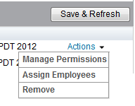

- The top template on the landing page is for executives. Use the up and down arrow keys to move the templates into the desired order. As the top template on the page, it will have the highest priority, because executive job level (not business unit) is the criteria which determines the template received. Select “Assign Employees” to the first template to bring up a popup with dynamic group assignment. Give the group a name, and select the attributes for this group. The user attributes visible in the dynamic group dropdown are controlled by the data model.
- Use the “Exclude people” functionality to suppress statements for employees who will not be receiving increases or bonuses.
- Once a dynamic group has been created, the system automatically locks the assignments. This is done so that the statements that are generated will reflect the user attributes in place at the close of the compensation cycle. You may unlock the dynamic group by selecting the “unlock” setting at the bottom of the popup, as long as no statements have been generated. Once statements have been generated, it is necessary to recall statements before the dynamic groups can be updated.

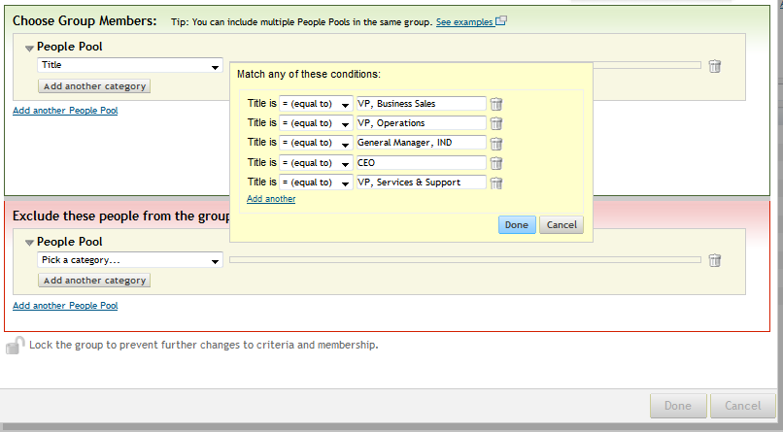

- The next two templates are assigned to each of the business units. Note that each time “Save and Refresh” is selected, the users move out of the default pool and are re-assigned to the appropriate templates.

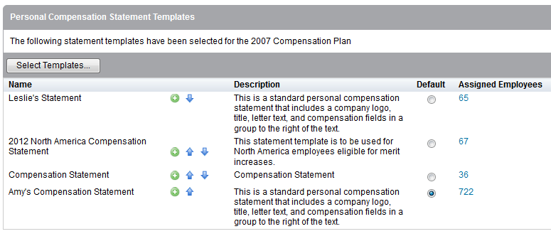
- If one template is being used multiple times with different statement release dates, select the green plus key to clone the template. Assign the newly cloned template to the appropriate employee group based on reward statement distribution schedules.
- The default template is used to capture any user who does not meet the criteria defined by the templates above. This could be the result of a missing field in the employee record. Also, inactive employees who are eligible for the compensation plan will be assigned to the default template. In a future release, the dynamic groups feature will be enhanced so that inactives will be included in the appropriate business unit or executive template.
- The “Manage Permissions” action controls the visibility of statements. As a best practice, all visibilities should be set to “none” until statements are generated and verified.
Generate Statements
Statements may now be generated. As a best practice, you may wish to create a dynamic group of one user for each template, to preview the statement and ensure it is correct, then recall the statement and start again.
Recall Statements
Statements may be recalled (deleted) from the system. However, due to the dynamic nature of the groups, it is necessary to recall all statements and start the process again. A future enhancement will allow the recall of specific user statements.
If you have more questions about Managing Statement Permissions, please consult with your Professional Service or Customer Success Consultant.

