

Recruiting Data Import/Export Guide

SuccessFactors Proprietary & Confidential – for SuccessFactors staff, partners, and customers only

Update history
Date | Author | Notes
March 16, 2010 | Will Doolittle | Describes features available in the b1003 release. This consolidated document supersedes previous documents about Recruiting imports.
March 25, 2010 | Will Doolittle | Minor clarifications and edits
March 31, 2010 | Will Doolittle | More clarifications; added recommended import order
April 2, 2010 | Yvette Arnold | Edits; added candidate tag assignments; added detail on quartz scheduler in provisioning.
May 7, 2010 | Will Doolittle | Incorporated feedback from Permanand & others

Contents
Importing Data 3
Supported Files 3
Candidate Profiles 3
Candidate Attachments 3
Candidate Background Fields 3
Candidate Tags 3
Candidate Tag Assignments 3
Job Requisitions 4
Applications 4
Application Attachments 4
File Formats & General Rules 4
File Details 5
Running Import Jobs 5
Initiating a Test Import Job via the Quartz Scheduler 5
Initiating a Production Import Job with Operations 8
Import Status Notification 8
Re-importing failed records 8
Recommended file import order 8
Exporting Data 10
New Hire Export 10
File Description 10
Included Data 10
Export Process 11
Ad Hoc Report Builder 12
Overview 12
Scheduling Ad Hoc Report Builder Exports 13

Importing Data

Supported Files
Below are general notes about the files (data objects) that are importable. In general, all system and custom fields for these objects are importable. See the File Details section for information on exceptions, mandatory fields, and other rules.

Candidate Profiles
Candidate profiles store general information about a candidate, independent of his/her applications.
This import file supports external candidate profiles only, not profiles for current company employees.
Your instance’s candidate profile is configured through a template, which includes the definitions & field types for both standard and custom fields in your candidate profile. Aside from some mandatory fields and system fields, only fields specified in the candidate profile template can be imported.

Candidate Attachments
The main candidate profile import file described above supports resume attachments only; the Candidate Attachments file, in contrast, supports 2 additional attachments to the candidate profile: cover letters and candidate history attachments.
The candidate history attachment will be fully supported in the b1005 (May 2010) release as an attachment which is visible only to operators (not the candidates themselves), and which cannot be modified or deleted.

Candidate Background Fields
Background fields are multi-row data elements in the profile, such as work history and education. This file supports all custom background element configurations with a file format that is very similar to the background import file for employee profiles.
Candidate Background data should be imported after the candidate profiles are loaded.

Candidate Tags
Candidate Tags are a new feature supported in b1003 (March 2010). This feature must be enabled by SuccessFactors provisioning staff before you can import tags from a legacy system.
Candidate tags should be imported after the candidate profiles are loaded.

Candidate Tag Assignments
To import candidate tag assignments, candidate tags must be enabled. This file associates tags to candidates.
Candidate tag assignments should be imported after the candidate tagss are loaded.

Job Requisitions
Unapproved (in-progress), approved, and closed job reqs can all be imported. Approved and Closed job reqs will appear in the system to have used a single-step routemap, whereas unapproved job reqs will use the routemap configured for the specified job req template and will appear under the first step of the routemap.
Only “true” job requisitions, not Events, can be imported at this time.

Applications
Applications should be imported after the candidate profiles and job requisitions are loaded, for they will reference both with unique identifiers.

Application Attachments
All application attachments are handled by this file, with a format similar to the Candidate Attachments file. Both attachments managed by the candidate (such as resumes or work samples) and attachments managed by operators (such as background check results) can be uploaded.
Application Attachments should be imported after the Applications are loaded.

File Formats & General Rules
Unless otherwise specified in the File Details section:
- Import files must be of CSV format. Standard CSV conventions are followed (see http://en.wikipedia.org/wiki/Comma-separated_values).
- Updating of existing records is not supported; the imports are designed to support one-time migrations of legacy data.
- Test data should be imported into a test instance prior to attempting the import of full data into a production instance. Always allocate time for testing, adjusting, and re-testing data transfers in your project schedule—migrating legacy data between systems can be quite complex.
- Imports should not be run until the instance configuration is complete for all objects: candidate profiles, job requisitions, and application templates, including related picklists.
- Date fields must be in the format of "yyyy-MM-dd'T'HH:mm:ss". Example: 7:01:59 p.m. on January 31 2009 would be represented as 2009-01-31T19:01:59.
- Date/time values are typically stored as the server date/time. For example, for an instance hosted in the US East Coast data center, to accurately reflect a last login date/time of January 1 2010 at 8:00 AM Pacific Time, the value imported should use 2010-01-01'T'11:00:00.
- Fields configured to use picklists should use the picklist label value, for the locale specified on the import job. The system will look up the appropriate picklist option ID based on this label and store the ID internally, for proper multi-lingual handling. Picklist values that are not found in the picklist definitions will generate an error that fails the record. (Note that this is a change from prior versions of the candidate profile import, which expected the picklist option ID.)
- Cascading picklist relationships are not validated by the import processes, but it is strongly recommended that administrators make every effort to keep parent/child picklist values as consistent as they would be for new data. For example, if country & state are configured as cascading picklists, and an import file specifies “USA” for the Country but “Quebec” for the State (not a US state), the import will succeed as long as both values are defined in the relevant picklists. If the user goes to edit the record in the UI and tries to save without changing these values, he/she will likely get an error since “Quebec” is not a child value of the parent picklist value “USA”.
- For proper picklist handling, per the above two points, picklist labels within each locale are assumed to be unique within each picklist.
- When importing objects that have multiple templates available in the system (such as Job Requisitions and Applications), each import file should only include the data for one template.

File Details
This spreadsheet includes file layout details and examples for all import files:
Double-click the icon above to open the spreadsheet. You can save a copy & supplement it with details about your legacy data sources & fields.

Running Import Jobs

Initiating a Test Import Job via the Quartz Scheduler
For small test files (less than 100 records), SuccessFactors services staff can schedule an import with the Quartz scheduler.
To schedule an import:
- Upload candidate data file and resumes to a folder on the SuccessFactors ftp server for the customer, ie. the /incoming folder.
- Schedule a candidate import job in the provisioning tool:
  - Go to Managing Job Scheduler → Manage Scheduled Jobs → Create New Job, and select the appropriate Job type of Candidate Import, JobRequisition Import, or Application Import from the Job type drop-down menu.
  - Once the Job type is selected, a sub menu will open with radio button to choose which type of import you are setting up.
  - You’ll need to choose the locale of the file and the character encoding. This should be agreed upon with the customer so that the correct values are used.
  - The host address, ftp login and password need to be entered. If the customer is already importing their employee file via ftp, then use their existing info. If they are new to our FTP here are the steps:
    - If they are starting with User Import, work with them to fill in the FTP setup sheet. It gives you and DCOPS what's needed to setup each part.
    - If it's another import, you can use the Additional Setup Sheet from Confluence or just ask for the info.
    - What you need is The IP address they will send files from. We open that in our firewall.
    - The name of the user (in the application) that they want us to use when we run the job. This person will receive the email notifications from the job. The names of anyone who should get email from the job.
    - Provide the info on a DCOPS JIRA. Operations will get the firewall opened for the address, create the FTP accounts and tell you the password.
  - Enter the file path of where the uploaded files are located and the filename.
  - Click Update Job to save your information.
  - Repeat this process for each of the file types that will be imported.
Example of a configured import job:
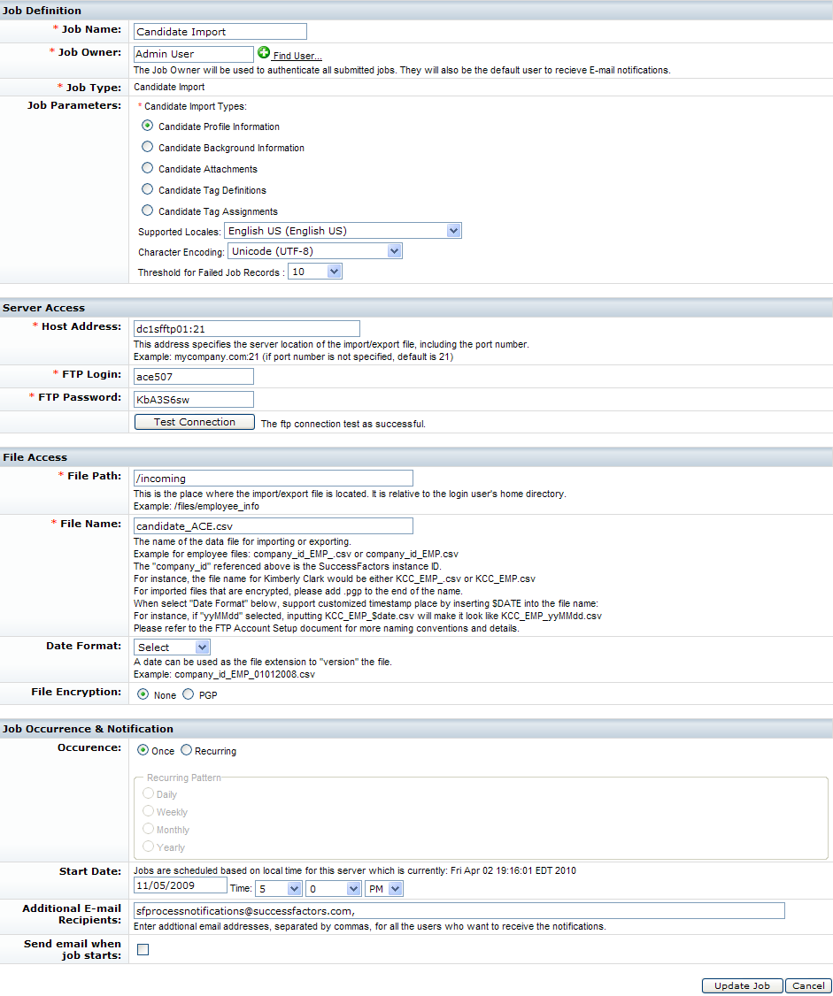
- To monitor job progress go to Managing Job Scheduler → Monitor Job in provisioning.

Initiating a Production Import Job with Operations
For production data imports, or a test file with more than 100 records, SuccessFactors services staff should file a Jira ticket with Datacenter Operations to run the import job. The ticket should include:
- Type of file being imported
- Filename and FTP server location
- Company ID
- Environment (datacenter)
- Email address (or addresses) that will get emailed results
- Character encoding (Western/ISO or UTF)
- Locale of the data (this is used to look up the ID numbers from the picklist labels in the import content)
- Threshold of failed job records (10, 100, 500, 1000, or 10000). If the threshold of failed records is reached, the job will stop processing remaining records (but the records already processed are committed to the system).

Import Status Notification
Upon the completion of candidate import, the SuccessFactors user who is the owner of the job and additional recipients will receive an email notification of the job status with summary section and optional detail section. The notification email typically includes:
Company: company name.
Total records: the number of records in the source data file.
Processed records: the number of processed records. It may not be the same as total records if the number of failed records exceeds allowed maximum number of failures.
Failed records: the number of failed records (rows that were not successfully saved).
If any records failed to import, the message will include a list of failed records identified by primary key and showing the reason for the failure.

Re-importing failed records
Failed records can be corrected and copied to a new CSV file to re-import. The system currently does not support re-importing existing records (all rows in the imported file will result in new records). For example, the candidate data file cannot mix both succeeded/existing candidates and failed/new candidates.

Recommended file import order
- Candidate profiles
- Job requisitions
- Applications – must be imported after candidate profiles & job reqs
- Application attachments – must be imported after applications
- Candidate background elements – must be imported after candidate profiles
- Candidate attachments – must be imported after candidate profiles
- Candidate tags – must be imported after candidate profiles
- Candidate tag assignments – must be imported after candidate tags
The supplemental candidate information (background elements, attachments, and tags) could be imported earlier in the process (anytime after the main candidate profile is imported). But, they are recommended to follow the other imports because for large data sets they could take many hours to process; during a live data transfer situation recruiters & hiring managers are often anxious to start working with job reqs and applications right away.

Exporting Data

New Hire Export

File Description
This function exports information about the new hire from the candidate profile record into a CSV file, which can then be imported into the HRIS to create a new employee record.
The export contains only those records that are newly hired, defined as: applicants that are currently or have passed through a status in the "Hired" category, since the last export was run. In technical terms, when applicants enter a status category of "Hired" and HiredOn date is null, it populates the HiredOn date with the current date, and the export process uses the HiredOn date to find exportable records. If the candidate moves to a Rejected status, the HiredOn date value (if any) is removed, and therefore will not be found by the export process.

Included Data
All standard system fields from the candidate and application records are included. Specifically:
Candidate Profile: (these fields are all prefixed with "CANDIDATE_")
- userID (blank for external candidates)
- contactEmail
- firstName
- lastName
- middleName
- gender
- ethnicity
- race
- address
- dateOfAvail
- cellPhone
- homePhone
- faxNumber
- city
- state
- zip
- dateOfBirth
- disabilityStatus
- minAnnualSal
- preferredLoc
- ssn
- veteranStatus
- currentTitle
- currentCompany
Application template: (these fields are all prefixed with "APPLICATION_")
- jobTitle
- jobReqID
- applicationDate
- lastmodified
- reviewDate
- source
- statusId
- referralSouce
- contactEmail
- firstName
- lastName
- middleName
- gender
- ethnicity
- race
- address
- availability
- cellPhone
- homePhone
- faxNumber
- city
- state
- zip
- dateOfBirth
- disabilityStatus
- minAnnualSal
- preferredLoc
- ssn
- veteranStatus
Job req template: (these fields are all prefixed with “JOBREQ_”)
- job req ID
- job title
- jobcode*
- form originator user ID
- recruiter user ID
- hiring manager user ID
- department
- division
- location
- country
* Jobcode is automatically populated on the req as long as the “Browse Families & Roles” option was used when creating the req.
Depending on your configuration, some of the fields listed above will always be blank (if they are not configured for use in the instance templates).
Custom fields, Background elements (complex field types with multiple rows), and Comments are not included in the export.

Export Process
The export is schedulable through the Quartz job scheduler (SuccessFactors support staff only), and can also be run manually by administrators with the function Export New Hire Candidates. The admin function allows the administrator to select truly new candidates according to the rules above, or candidates that were previously exported.
Once the process is complete, the exported applications are stamped with the date and time the export finished. For example, if 10 records are exported and the export finishes at June 25 2009 at 10:23:15 a.m. EST, that exact timestamp should be recorded in all 10 applications.

Ad Hoc Report Builder

Overview
The Ad Hoc Report Builder is a tool in the SuccessFactors application under the “Reporting” tab that allows users to create and run reports from a variety of modules. Reports can then be exported to Excel for use outside the system.
Access to the report builder must be enabled both in provisioning (by SuccessFactors services staff) for the instance, then by the company administrator for use by specific users. Users may have access to run reports only, or to both build and run reports.
To create reports on Recruiting data:
- Create a new report of type “Recruiting 2.0”.
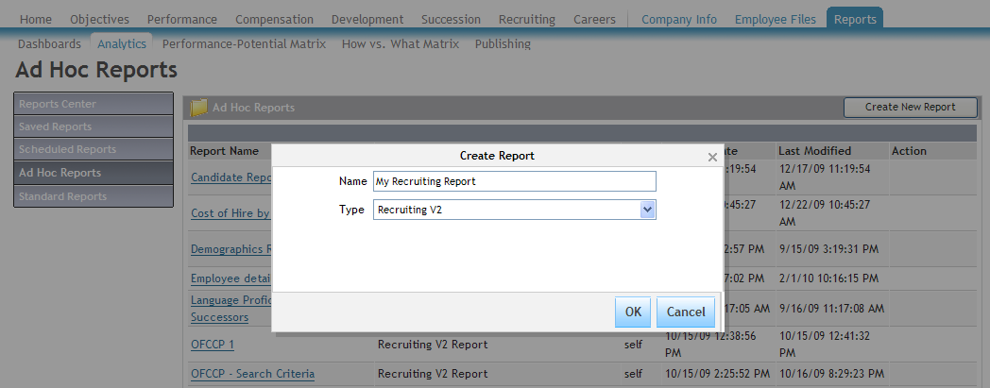

- Add the fields you want to include by selecting them in the View panel on the left
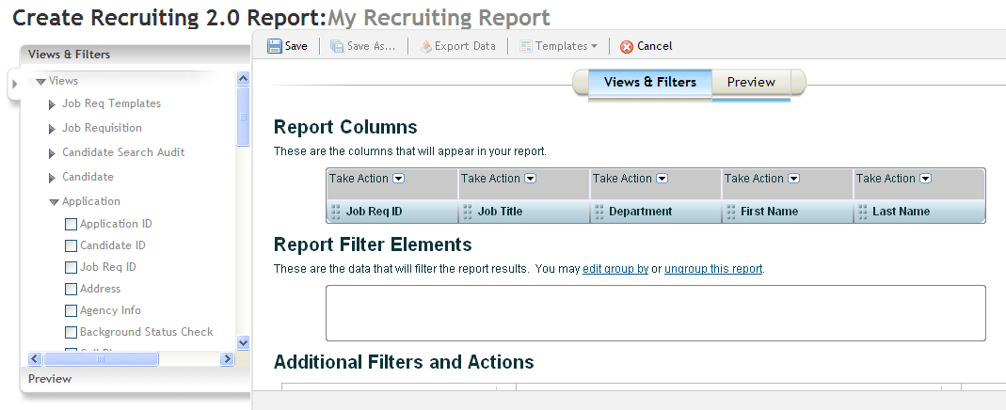

- Customize your report by dragging & dropping fields to change their order, adding sorting rules, and adding filter criteria as desired.
- Preview the report to make sure it looks right.
- Save the report to generate the final output.
- Once generated, click “Export” to save the results to Excel.

Scheduling Ad Hoc Report Builder Exports
Once an ad hoc report builder is defined, customers can schedule automated exports of the results. Contact the Customer Success team for assistance with this request.

