Xcelsius Issue

- There are “1389” and “1389E” in the database.
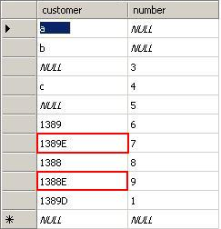
- Create a Universe based on this table
- Create a WebI report based on this Universe
- In Live Office, we insert these data into Excel by inserting Webi report content. (we can see that 1389E display well)
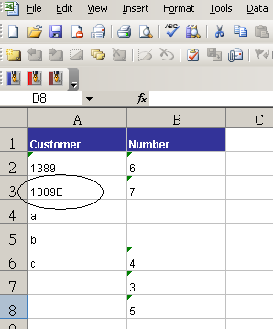

- Import it to CX and use a list builder. Put a refresh bottom to refresh the Live Office connection.
- Preview it. Data display well, no data missing.
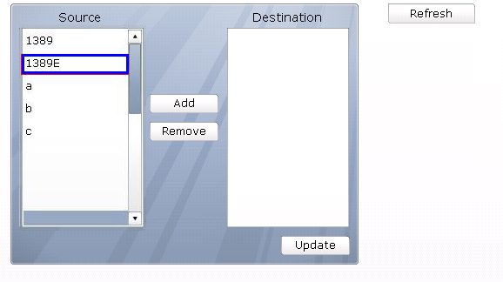

- Click Refresh button, you will find the ‘E’ is lost
