Steps 1 & 2
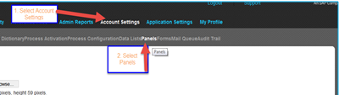
Step 3 Select Panels
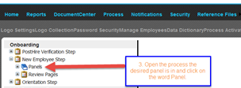
Step 4 Select the Panel you wish to disable
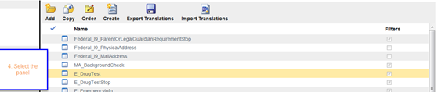
Step 5 Click on the Disable icon
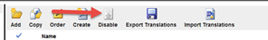
Step 6 Click on “ok” to complete the disable process.
