Scope payroll for Germany
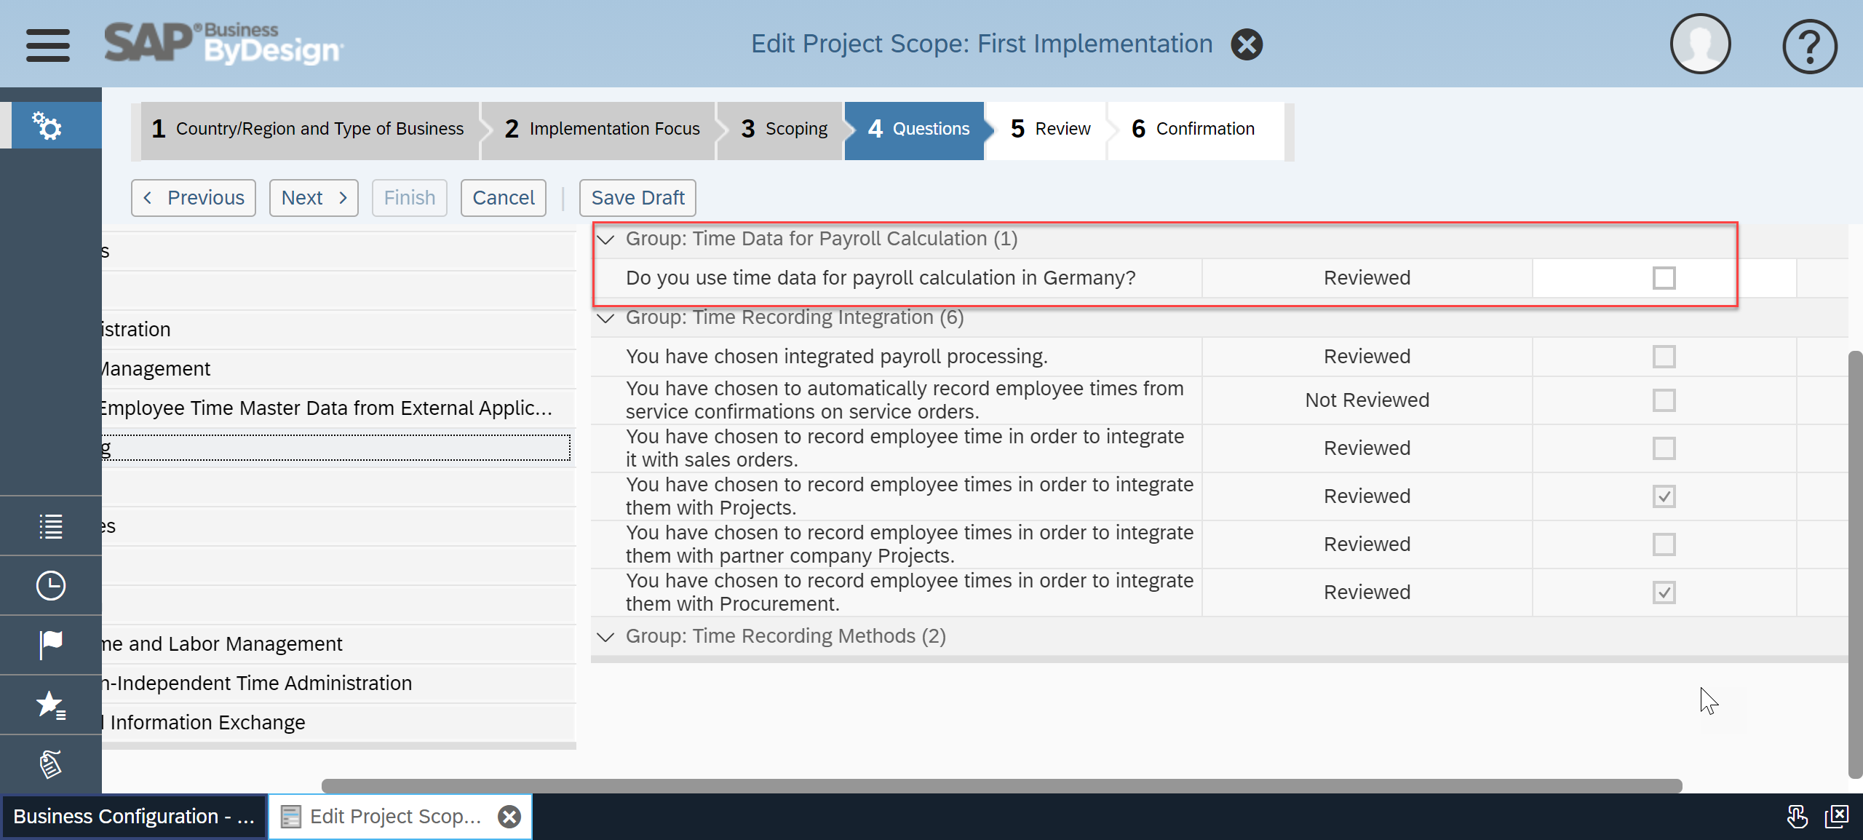
Create a new time profile
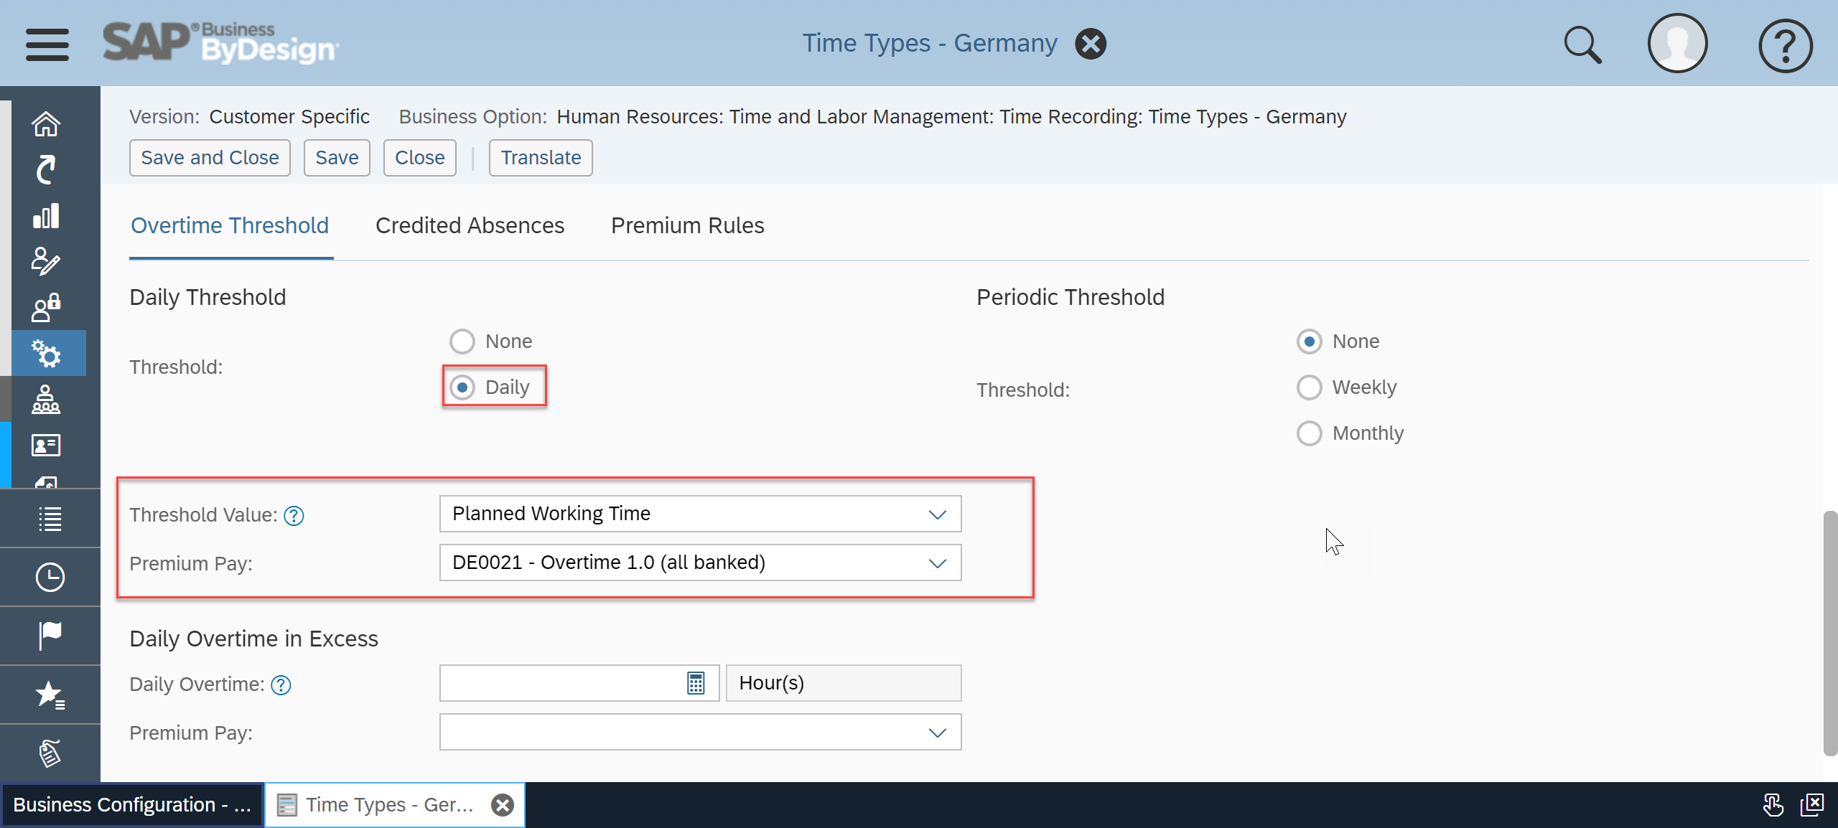
Select the absences you want to count towards the overtime calculation
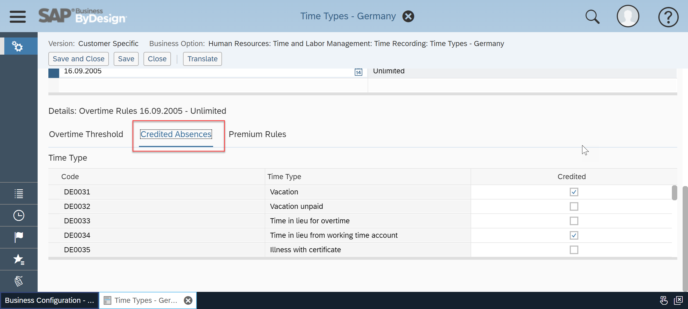
Create a time account rule to transfer the remaining balance to the working time account (You can also change the DE0036 account to Recurring Weekly if you want the transfer to happen weekly instead of monthly):
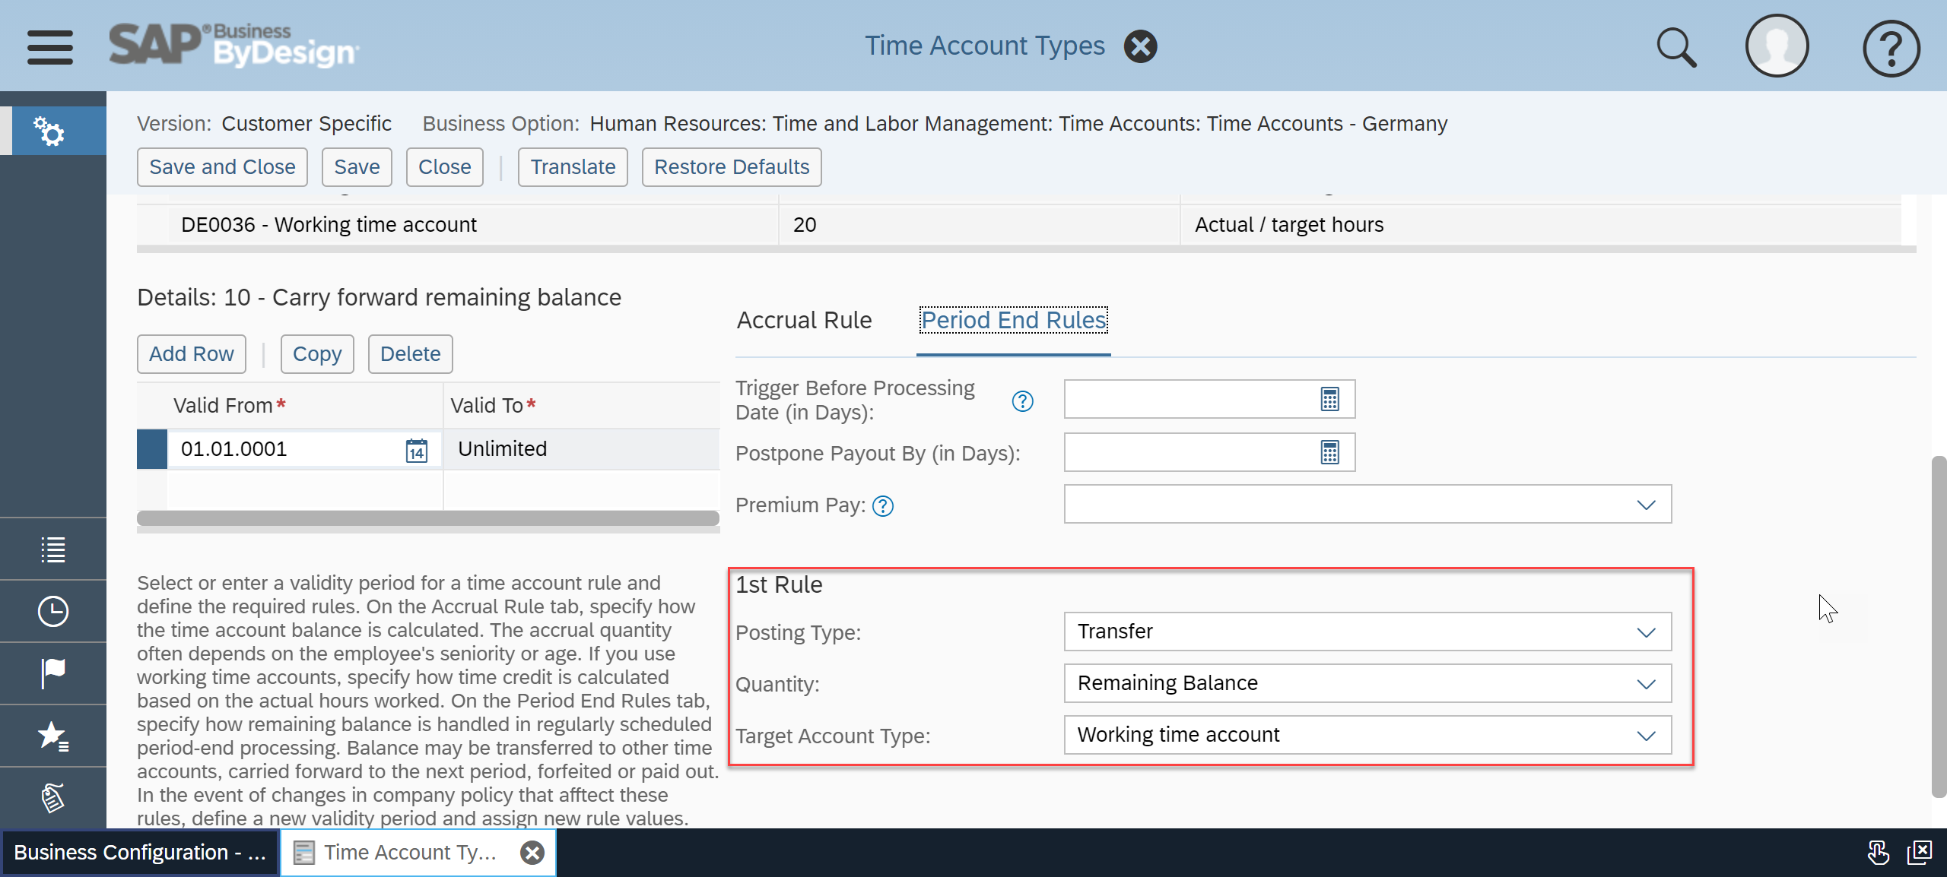
Assign the time profile and the overtime account to the employee
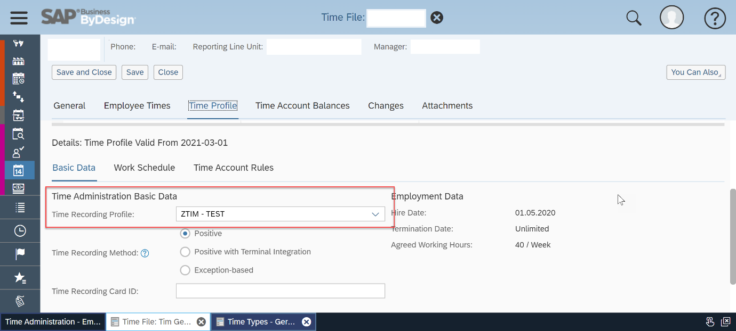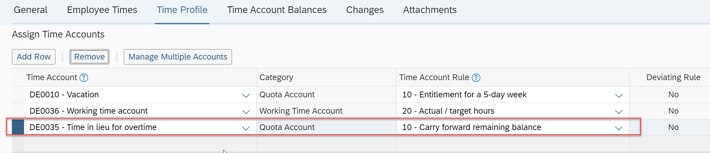
Run a day closure run for the employee or for all employees choosing a start date from when this fix should apply. i.e. the start of this year.

