The rates mentioned here in the activity Mileage Rates – UK are the statutory mileage rates for country UK, these rates are picked from the link mentioned below.
https://www.gov.uk/expenses-and-benefits-business-travel-mileage/rules-for-tax

I’ve attached the screenshot from both the sources that is first from the system and second one from UK Gov website. Here you can clearly see that there is no difference in the rates.

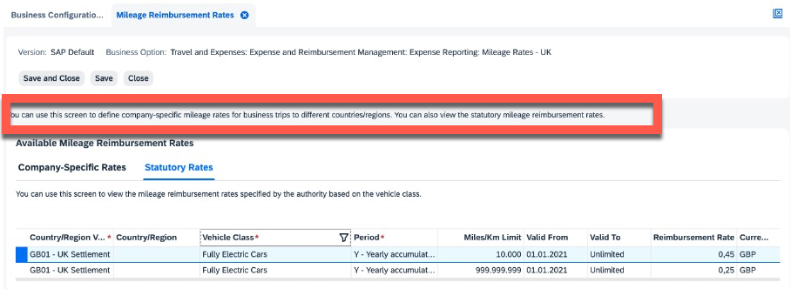

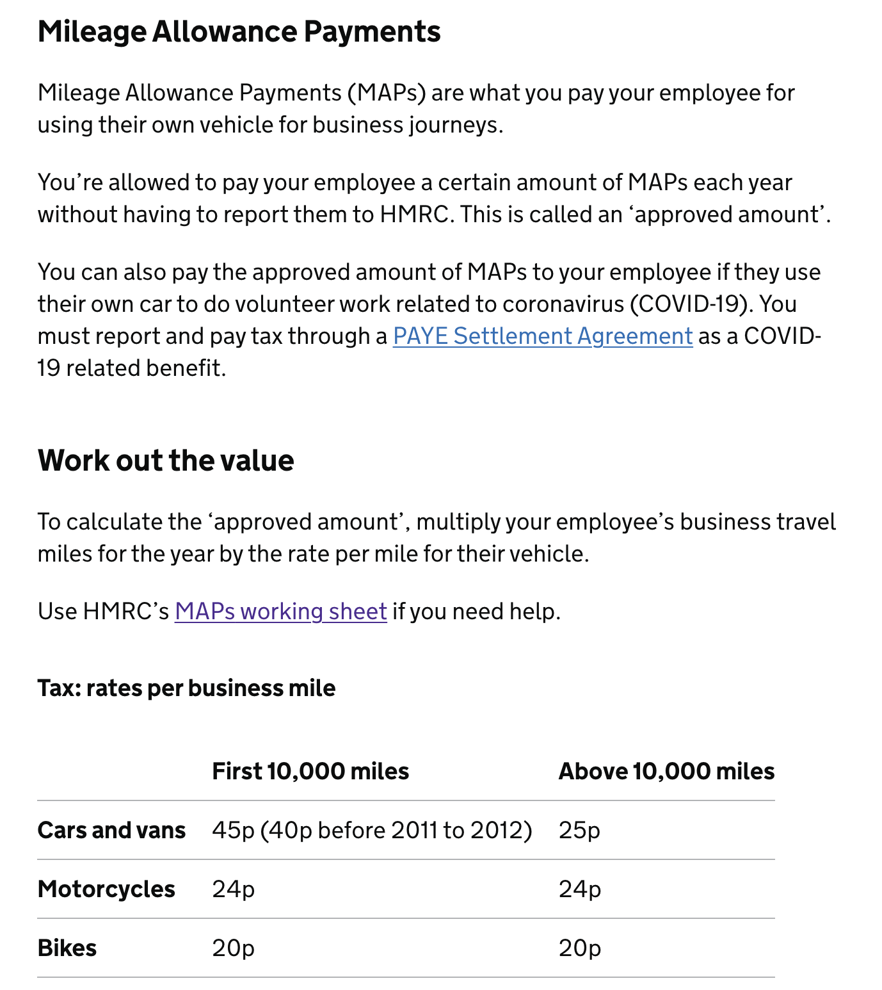

The advisory fuel rates which are maintained as per the latest notification issued by UK gov and were picked from the website. https://www.gov.uk/guidance/advisory-fuel-rates

The latest Notification says that advisory fuel rates for electric car are raised from 8 pence to 9 pence and we have mentioned the same in the system. The UI for BC activity (BC set) responsible for these advisory fuel rates is and was never available for end-user.
I’ve attached the screenshot here, it’s from the UK gov website. The similar rates are maintained in the backend in respective BC Set

