Time Off notification Workflow Enhancements

Symptom:
In the current scenario customer is facing the following issues mentioned as under:
- "Create Employee Time" is a standard terminology for "Type-of-Action" no matter whether the notification is for Pending workflow or Approval Workflow or Cancellation workflow.
- In the notification email, value for “Effective Date” seems to be empty.

Environment: EMPLOYEE CENTRAL: Time Off.

Scenario:

Here is the email templates for workflow notifications.

Workflow Action Cancelled Notification

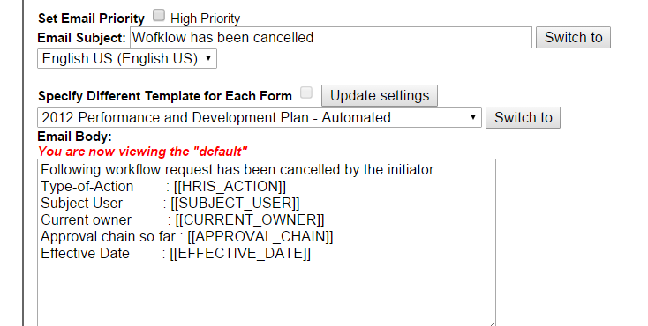

Workflow Action Approval Notification
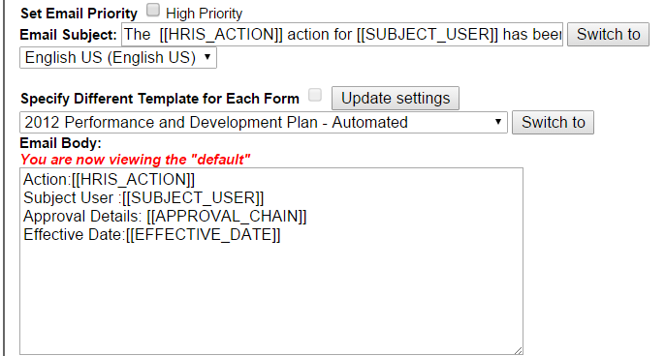

Workflow Action Pending Notification

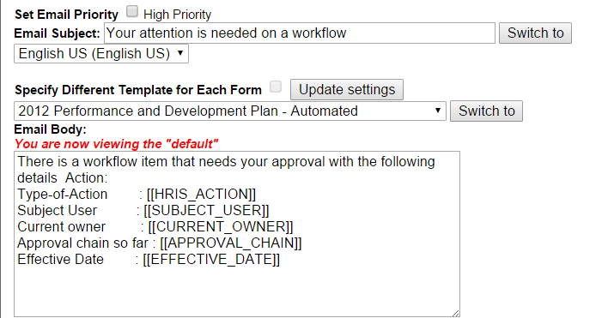

Here are the emails being triggered where Type of action is being populated as “Create Employee Time” every time and “Effective Date” seems to be empty.

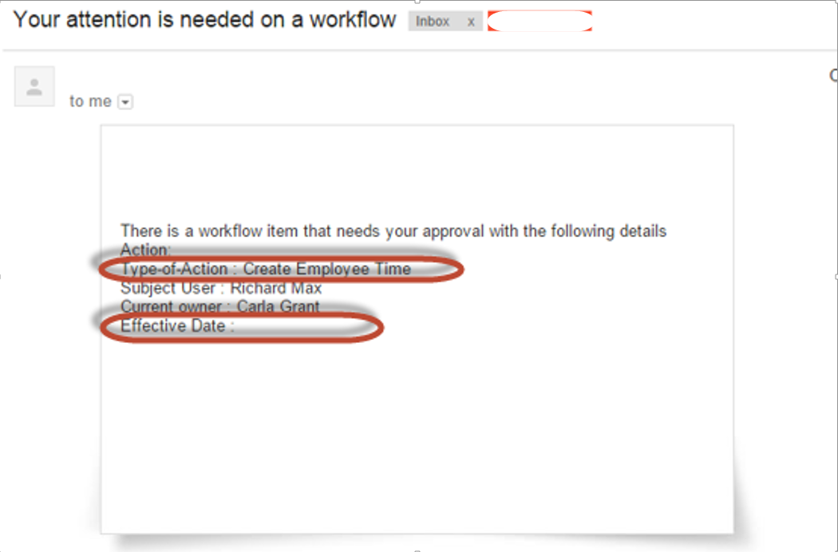
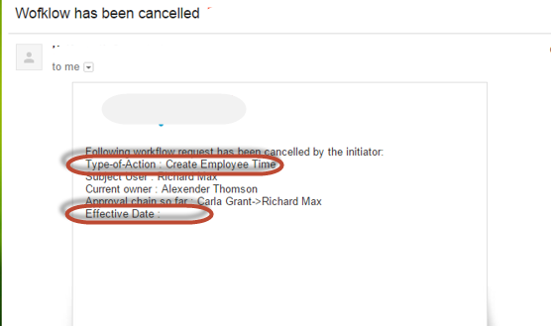

Resolution:

On extensive testing in our local system, we found it to be an expected behavior as of now.
System does not tell the difference what Action has been taken to the employee making it ambiguous.
For application-specific Tags it shall be possible that it can overwrite the standard content of the following tags with detailed, application-specific content for the applications like time off:
[[EVENT_REASON]]
[[EFFECTIVE_DATE]]
[[SUBJECT_USER]]
[[SUBJECT_USER_ID]]
This enhancement has been added to the list of roadmap items for Product Management to evaluate for the 1605 release. Related Jira - ECT-26389 and ECT-34986 - Time off WF enhancement

