- Select the Lense Icon On Top Right

- From the Drop Down showing “ All Categories” select “ Individuals”
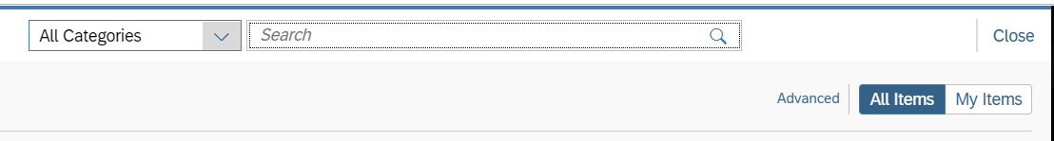
- Click on Advanced

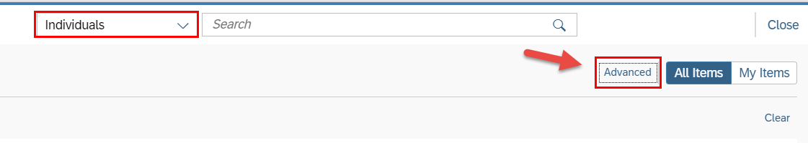

- Fax Field is not available for Individuals in Enterprise search.
