Overview:
Some users are missing from the Executive Review although they are present in the manager’s form and Executive Review filters selection is not sticky.

Environnent:
Compensation Module, Ultra, V12

Issue Description:
Manager’s form includes 4 users.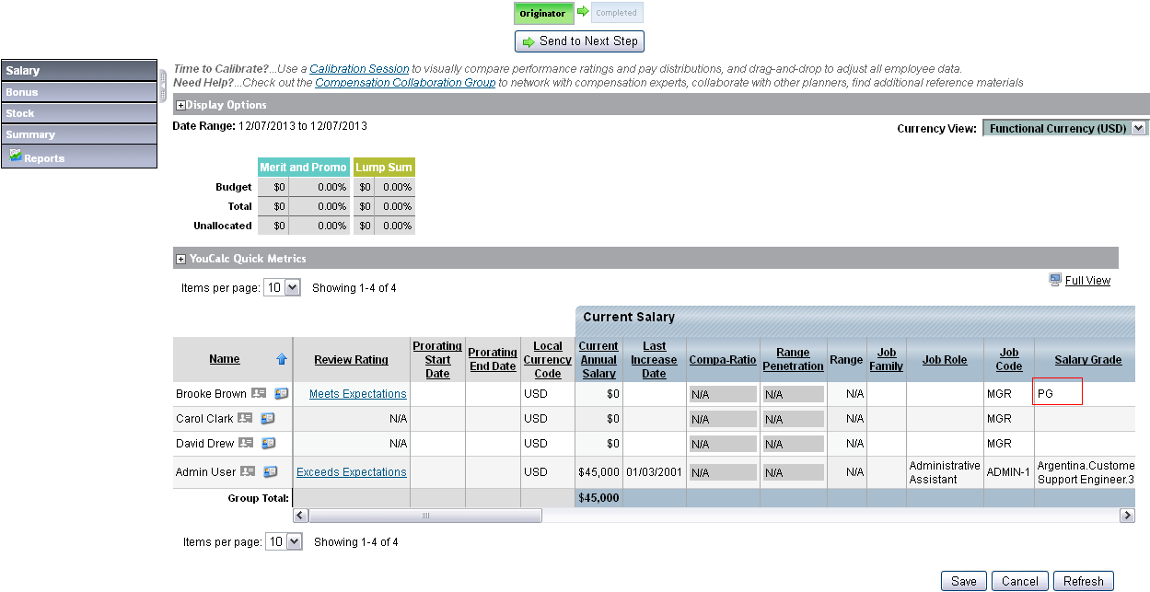
In the Executive Review, we can see the 4 users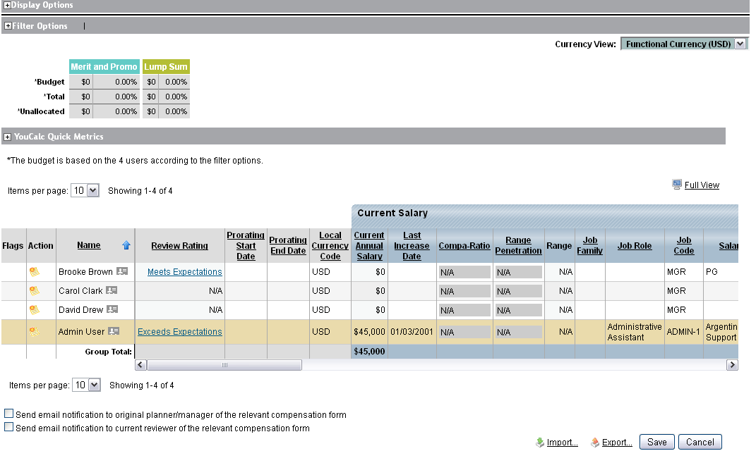
Brook Browns becomes inactive but she is still compensation eligible. So during the next user import she was made inactive but not removed from the manager’s form (Remove Inactive Employees from Compensation Forms is NOT checked).
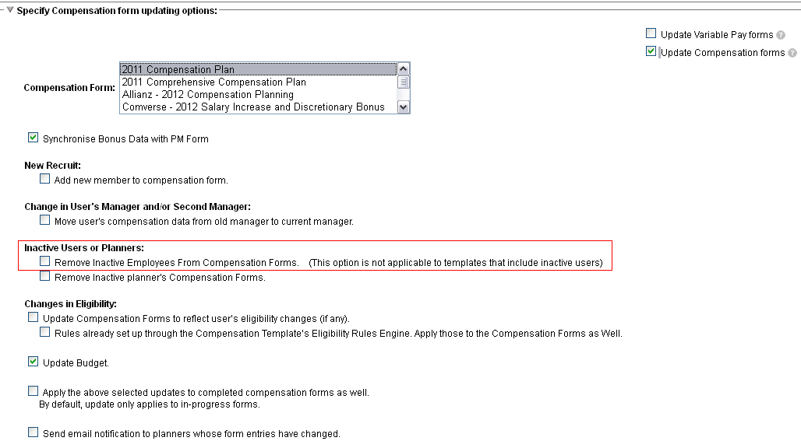
When opening the manager’s form, everything is fine Brook Browns is still there.
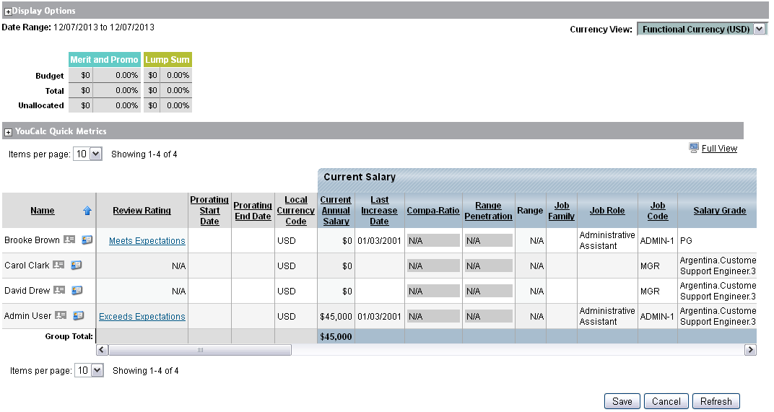

But in the Executive Review, she doesn’t show up anymore! (Even after hitting the Update button)
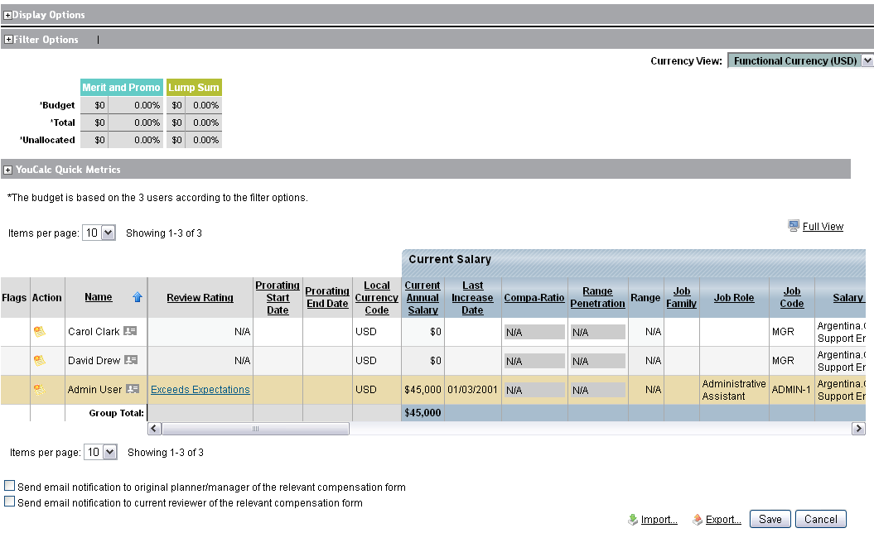
In addition, Salary Grade filter is not sticky… we can’t select every Salary Grade anymore (it could be any other filter).

Every filter is checked
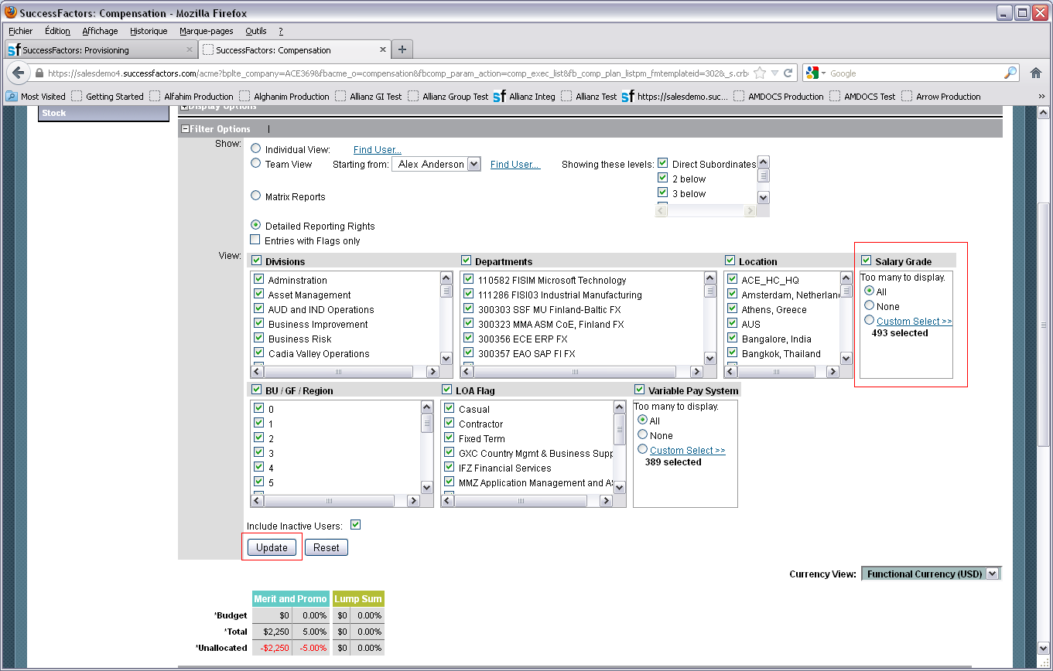
After hitting the Update button
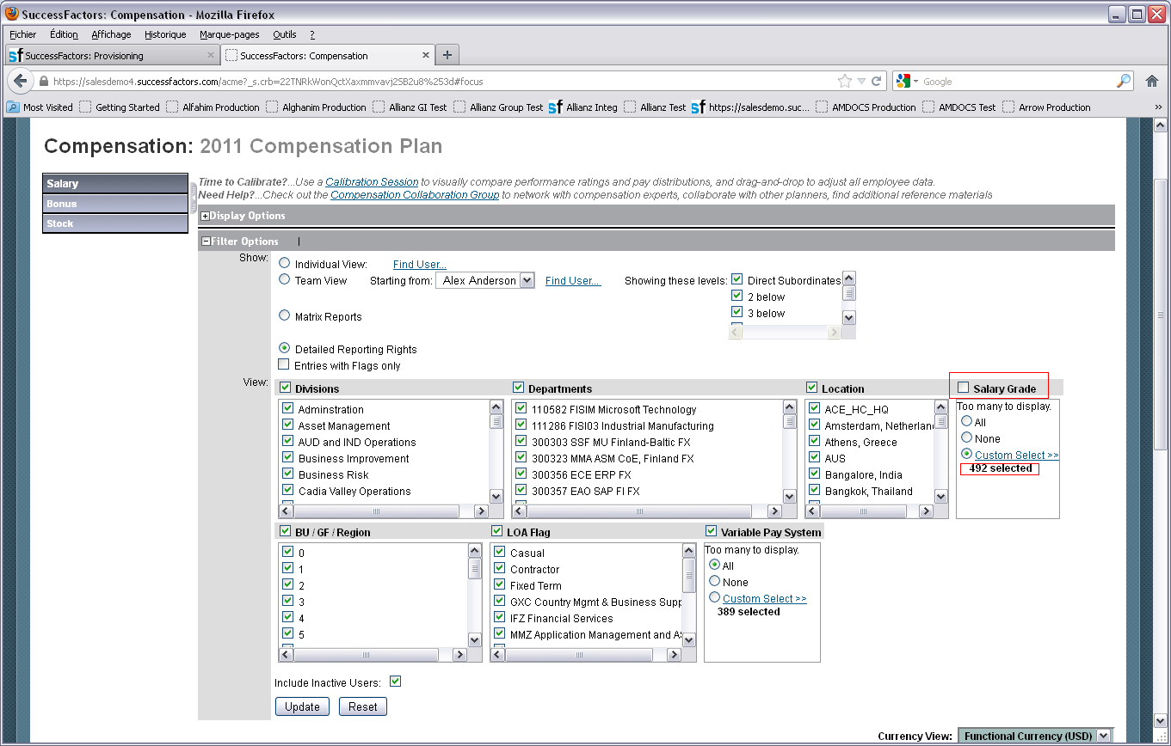
Salary Grade selection is not sticky and its count has changed (from 493 to 492).
Explanation:
This is a classical issue with Executive Review.
Executive Review Filters values are based on the current User Directory, not on Compensation Forms data.
In our example, Brook Brown is the only user who has a Salary Grade equals to PG and since PG is not a valid Salary Grade filter value anymore, she is filtered out and doesn’t show up in the Executive Review anymore.
Solution:
To fix this issue, we are going to change Brook Brown’s Salary Grade to any valid value (a value which is still associated to an active user). For instance Carol Clark’s Salary Grade which is Argentina.Customer Support Engineer.3

To do so, we need to update Brook Brown’s Salary Grade in the User Directory.

Import the update User Directory (check Process inactive Employees)

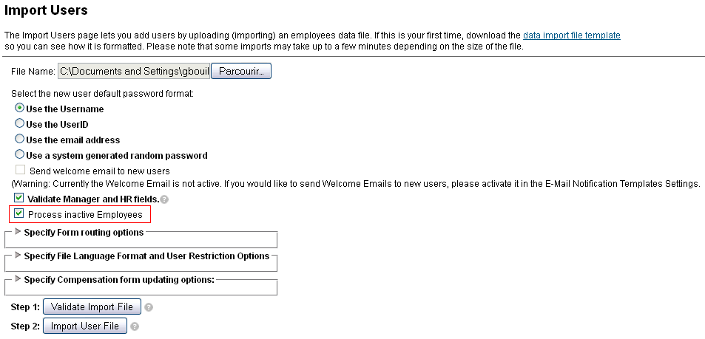

And specify to update Compensation Forms (not mandatory since you can manually run this command from Admin Tools or if you want to update only one manager’s form, you just have to open and save it).
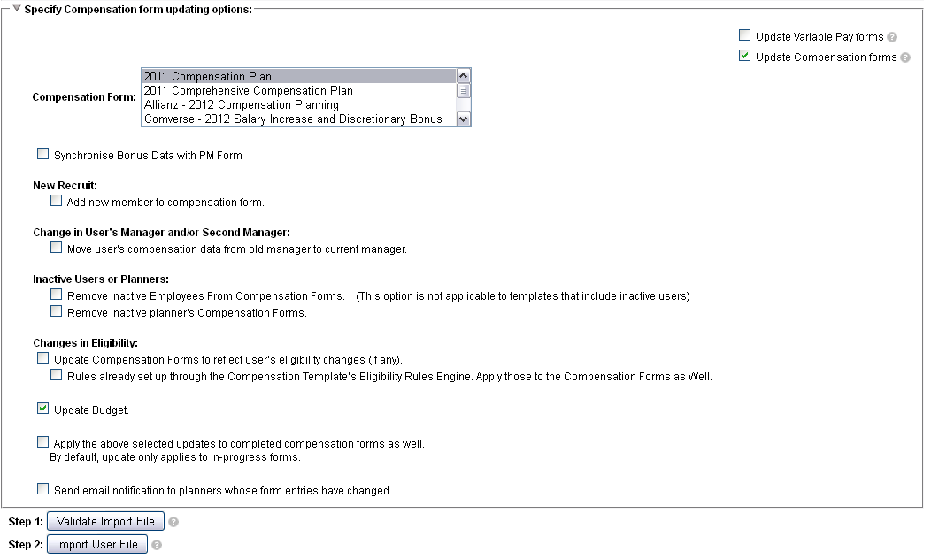
Now go back to Executive Review and update it.

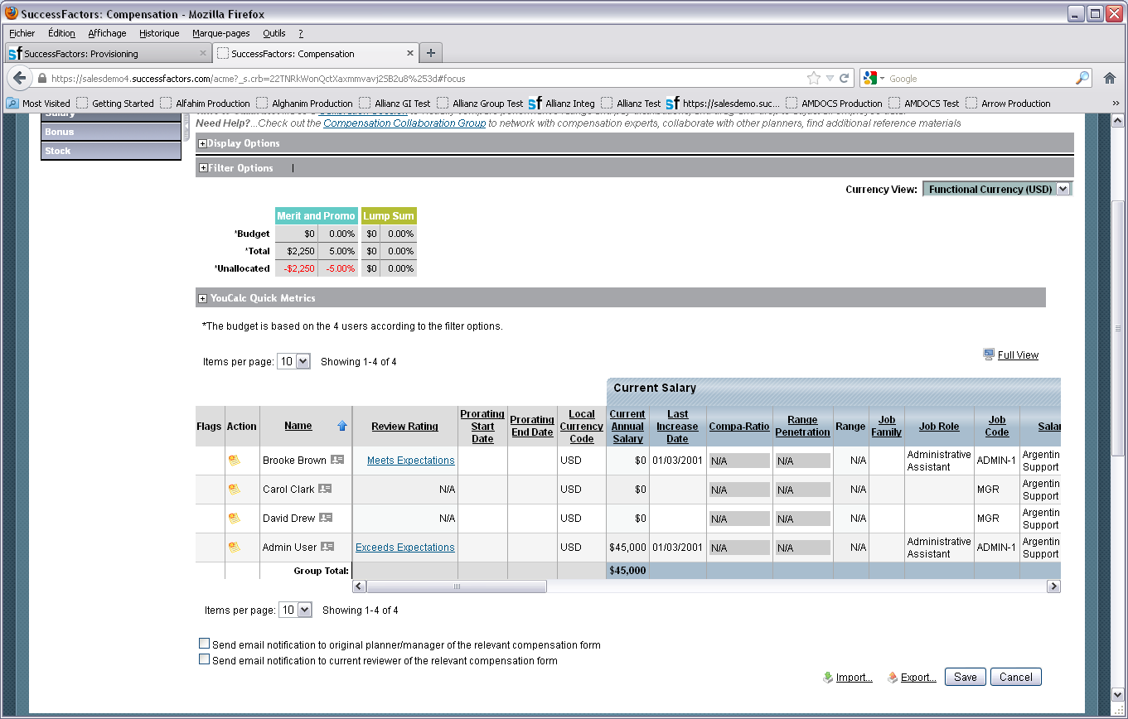
Brook Brown is back and Salary Grade filter is fixed (the extra invalid value is not taken in account anymore).

