Duplicate Key Error

Solution via Configuration
The solution to avoid the error is to adapt the configuration of the Multi-Bank Connectivity feature in order to use another format setting for the bank statement format CAMT. The basic idea is to create a configuration via a newer more flexible bank statement import configuration that mimics the default import but avoids the error.

Define a Parameter Set:
This just describes how to define a parameter set which does the same as the default bank statement import parameters. It can also be used to define different import strategies (e.g. do not post during import)
- Go to the configuration – Tile Manage Your Solution
- Search for “Electronic Bank Statement”
- Open the Step “Define Parameter Sets”.
- In there, create a new Parameter Set. This basically can be used for controlling some features of the import.
- Just select:
  - Enter some ID
  - Enter a name
  - Posting Method: “Import and Post”.

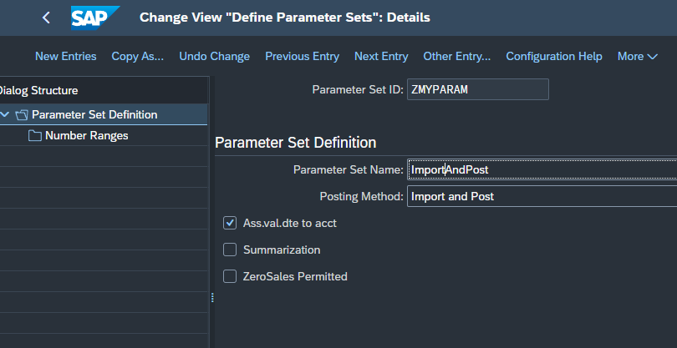
- Goto the subsection “Number Ranges” and enter:
Document Number
From: 0000000000 (10 zeros) To: 9999999999(10 x “9”)
  - Reference Document Number
From: space(leave empty) To: ZZZZZZZZZZZZZZZZ (16)
- OPTIONAL: You may also use more appropriate ranges to achieve a better automatic clearing rate.
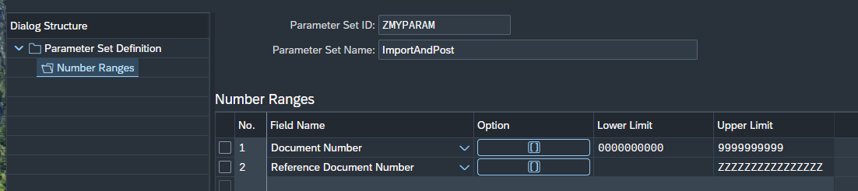

Assign the Parameter Set and the Format
- Go to the configuration – Tile Manage Your Solution
- Search for “Multi-Bank”
- Go to the step “Maintain Statement Parameter Set Assignments”
- Create a new entry:
  - Sender ID: leave empty
  - Message Type: CAMT.053.001.02
  - Parameter Set ID: (select the parameter set defined in the previous step)
  - Format: “XML or Bank-Specific Format”
  - XML or Bank Specific Format: CAMT.053.001.02
  - Leave the other fields empty
  - Save the entry.
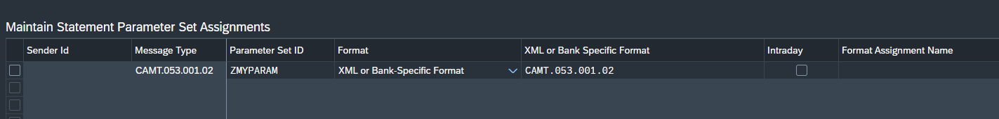

This setting will override the default MBC variant which runs into an issue. While the issue will be fixed with the next release, this setting is a sustainable solution as it is the more up-to-date way of controlling the MBC import which provides more configuration options.
The import via MBC shall now work again for the bank statements with issues.

