SYMPTOMS
Dynamic Role in the workflow shows one person when there are more than one person maintained.
ENVIRONMENT
EMPLOYEE CENTRAL: Workflow
REPRODUCING THE ISSUE
- Create a Dynamic Role where two or more conditions are same (here, Business Unit for two entries are ACE_SVCS).
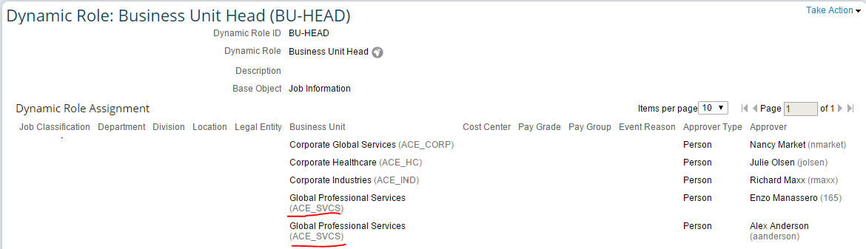
- Create a Workflow with one of the approver as Dynamic Role.
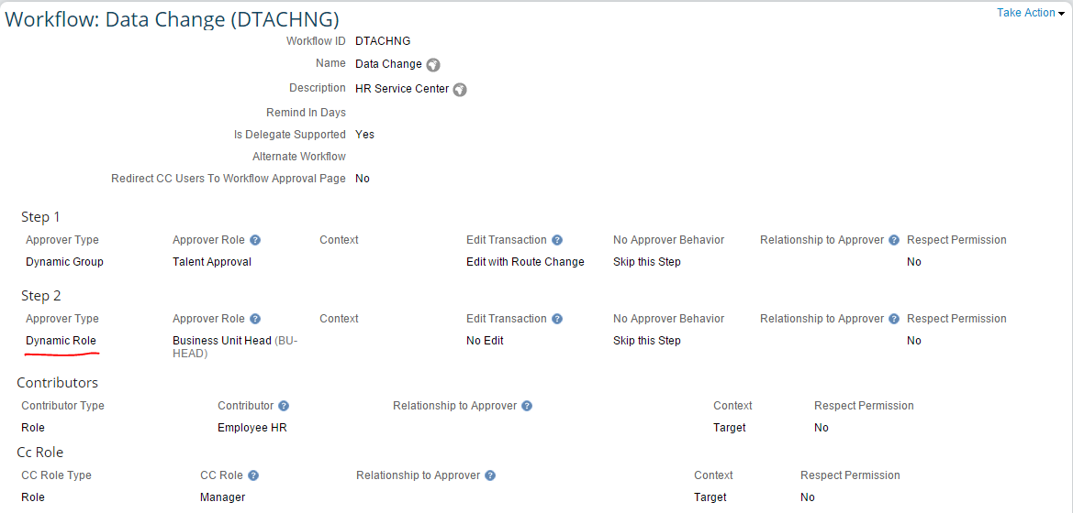
- Navigate to Employee’s Employment Information and Take Action to change Job and Compensation Information. Select Job Information to Make Job Information changes.
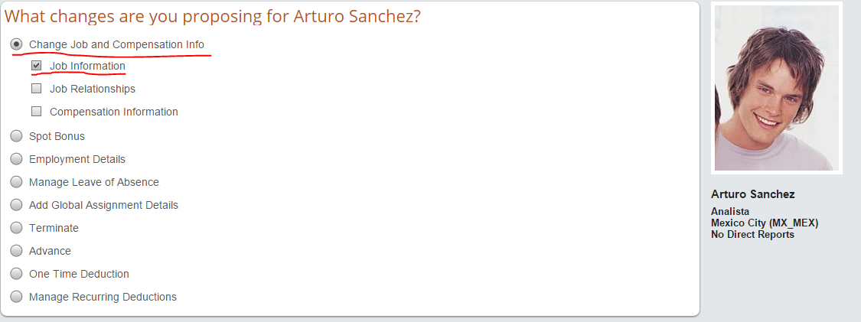
- Make the necessary changes and click on Submit. The Workflow associated to the changes (here Data Change Workflow) would trigger. Click to view workflow participants.
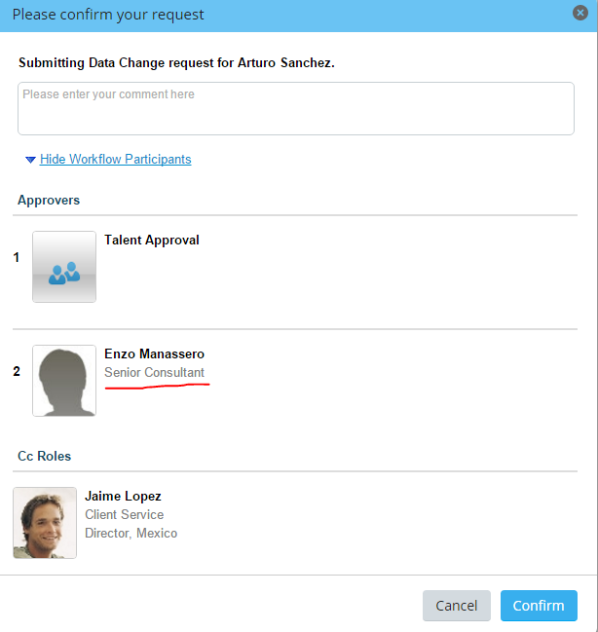
The workflow would show the first match available for the Dynamic Role (here Enzo Manassero). The second match in the Dynamic Role (here Alex Anderson) is not displayed as an approver.
CAUSE
In the Dynamic Role, if the same condition matches for different approvers (here same Business unit for two different approvers), the system picks the first in the match. The system checks for the “If” condition (here Business Unit) and when it achieves the first match it skips.
RESOLUTION
This is a system expected behavior. If the customer still needs more than one approver through Dynamic Role, it can be achieved as well.
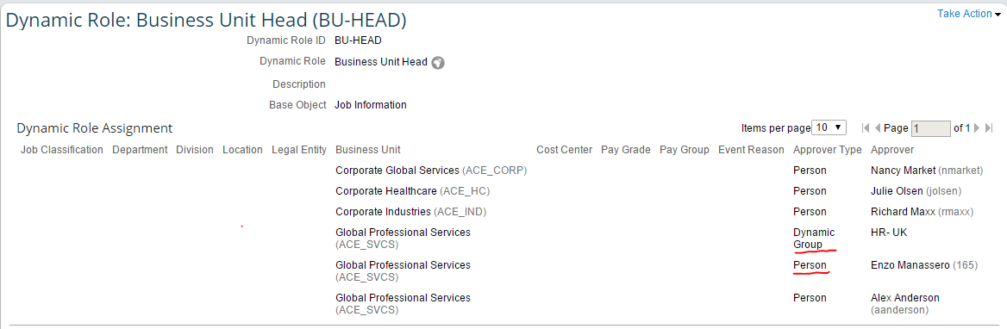
Instead of the Approver Type as Person, Dynamic Group can be selected. Within the Dynamic Group, you can have approvers whom you wish to have.
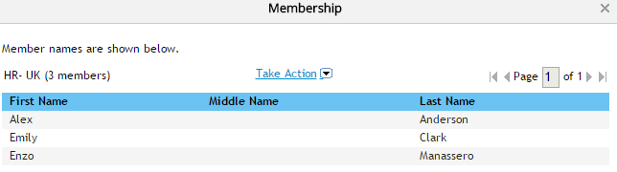
The workflow would then pop up as below.
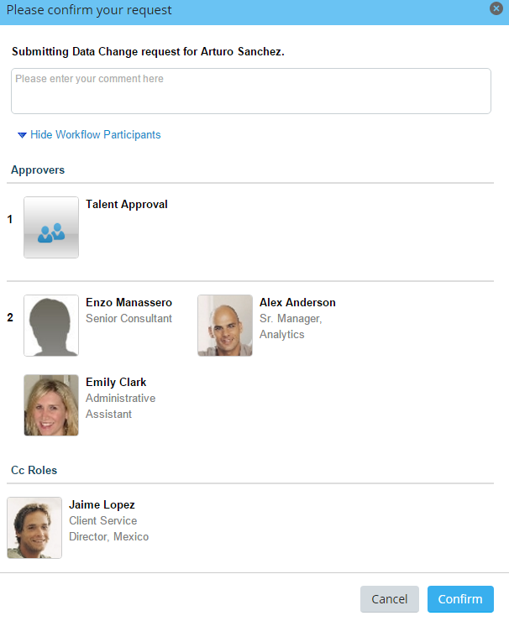
The Dynamic Group – HR-UK has three members, and all three would get notified.

