ACR Report Entity SSCUI
Setting Up Your Compliance Reporting

Step1: Access “Manage Your Solution” App under group “Implementation Cockpit”.
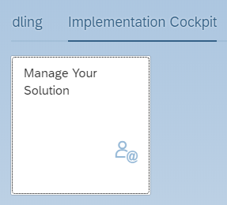
Step2: switch country version, e.g. “Malaysia”
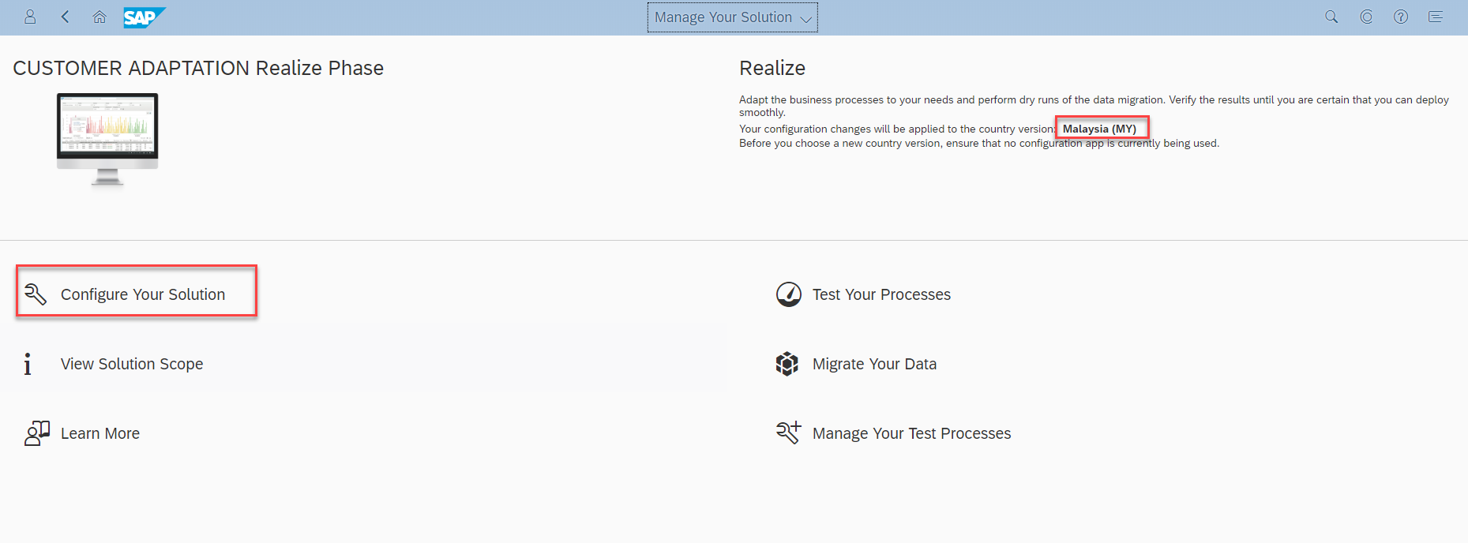

Step3: Fill Application Area = “Finance” and Sub Application Area = “Localization”
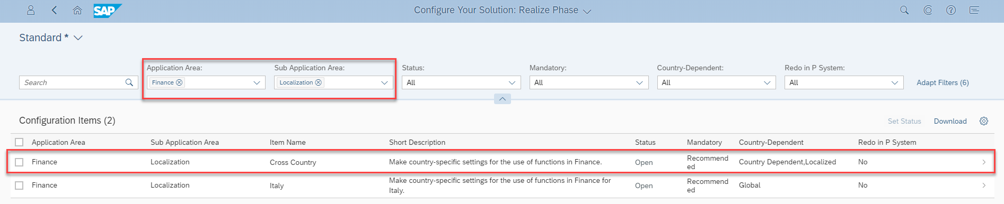

Step4: Open configuration for activity “Setting Up Your Compliance Reporting”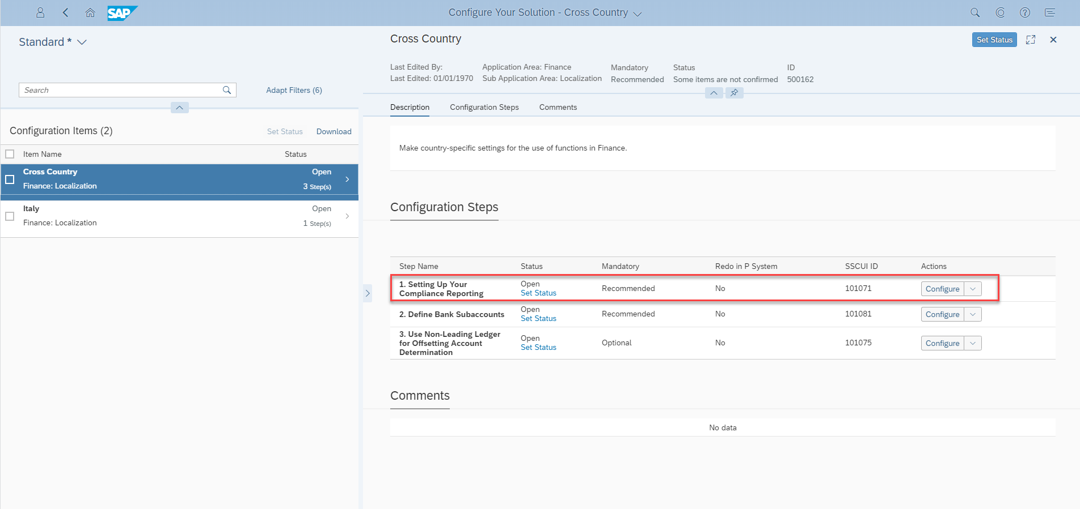

Step5 Make configuration change in this WEBGUI SSCUI.
