Map the WebDAV folder to a network drive in Windows

Getting the URL of the destination in the Application server.
Login to your ByD system with a user with access to ‘Application and User Mgmnt’ WOC and ‘File Input’ WoC view.
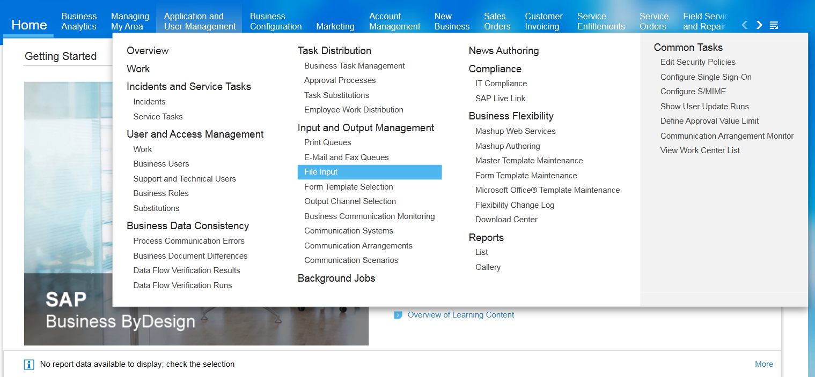
In the “Direct File Access (WebDAV)” section, select the inbound files URL.
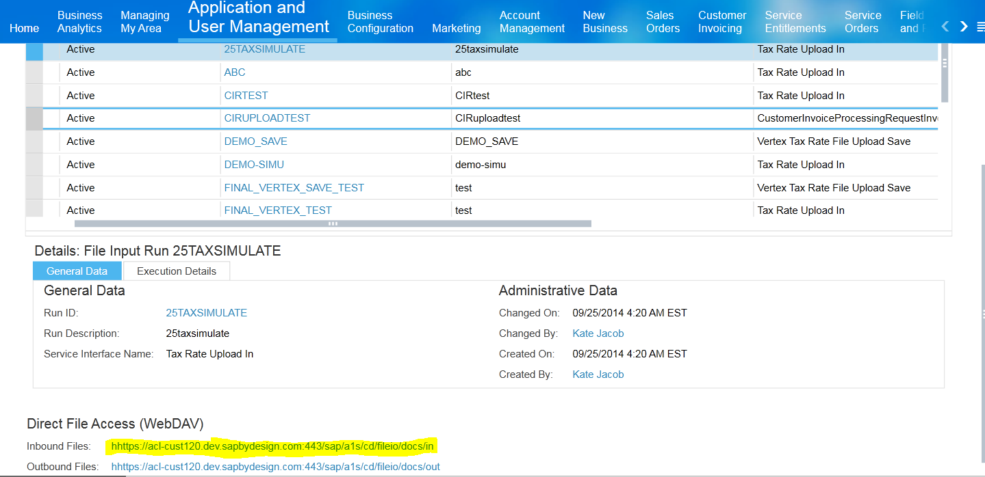

Create Logon Credentials for the WebDAV folder
Go to the "Application and User Management" work center, subview "Communication Arrangements", select the communication arrangement "Access Documents via WebDAV", and press “Edit Credentials”.
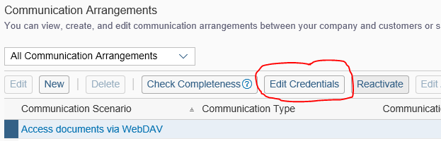
Enter a password for the user (standard user ID is _SAP_WEBDAV1), press Ok, close the screen, save the changes.
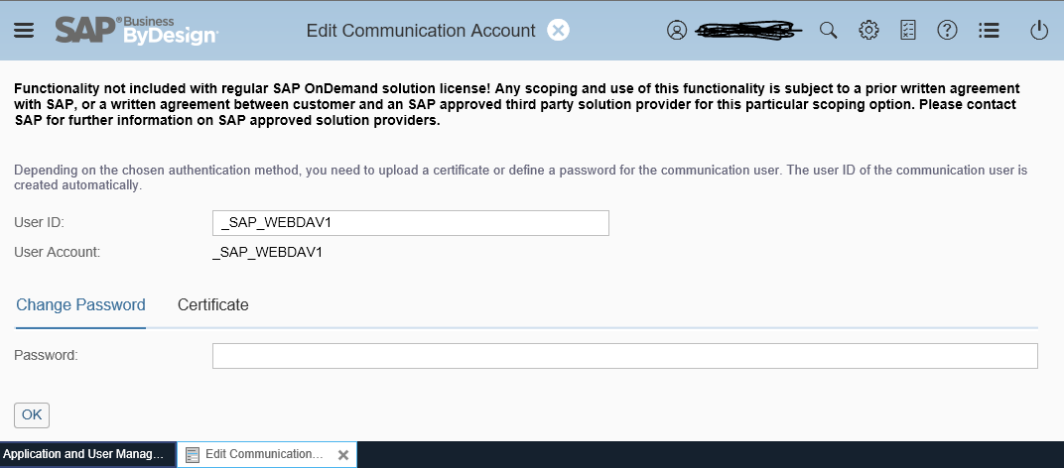

Windows 7
Add a shortcut to your computer that allows you to upload and access files in required folder using WebDAV:
- On the Desktop, double-click Computer.
- Click Map Network Drive.
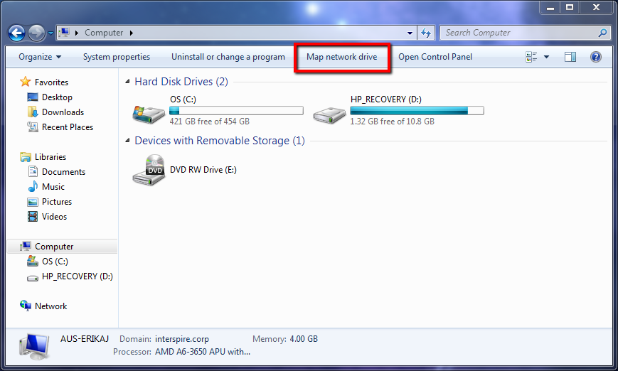
On the Map Network Drive screen, specify the URL of your destination in the application server (as shown above), click Connect to a Web site that you can use to store your documents and pictures, and then click Next.

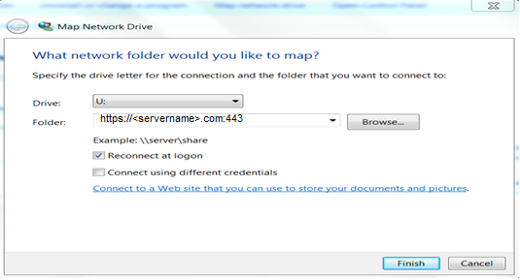
Click Choose a custom network location, and then click Next.
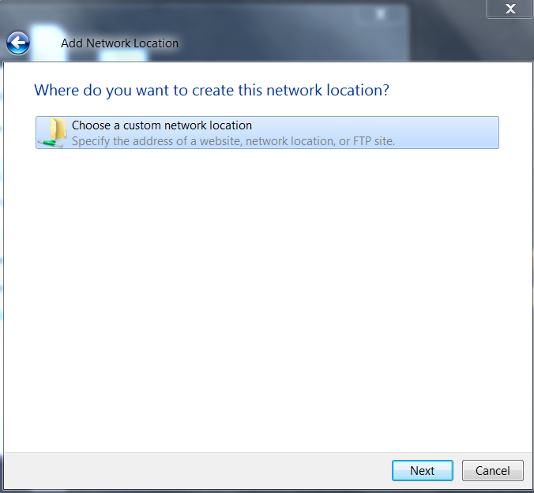
In the "Internet or network address" field, enter the same URL that points to the destination Resources tool, and then click Next and Finish.
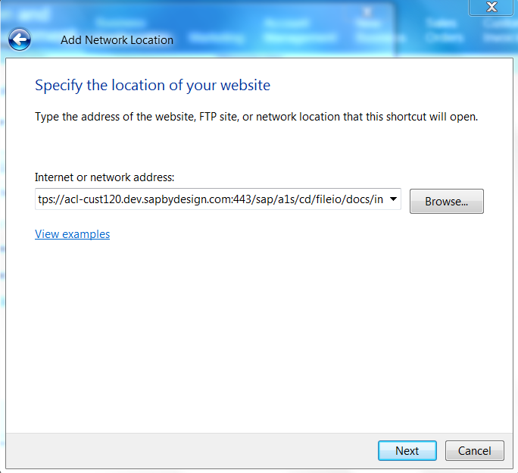

You should now be able to drag and drop file between your computer and the destination site to which you just connected.

Windows 10
In Windows File Explorer right-click on this PC and select "Map network drive".
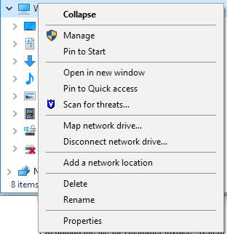
In the popup check the box "Connect using different credentials" and open the link "Connect to a Web site that you can use to store your documents and pictures".
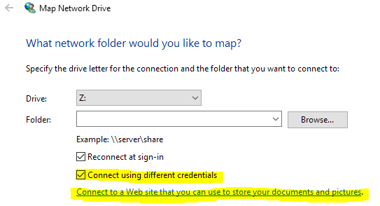
Follow the wizard, choose the option for a custom network location.
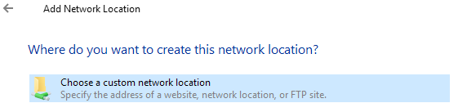
Enter the WebDAV URL, do not use subpaths. Cancel any possible popup for certificates and enter the user credentials you maintained in the first part.
After finishing the wizard you should be able to upload files into the correct folders in the mapped network drive.

BLOG: http://help-legacy.sap.com/saphelp_byd1611/en/KTP/Products/96e54f70e7b24 50895d71966b531edf7/WEKTRA_for_Work_Centers/CROSS_TOPICS/FILE_INPUT/ESS_FileInput.html

