Cannot load field Region of Birth in Biographical information

Symptom:
In the current scenario, field "Region of Birth" cannot be entered it manually on to the UI in biographical information but when we try to import it the import says it is successful but the information does not appear on the record.

Environment: EMPLOYEE CENTRAL

Scenario:

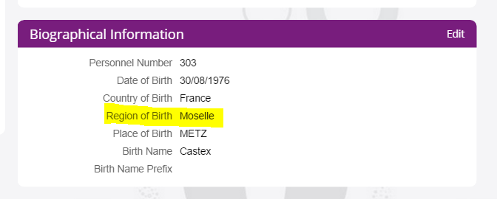

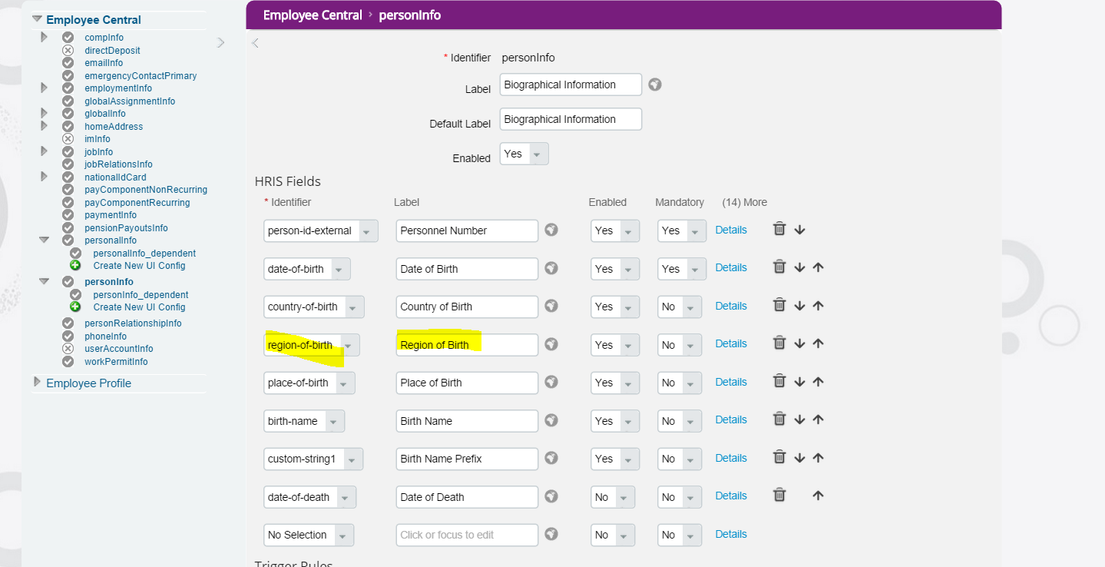

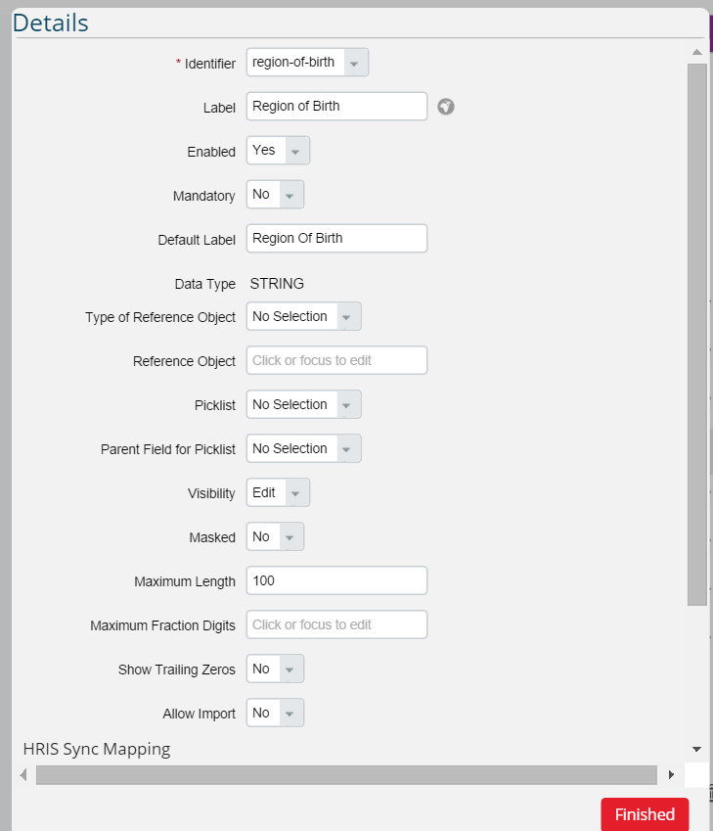

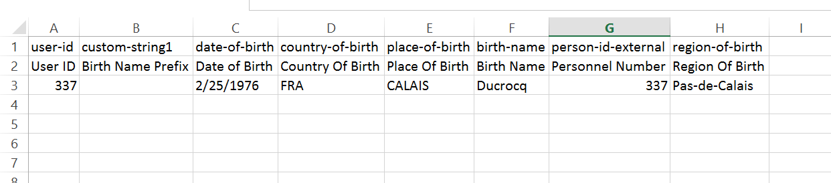

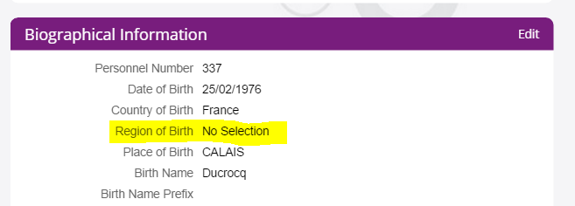

Resolution:
We have a standard delivery for the field "Region of Birth" to show the picklist for France, Italy and Venezuela when the Payroll switch is enabled.
But we see that the configuration done for the fields "Country of Birth" and "Region of Birth" are conflicting to what is delivered by us and so you see it blank in the Personal Information page.
Since a custom specific configuration has been done for the field "Region of Birth", can you please configure the same cascading picklist for a custom field in Biographical Info Portlet instead of the standard field available for "Region of Birth" here (example given below)?
kindly disable this standard field once the custom field is enabled for the same from the data model.
<hris-field max-length="100" id="country-of-birth" visibility="both">
< label>Country Of Birth</label>
< picklist id="ISOCountryList"/>
< /hris-field>
< hris-field max-length="100" id="custom-string1" visibility="both">
< label>Region Of Birth</label>
< picklist id="DEPARTMENT_FRA" parent-field-id="country-of-birth"/>
< /hris-field>
By configuring this way, the cascading picklist should work as expected in New Hire as well as in the Personal Information Page.
In the standard behavior, the “region of birth field” is a free text field and there is an additional handling for few specific countries like France, Italy and Venezuela with pick lists from code for payroll purposes.
In case of customer needs (like the case described here), it is imperative to use a ‘Custom field’ due to the reason that, cascaded option is not supported here due to ‘specific handling’ needs of ‘region of birth’ which is implemented through code for other countries like described above.
Moreover, I see it as nice way (though looks using a custom field), so that we can define customer specific list of values as pick-list and override the standard behavior. Also can control the ‘mandatory/ non-mandatory’ purpose of the field.

Even after enabling the new custom field with cascading picklist in data model, the existing data for the Region of Birth Field for existing users will remain as it is in that field.
But as it is advisable to use only one field in the system for capturing a particular information, the data of all existing users for Region of Birth can be moved to the new custom field by exporting it from Region of Birth and importing into the new custom field.
Also, upon doing this please make sure that all other implications related to the field "Region of Birth" that are available in the customer system like payroll mapping, reports etc, are accordingly adjusted to the new custom field instead of using the Region of Birth Field.
Related Jira: ECT-41669

