Issue: - After doing a full purge on job history, user is trying to import manager’s data using incremental load. Both the imports are successful, however once we open the employment details for the employee, we cannot find any user information.

User able to view information after full purge on JOB INFORMATION without managers data being imported.
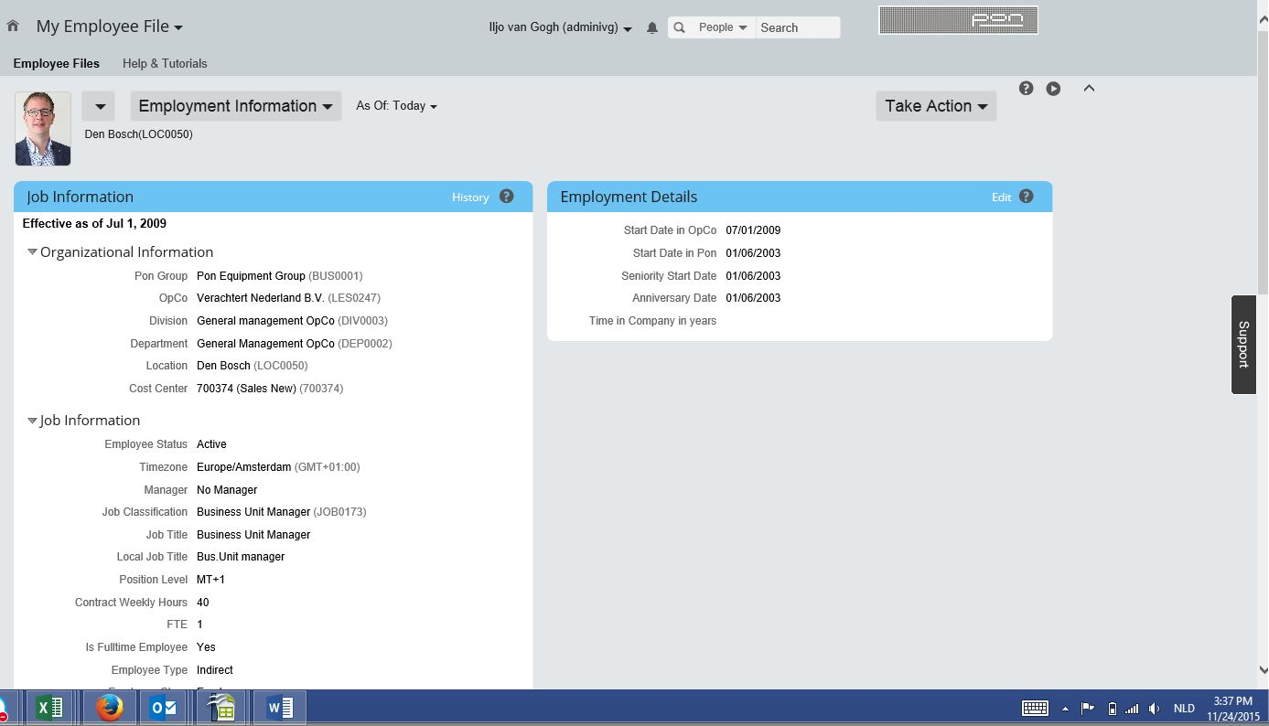

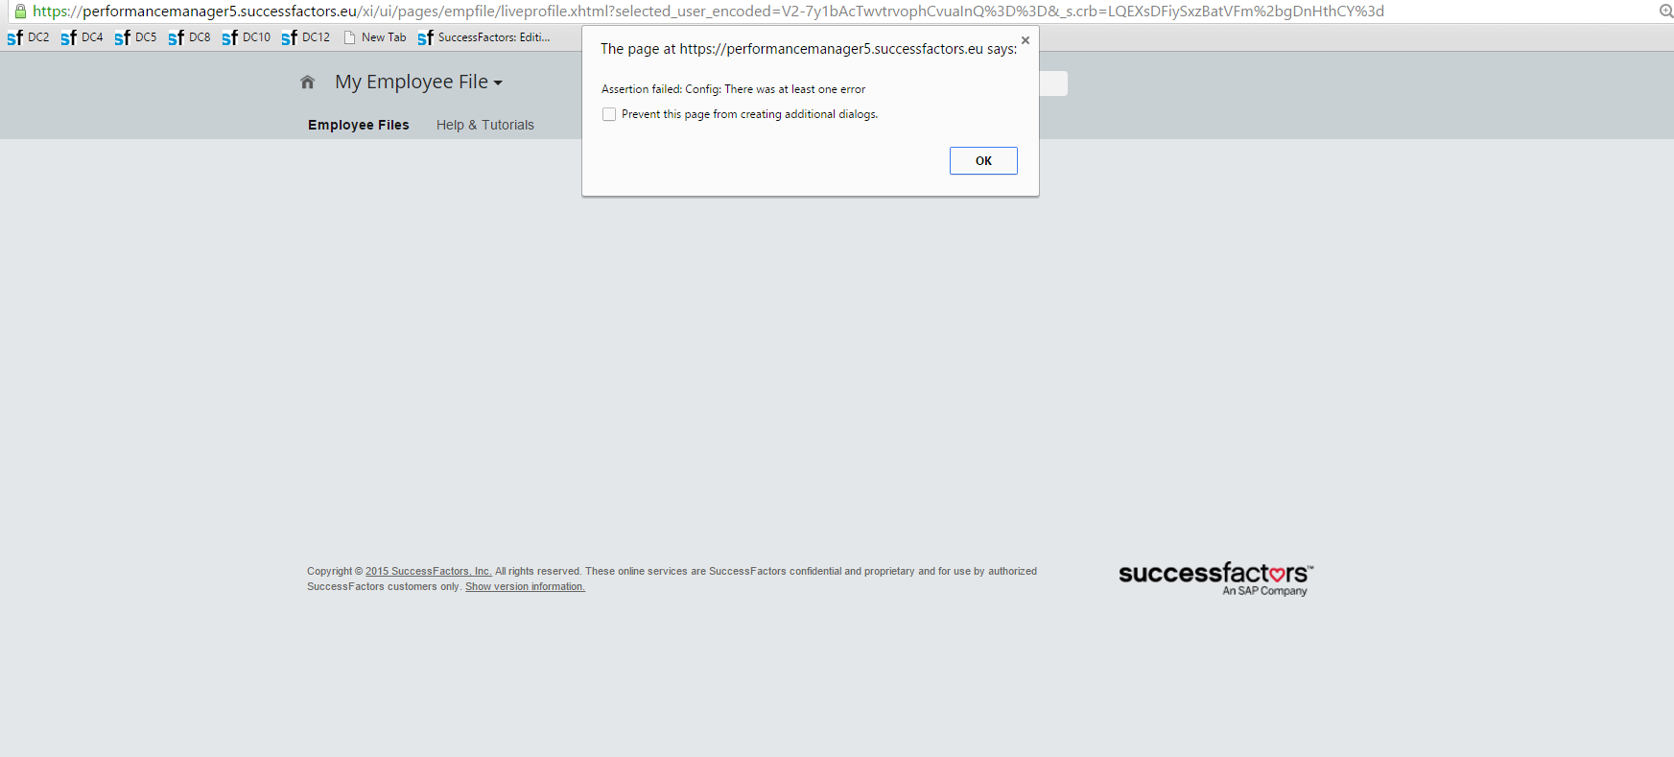
Press Ok - job information details are empty

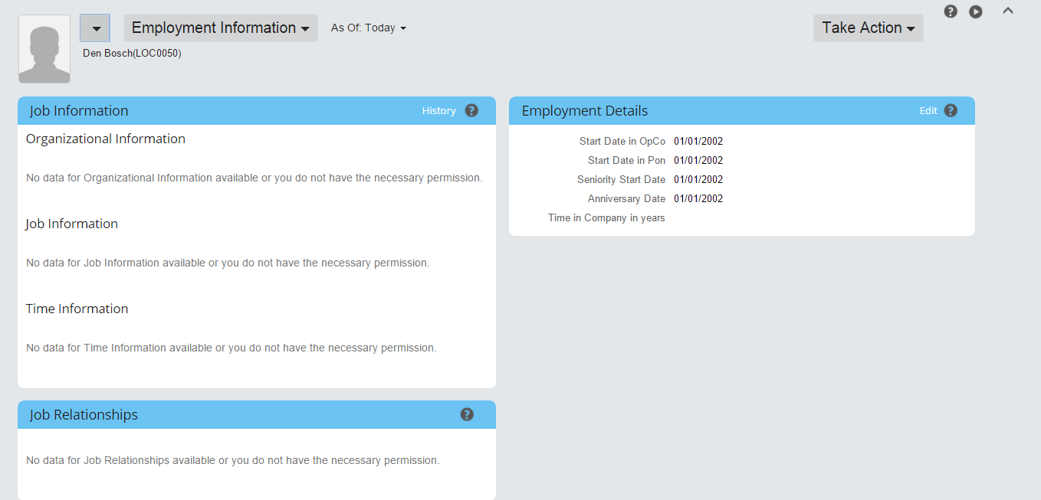

Go to history application error pops up
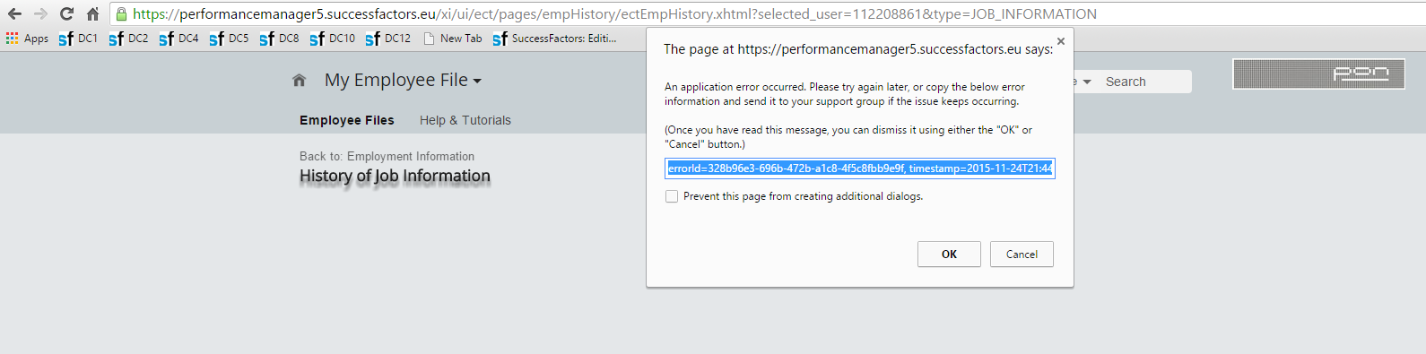

errorId=328b96e3-696b-472b-a1c8-4f5c8fbb9e9f, timestamp=2015-11-24T21:44:52.855+0100, server=10PC12BCF24, versionInfo=Release%3A%20b1508.879783%0A%20%20%20%20Server%3A%2010PC12BCF24%0A%20%20%20%20Timestamp%3A%202015-11-24T21%3A44%3A51.337%2B0100

Person and employment export report for the employee worked fine
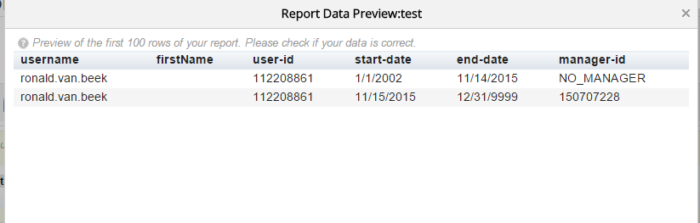

Cause of the issue: - Customer has not imported the personal information for the employees hence this was giving a error while uploading the managers data.

Also there was no HRIS sync scheduled for the instance due to which the data was not synced to EP.

Resolution –
1)Upload the employment information(full purge) data for the employee.
2)upload Personal Information data for the employees
3)Run a full HRIS SYNC job to sync the data to EP
4)import managers data using incremental upload for job history.

