WFA – DTD - Set up Default Views for Users

Have the user Logon
Drill into required Metric
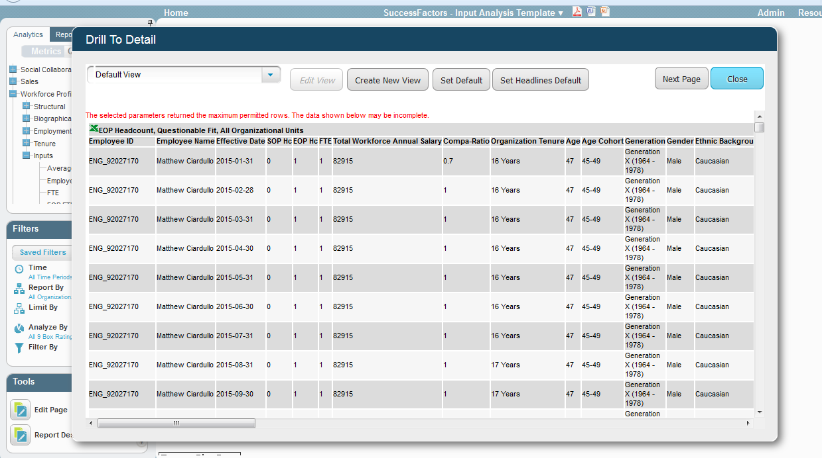
Click on “Create New View” button
Select the required Columns
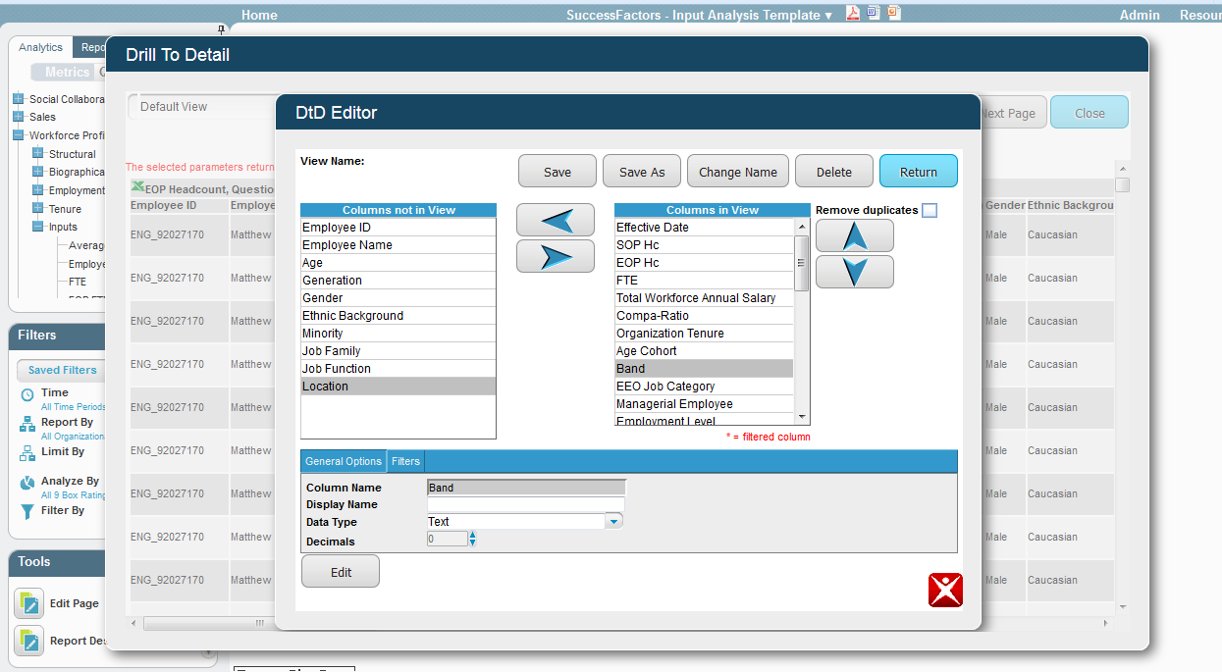

Then click on “Save As” button, Type in default view name, then the “Return” button.
New view will appear. Click on the “Set Default” button.
This will now be the default view for this user.
Click on Close to leave DTD windows.
