CR 2008 Workflow for ADAPT00012172

Enter a value of 12/31/999 as a parameter value
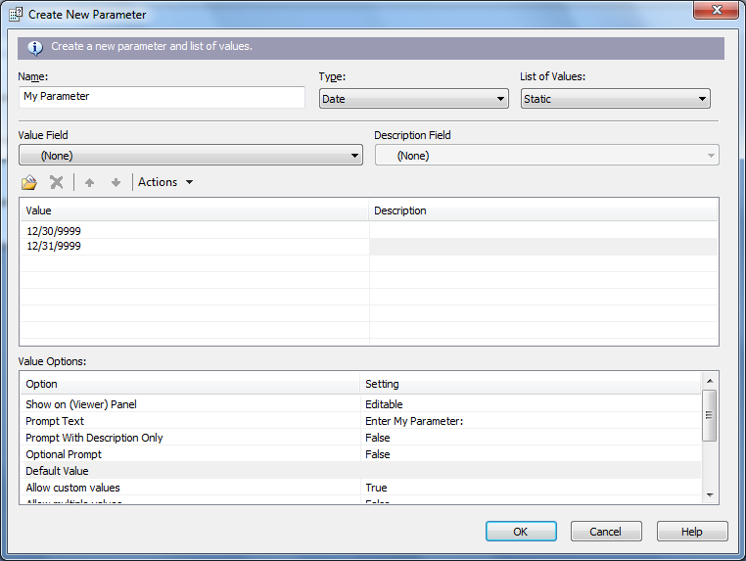

When hit enter the value disappears without an error message.
