Emergency Contact Import Error

Symptoms:

Partners might report an issue that they are getting "Internal System error encountered while importing record “while importing Emergency contact
Environment:
Employee Central
Reproducing the Issue:
The below appears when you Import Emergency Contact without the relationship field
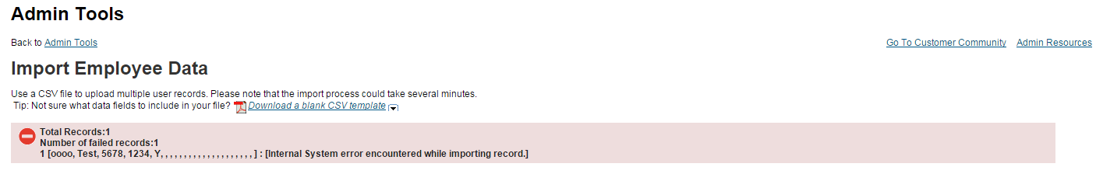
Cause:
The error is appearing because if the “Relationship” field is not visible on the Emergency Contact Portlet then we will experience this error.
Resolution:
1) In the Succession Data Model for HRIS element EmergencyContact - the field "relationship" could be configured as "visibility=none". So "relationship" field doesn't come up in the Import template. Hence there is internal system error on trying to import.
2) Please update "visibility=both" for field "relationship" in SDM as shown below for emergency contact and upload the SDM. Now "Relationship" field should come up in the Import template. Fill up the mandatory field relationship value and import now it should work fine.
