Go to Business Users View present in Application and User Management Work Center:

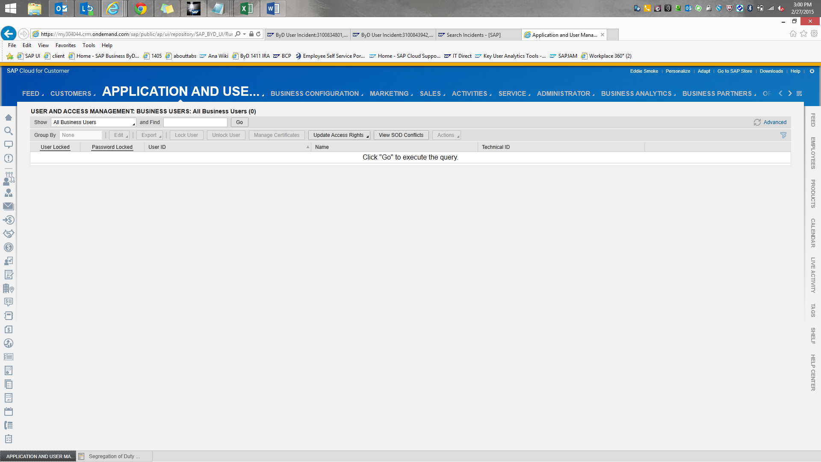

Click on View SOD Conflicts:

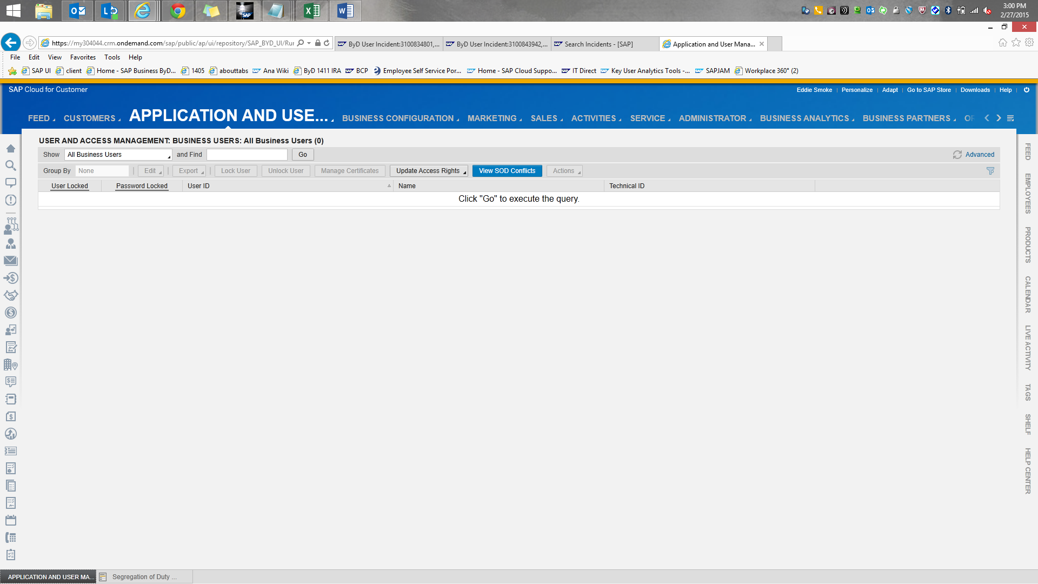

If you want to view all the SOD conflicts irrespective of the user then click on Go:
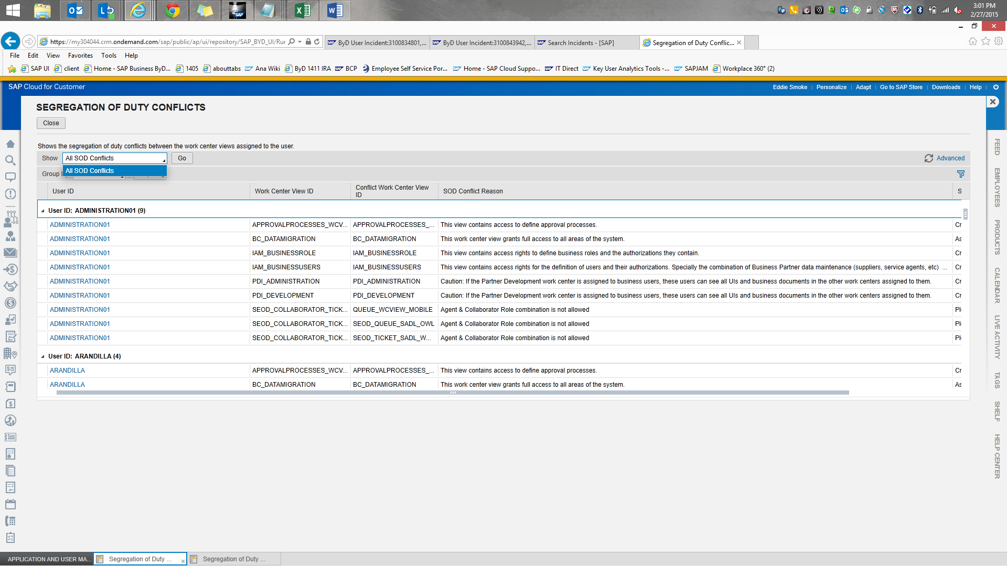
Or if you want to view the SOD conflicts for a specific user then click on Advanced option and then filter by User:
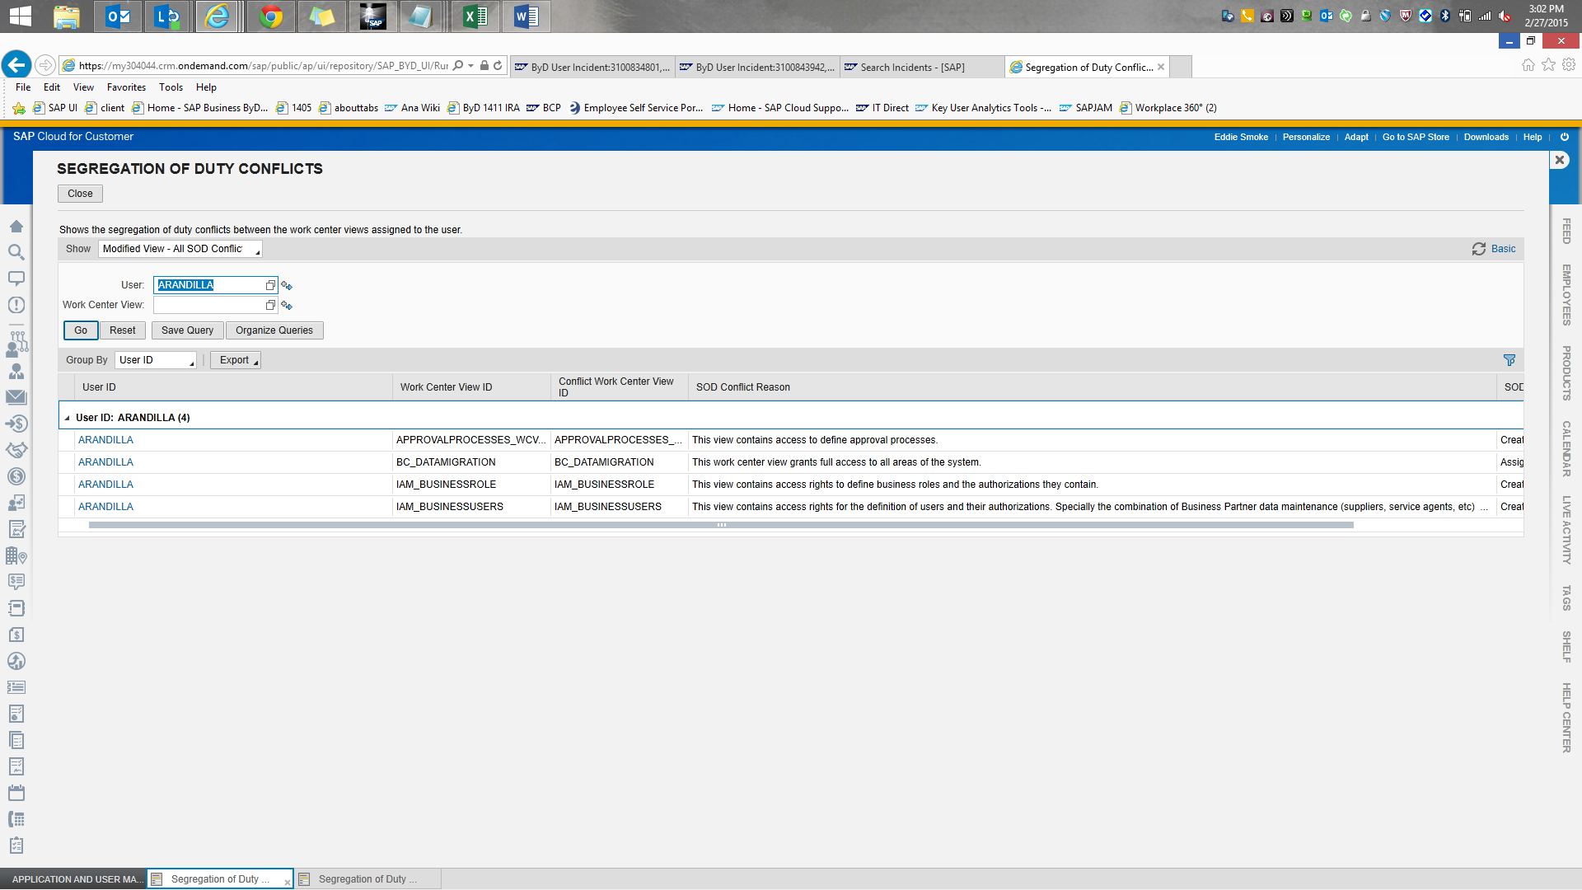
Now use the Export option to download the SOD data To Microsoft Excel:
