You can resolve this filter condition issue by following one of the two ways:
- Add both the negation values in the exclude condition:

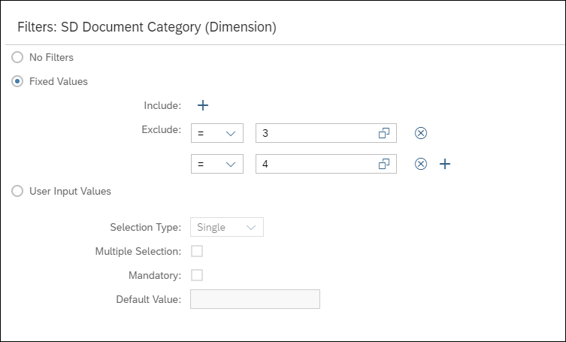

- Add only one negation value in Include condition and other conditions in exclude.
