Delegate an Activity to another user:
User 1 is going on a vacation and wanted User2 to take care of the Onboarding activities assigned to User1. This can be done through delegating the activity to User2.
- Create a Delegation group in security
- Select activity and monitoring steps
- Add the conditions
- Add User2 to the created delegation group

Create a Delegation group in security
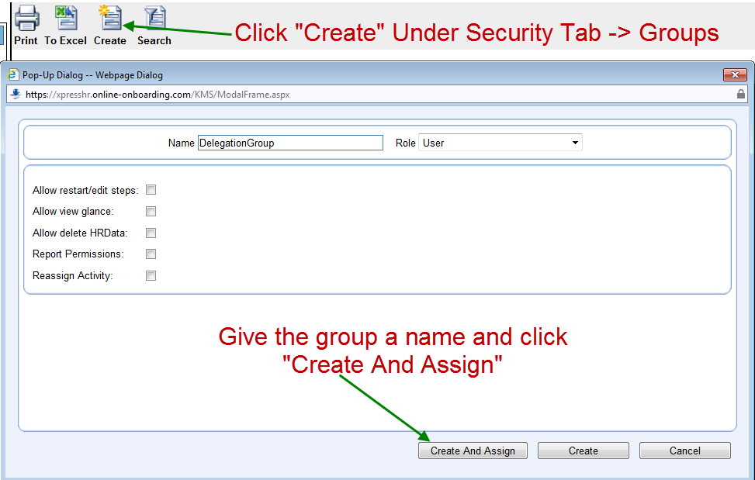

Select activity
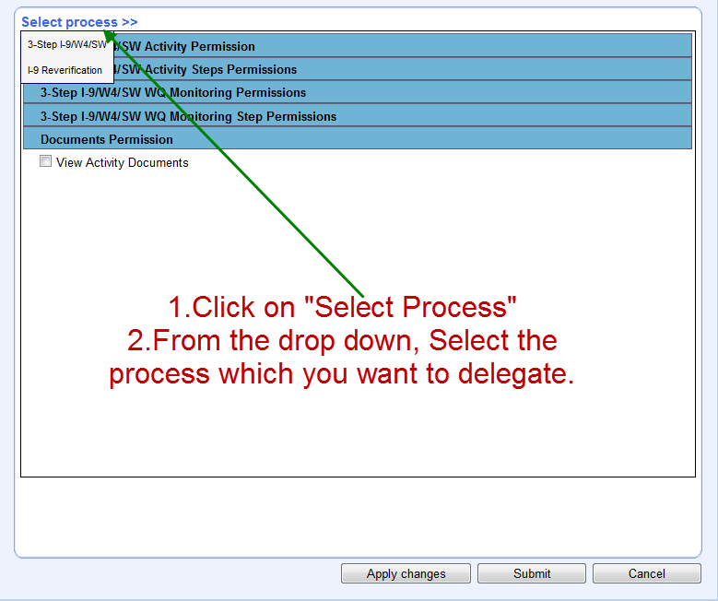

Select monitoring steps
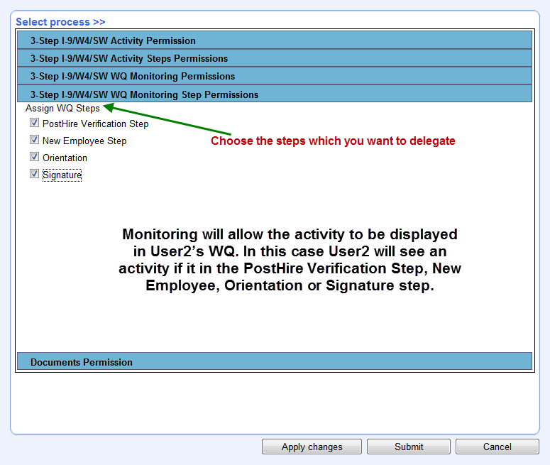

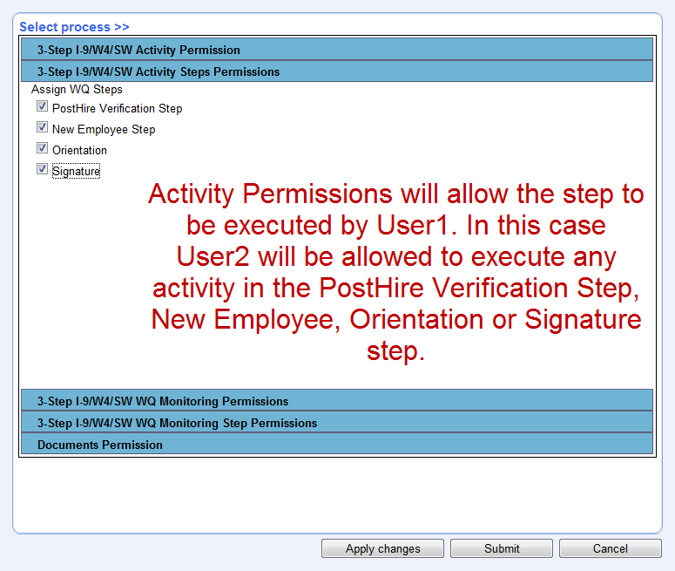

Add the conditions

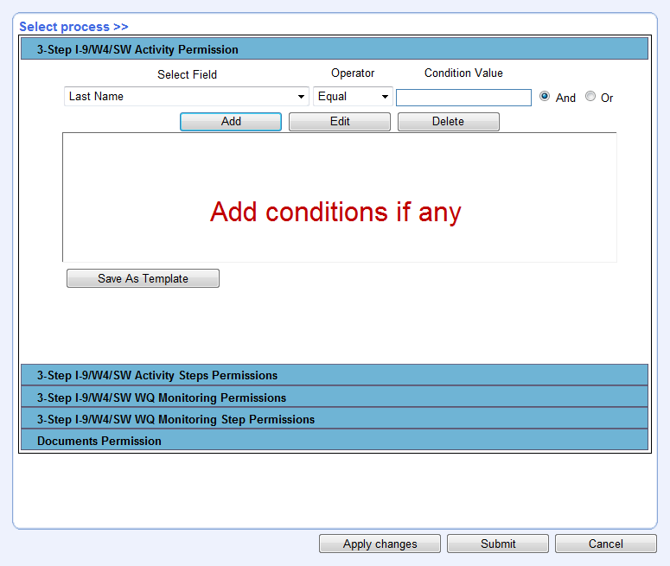
Click submit

Add User2 to the created delegation group

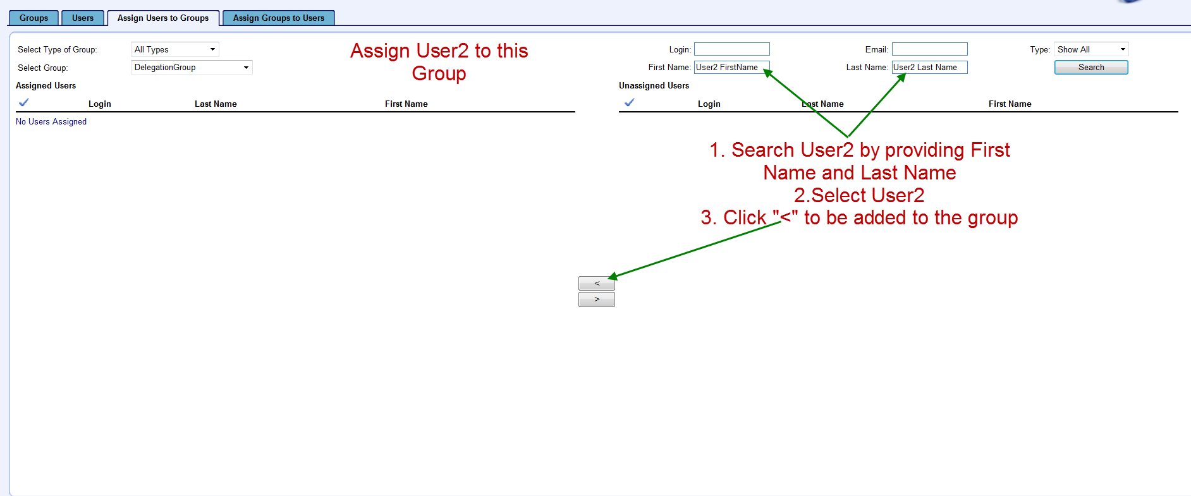

Search the work queue of User2
