Go to “Manage Home Page” in the “Admin Centre”.
Click on the “Add Custom Tile” button.
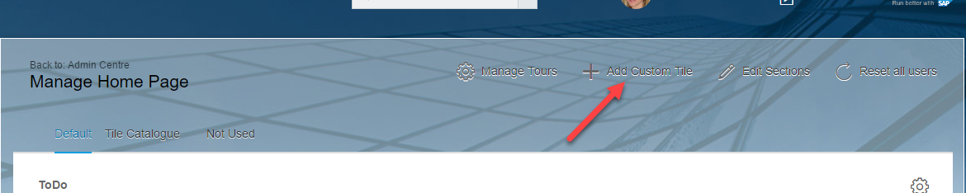
Insert a title and a description.
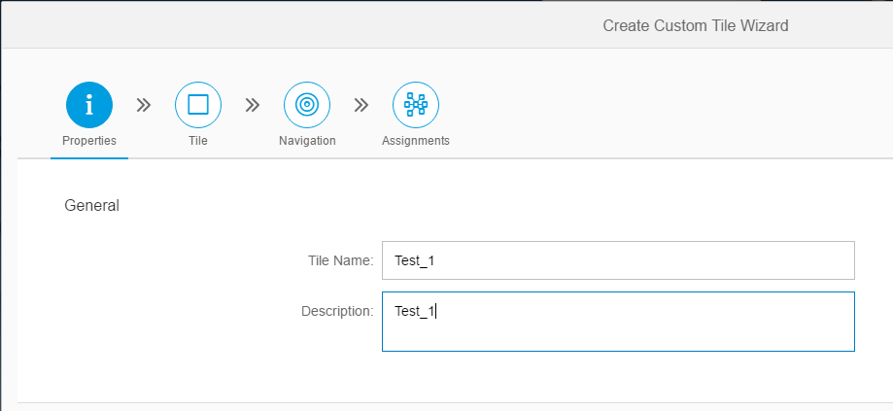
Set the language, title, sub title and size.
You have to set a background image here too.
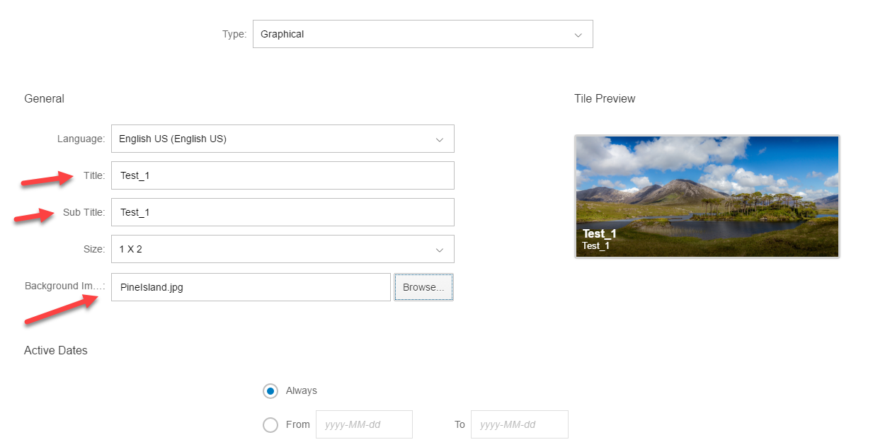

To insert a video, click on the little video icon highlighted by the arrow.
Insert the source URL and set the size.
Click the OK button and the tile is created.
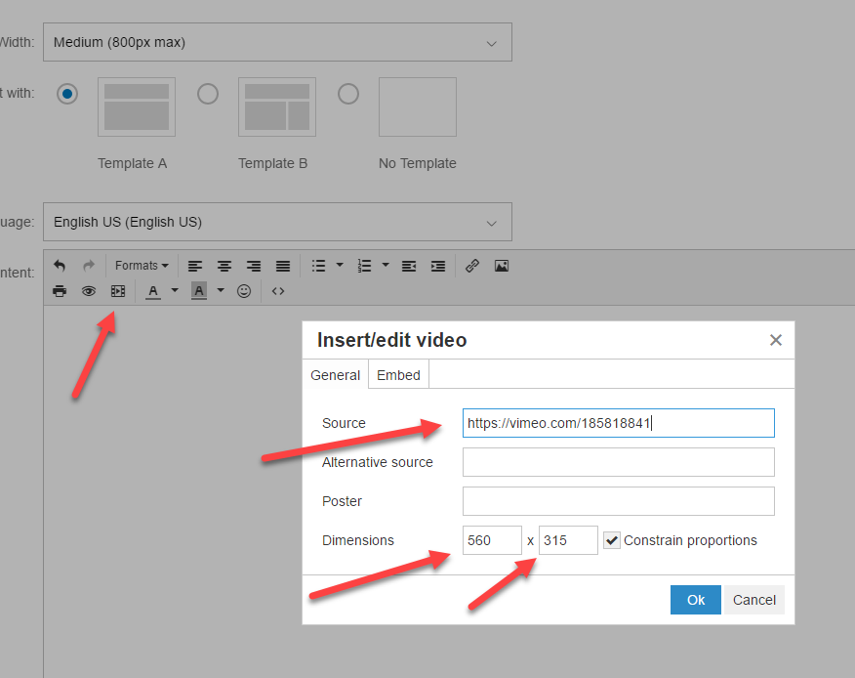
If you want to view the code select the “Embed” tab.

