

Recording Diagnostic Information via Webmeetings, Screenshots and HttpWatch

1. Screenshots
2. HttpWatch
3. Webmeetings/GotoMeeting

## Capturing Step-by-Step Replication in Screenshots

**The most helpful practice that helps Support resolve issues quickly is the use of clear step-by-step screenshots of the issue.** When the steps leading up to an issue, and including the issue are fully captured in screenshots, Support can not only quickly replicate the issue, but also has a record of the issue that will be shared with SuccessFactors Engineers to review. For screenshots to be most helpful do not simply capture the error itself, and crop the image, as that provides no context on how the error occurred and will not typically help support replicate the issue, which is the first step towards successful resolution.

Please take note of the step-by-step screenshots we have in this document explaining the use of HttpWatch and Recording Webmeetings. These are good examples of how you might use screenshots to document and comment on your issue in a word document.

Open a Microsoft Word. Copy & paste into this word doc screenshots of the issue (full screen – not cropped) then attach your document to the case.

It is helpful for screenshots to contain:

* Server Info & timestamp of test
* A brief explanation for each screenshot that clarifies what aspects of the shot we should take note of.
* Shows the usernames involved and who I might need to proxy in as
* Steps leading up to the issue so we quickly understand how to replicate
* Comment on what might be missing if that is the issue
* When showing comparisons, explain what differences you are highlighting
* We ask that you not crop the screenshots, just leave full screen as there are many other elements on the page that we may want to take note of that help us in troubleshooting.

**What Not to Do**

* Along with the best practices above that speed up troubleshooting, take care to avoid the following which can hinder and slow down progress
* **DON’T rely on just a webmeeting recording! Always provide supporting screenshots.**
* Recordings can be helpful in the case of showing slowness or some real-time processing issue, but are NOT required for simple issues that can be sufficiently demonstrated with screenshots.
* DON’T just take a recording, because “it’s easier” for you to do than creating screenshots.
* Since recorded movies become very large, they are often difficult to use. Recordings may be so big you cannot even attach to a case or share with engineering.
* Recordings are hard to follow and tend to include other activity that is unrelated to the issue and therefore possibly misleading to the watcher.
* Don’t just attach a recording without these detailed notes which should include timestamps of the events to watch for. It’s not always intuitive what specifically you want the watcher to take note of, so you must provide very detailed notes along with your recording if one should be taken.

## The Instruction of HttpWatch

1. **Overview**

HttpWatch integrates with Internet Explorer and Mozilla Firefox to provide unrivalled levels of HTTP monitoring. It is very useful to collect performance diagnostic information by using HttpWatch.

1. **where to download**

HttpWatch Basic Version can be downloaded from:

<http://download.httpwatch.com/httpwatch.exe>

1. **how to install**
   1. **Run the httpwatch.exe file, and click Next to proceed.**

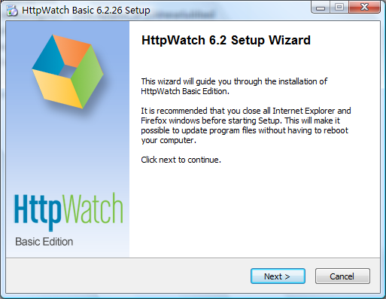

* 1. **Review the license agreement, and choose I Agree.**

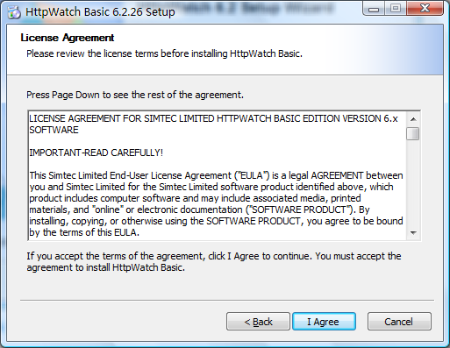

* 1. **HttpWatch plug-in to Firefox can be optional.**

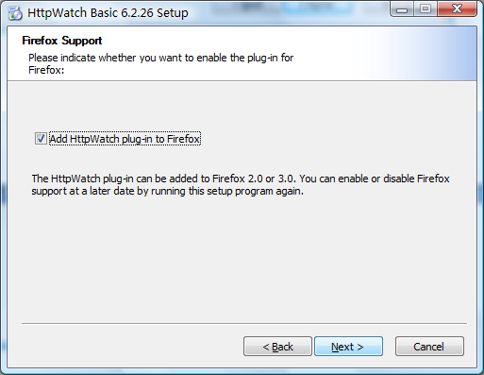

* 1. **Choose install location, and click install to start the installation.**

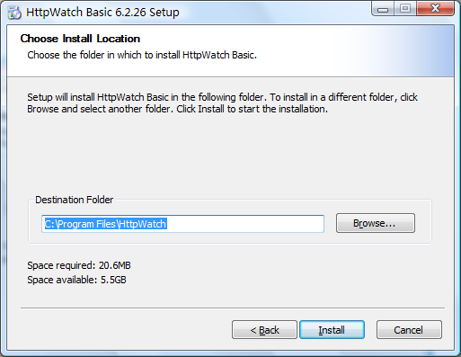

* 1. **Finish the installation.**

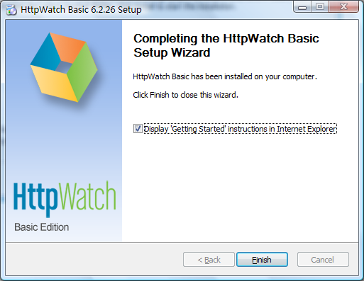

1. **How to enable HttpWatch in IE**

After the installation, HttpWatch plug-in is installed in Internet Explorer, and optionally in Firefox. The HttpWatch plug-in can be displayed in the lower part of the Internet Explorer (IE) window by using one the three methods shown below:

1. Click on the HttpWatch toolbar button which is normally on a hidden part of the IE command bar. You need to click on the toolbar chevrons (>>) before clicking on the HttpWatch button:

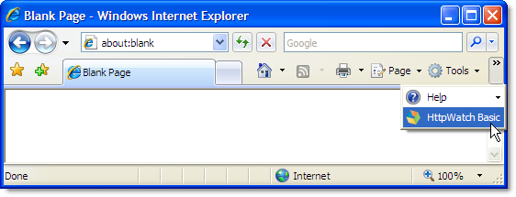

If the HttpWatch button is not in the IE command bar you can use the Tools->Toolbars->Customize... menu item to make it visible (see the Customizing the location of the HttpWatch Toolbar button section below).

2. Select it from the Tools->Toolbars->Explorer Bar menu:

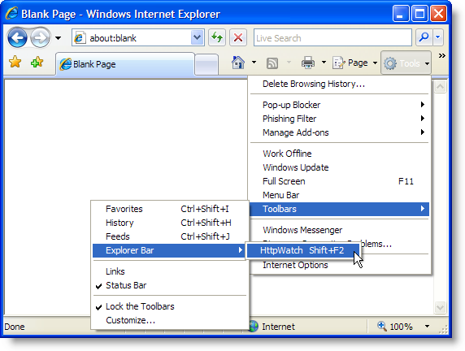

3. Use the shortcut key, Shift+F2, within Internet Explorer.

If none of these options open the HttpWatch window, please restart Windows.

1. **When to click on Record(just before the slow actions)**
   1. **Navigate to the page that contains the link to the slow action, e.g.**

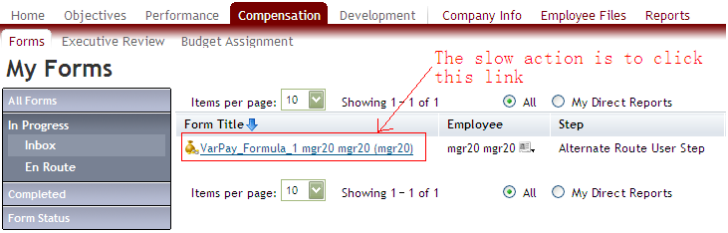

* 1. **Open HttpWatch, and press the Record button.**

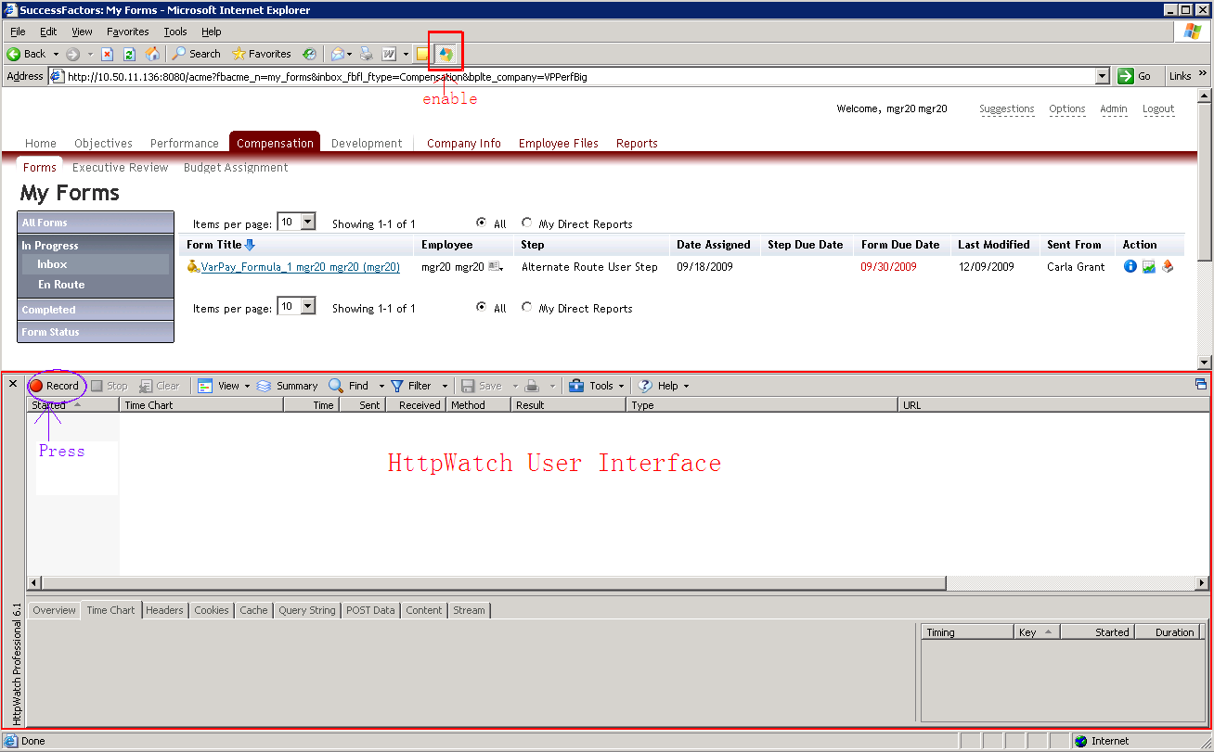

* 1. **Click on the link and trigger the slow action.**

1. **When to stop**
   1. **Make sure: ①No more downloading resources in the Request Grid of HttpWatch. ②IE shows “done” status. ③The progress/loading bar in the bottom right of the status bar which shows the loading of the page disappears.**

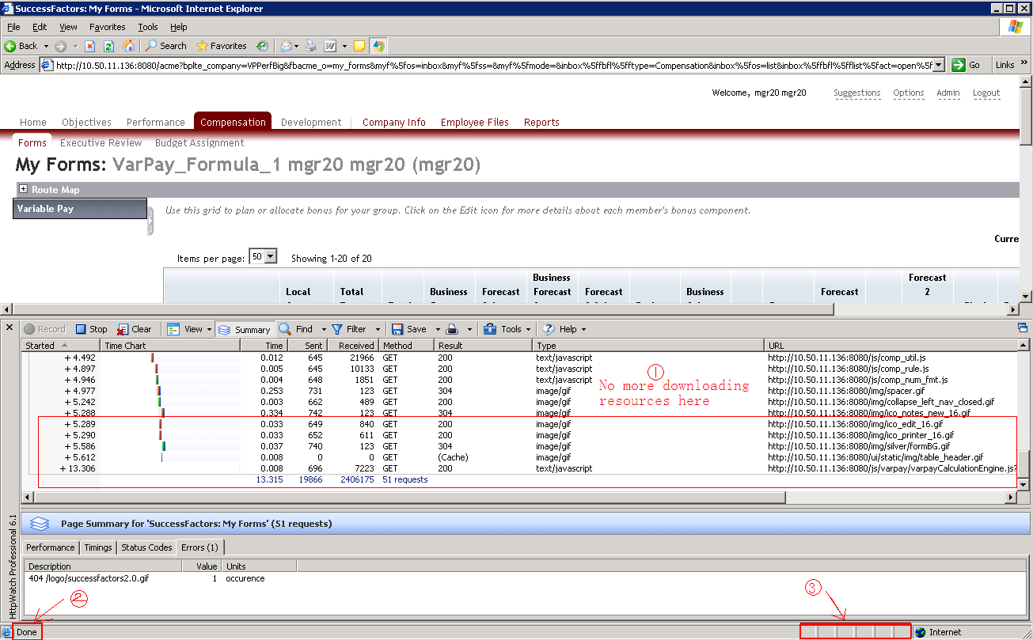

* 1. **Press the Stop button.**

1. **How to save**
   1. **Press the Save button.**



* 1. **Choose File name & Save location, and click Save with default save type (*.hwl).**

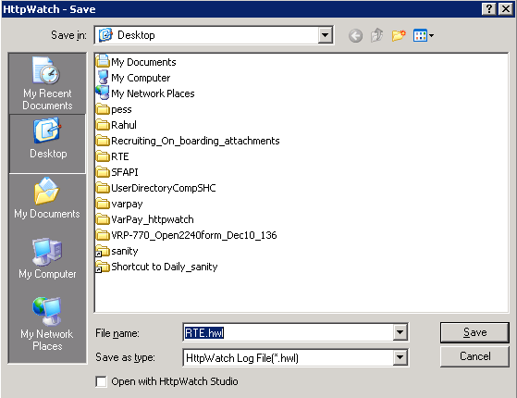

## Recording GoToMeeting session.

To start recording follow the steps below.

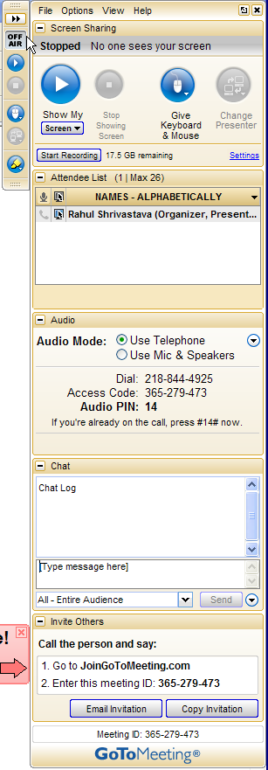

In order to do a voice recording, please dial into the number provided in the “Audio Mode” setting.

Step 2 - Click on the “Show my screen to attendees”.

Step 3 - Click Start Recording. When finished, click the same button to stop recording. In order to locate the recorded file, open directory that you provided in step 1 (see Figure 16).

Step 1 - Click on setting which will open Figure 16. Pick right setting options and click ok.

Figure 15: GoToMeeting screen sharing

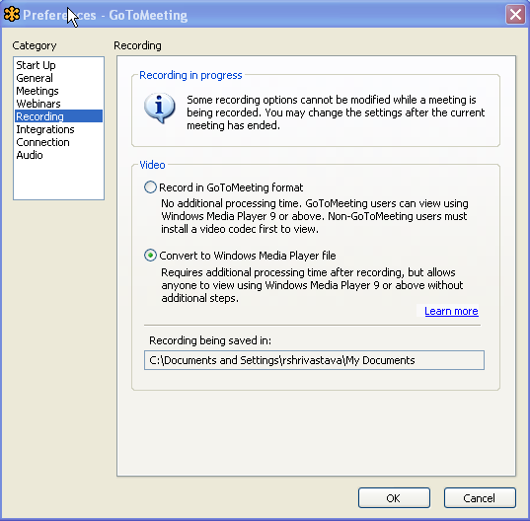

Make changes to video format and directory setting if needed.

Figure 16: Recording option