

Recording Diagnostic Information via HttpWatch

1. HttpWatch

## 

## The Instruction of HttpWatch

1. **Overview**

HttpWatch integrates with Internet Explorer and Mozilla Firefox to provide unrivalled levels of HTTP monitoring. It is very useful to collect performance diagnostic information by using HttpWatch.

1. **where to download**

HttpWatch Basic Version can be downloaded from:

<http://download.httpwatch.com/httpwatch.exe>

1. **how to install**
   1. **Run the httpwatch.exe file, and click Next to proceed.**

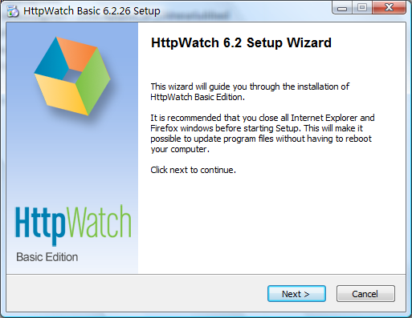

* 1. **Review the license agreement, and choose I Agree.**

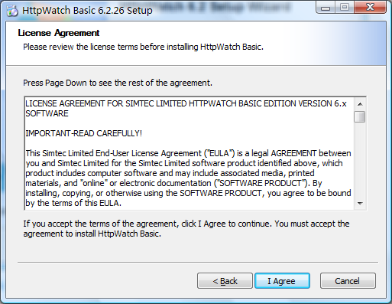

* 1. **HttpWatch plug-in to Firefox can be optional.**

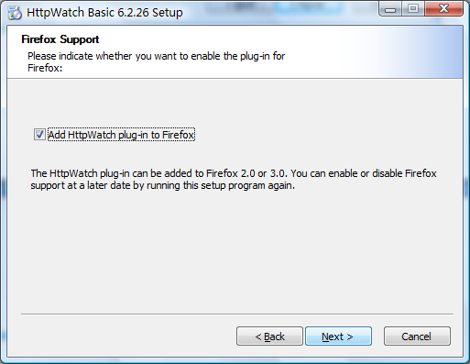

* 1. **Choose install location, and click install to start the installation.**

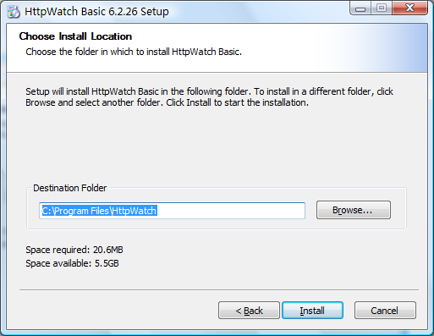

* 1. **Finish the installation.**

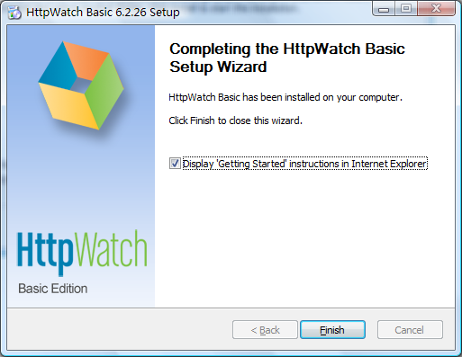

1. **How to enable HttpWatch in IE**

After the installation, HttpWatch plug-in is installed in Internet Explorer, and optionally in Firefox. The HttpWatch plug-in can be displayed in the lower part of the Internet Explorer (IE) window by using one the three methods shown below:

1. Click on the HttpWatch toolbar button which is normally on a hidden part of the IE command bar. You need to click on the toolbar chevrons (>>) before clicking on the HttpWatch button:

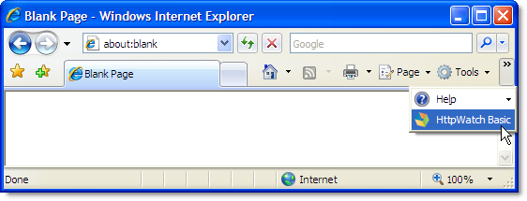

If the HttpWatch button is not in the IE command bar you can use the Tools->Toolbars->Customize... menu item to make it visible (see the Customizing the location of the HttpWatch Toolbar button section below).

2. Select it from the Tools->Toolbars->Explorer Bar menu:

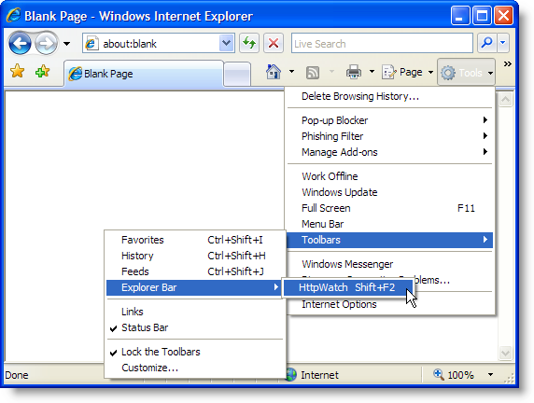

3. Use the shortcut key, Shift+F2, within Internet Explorer.

If none of these options open the HttpWatch window, please restart Windows.

1. **When to click on Record(just before the slow actions)**
   1. **Navigate to the page that contains the link to the slow action, e.g.**

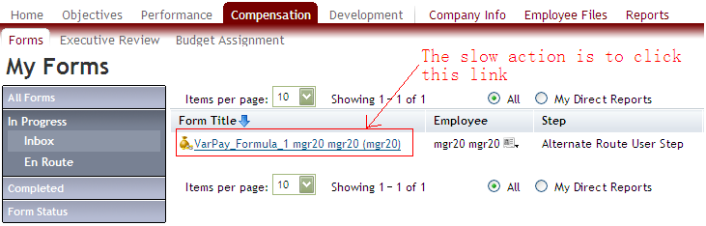

* 1. **Open HttpWatch, and press the Record button.**

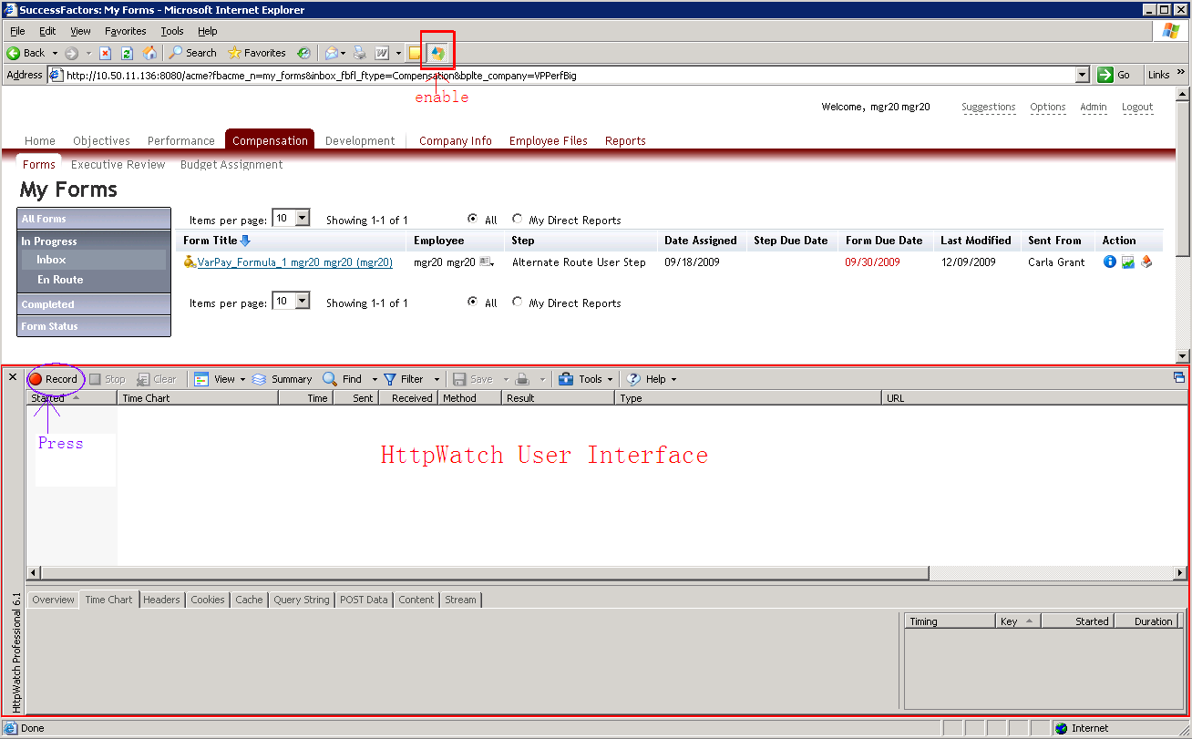

* 1. **Click on the link and trigger the slow action.**

1. **When to stop**
   1. **Make sure: ①No more downloading resources in the Request Grid of HttpWatch. ②IE shows “done” status. ③The progress/loading bar in the bottom right of the status bar which shows the loading of the page disappears.**

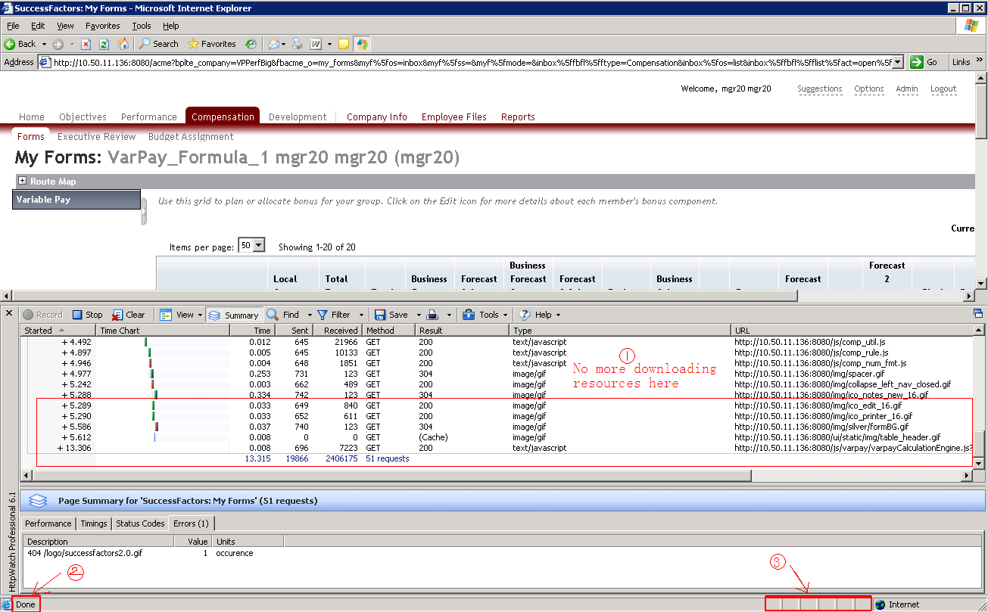

* 1. **Press the Stop button.**

1. **How to save**
   1. **Press the Save button.**



* 1. **Choose File name & Save location, and click Save with default save type (*.hwl).**

