Custom fields created under context ‘Market Segment’ using key user tool can be added in TDD template.

Open the TDD template in SSCUI and double click ‘Maintain Processing Instructions’, click button ‘Add More Characteristics’.

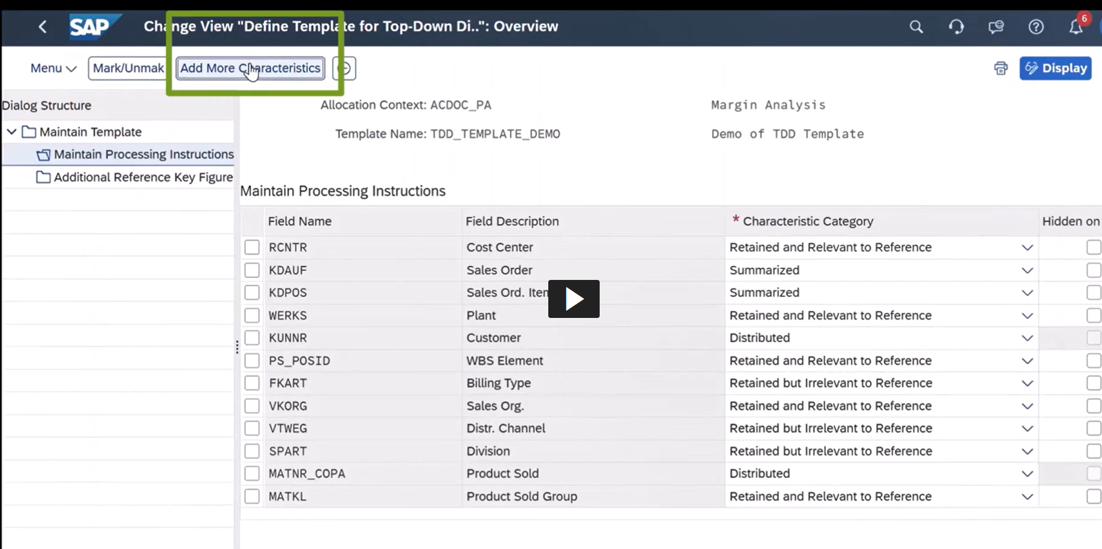

In the popup window, choose the custom fields under node: ‘Universal Journal Entry: CO-PA fields.

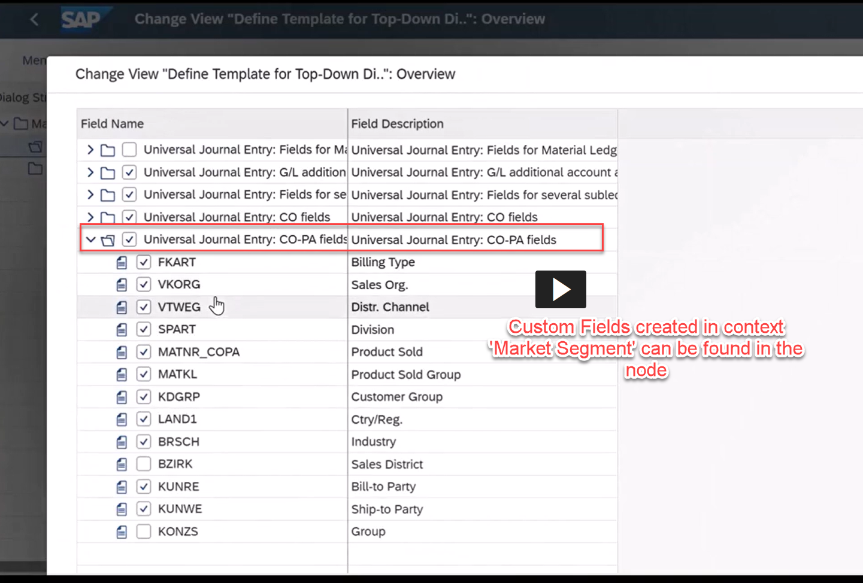

**Note: the newly added fields will be se as ‘Hidden On UI’ by default, it’s required to uncheck the checkbox in ‘Maintain Processing Instructions’ page so that the fields can be available in Universal Allocation Top-Down Distribution Cycle segment.**