**1. Deletion blocks: Pre-2502 location.  
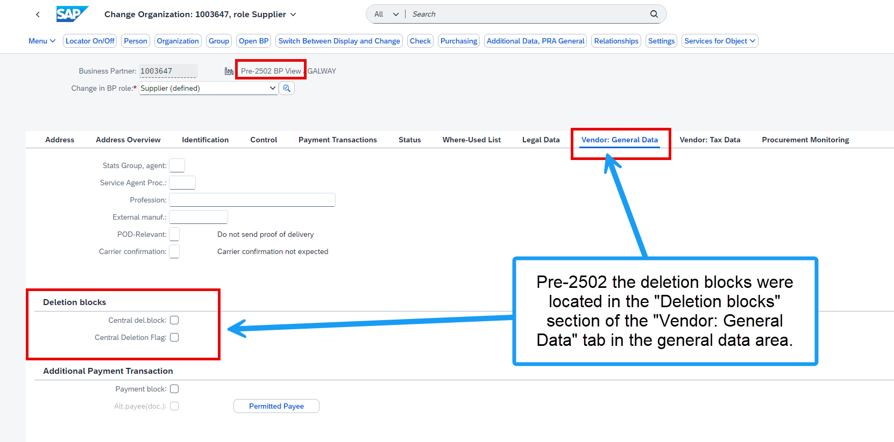**

**1. Deletion blocks: 2502+ location.**

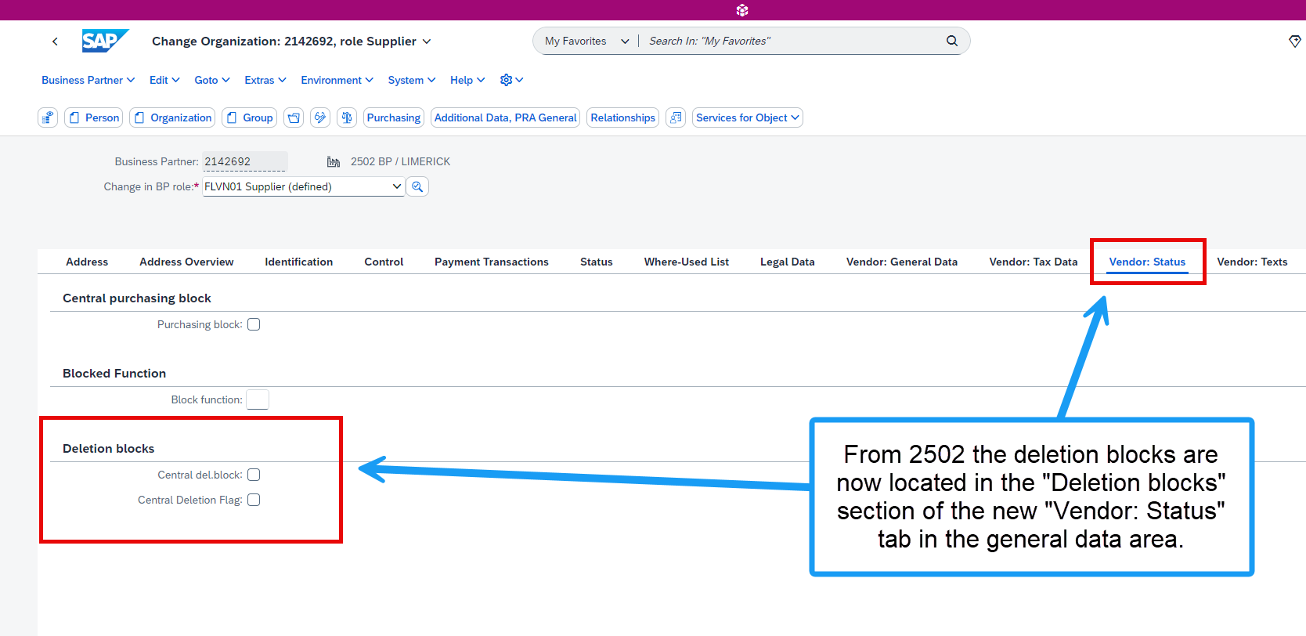

**2. Posting Block for “All Company Codes” : Pre-2502 location.**

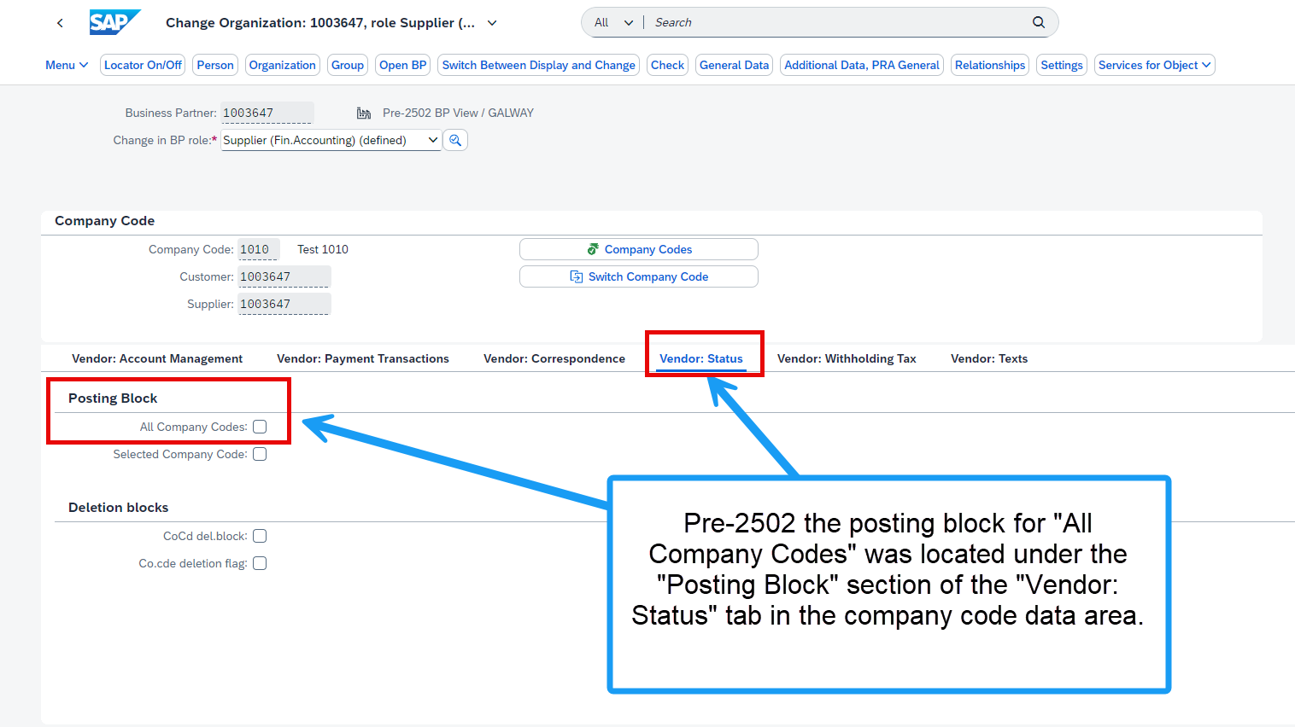

**2. Posting Block for “All Company Codes” : 2502+ location.**

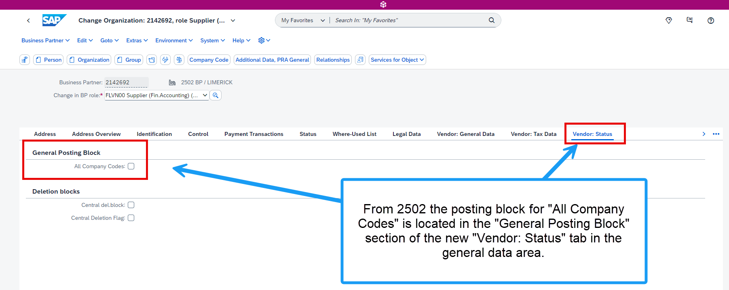

**3. Posting Block for “Selected Company Codes” : 2502+ location.**

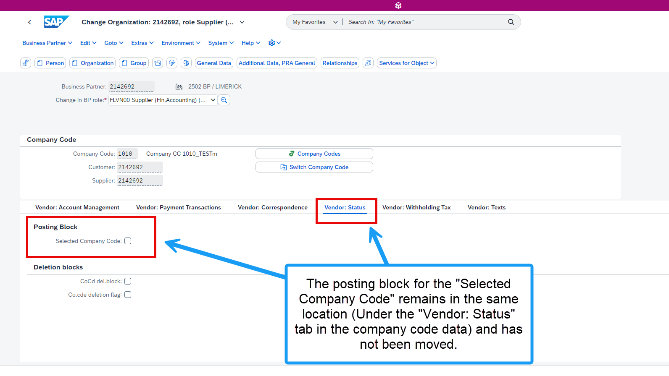

**4. “Delete flag for Purch Org” and “Purchase block POrg level” pre-2502 location.**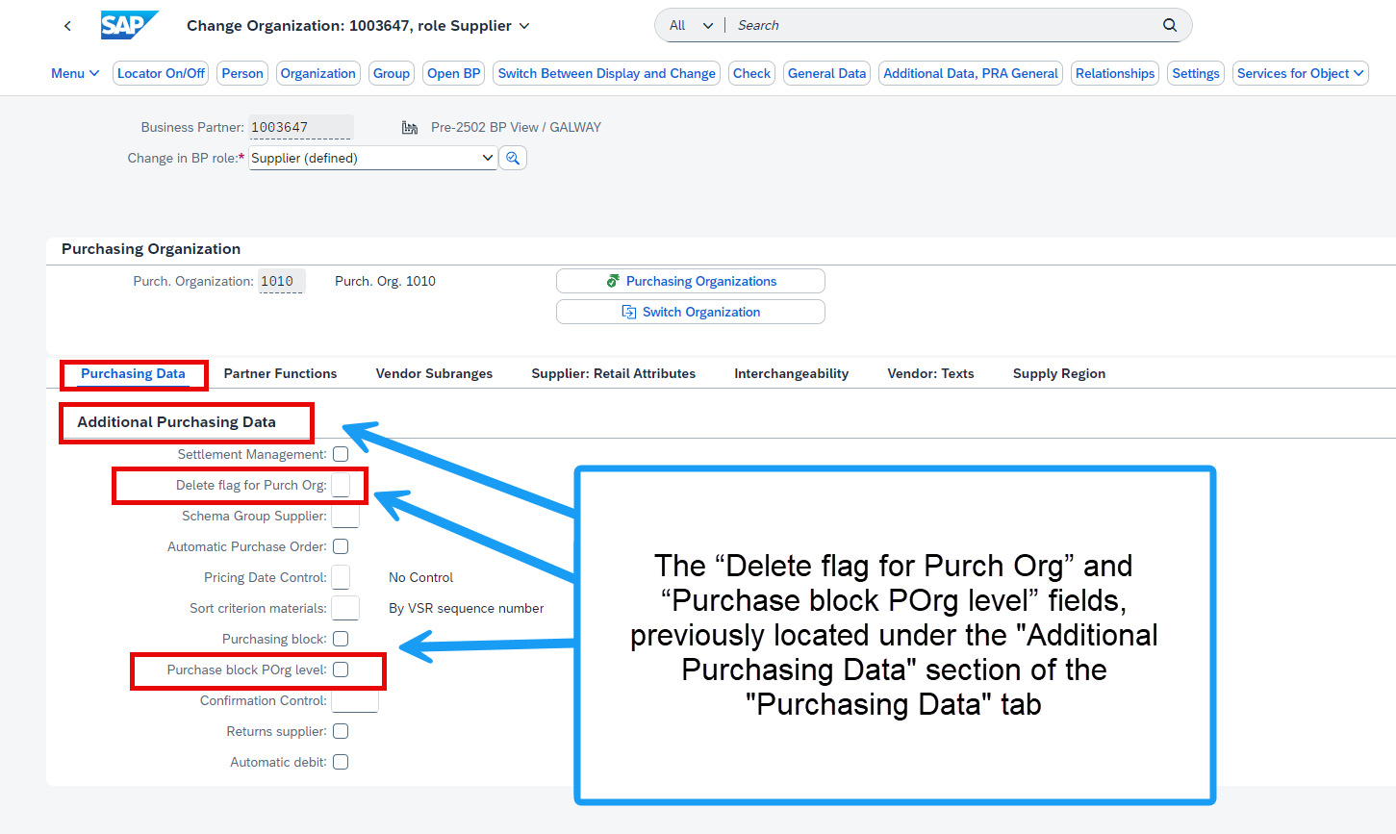

**4. “Delete flag for Purch Org” and “Purchase block POrg level” 2502+ location.**

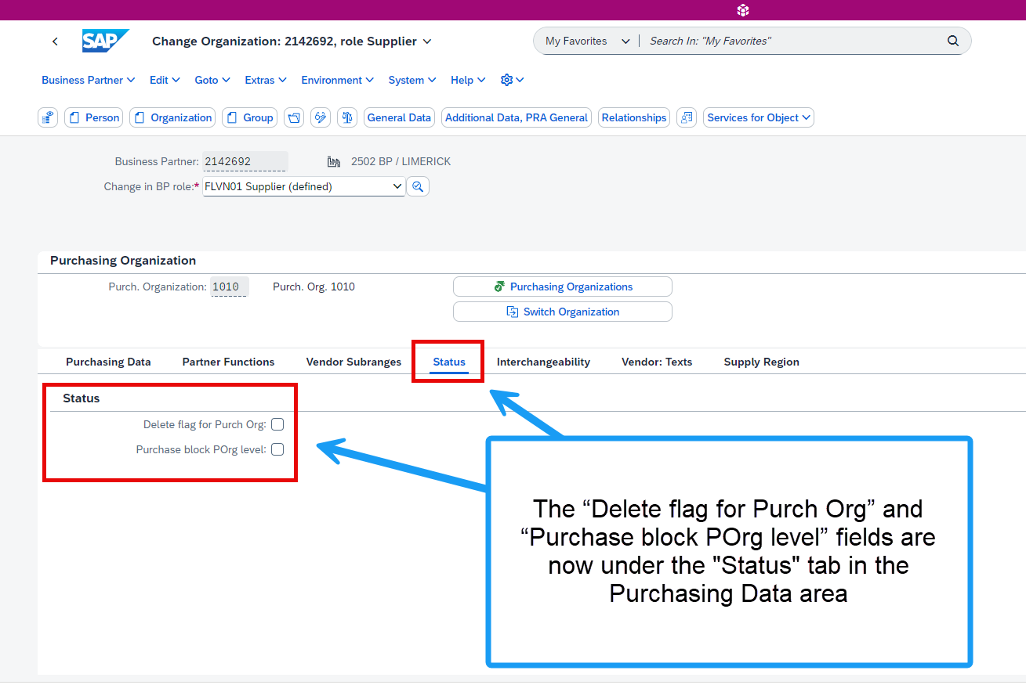

**5. Purchasing block pre-2502 location.**

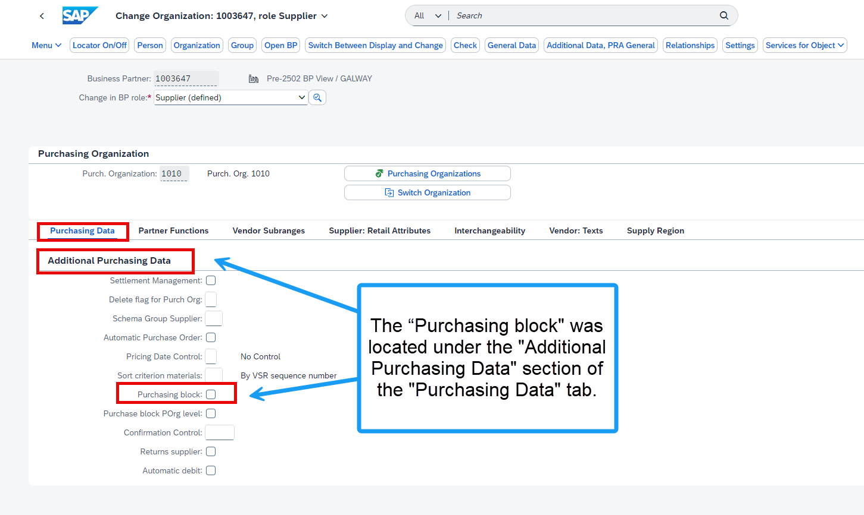

**5. Purchasing block 2502+ location.**

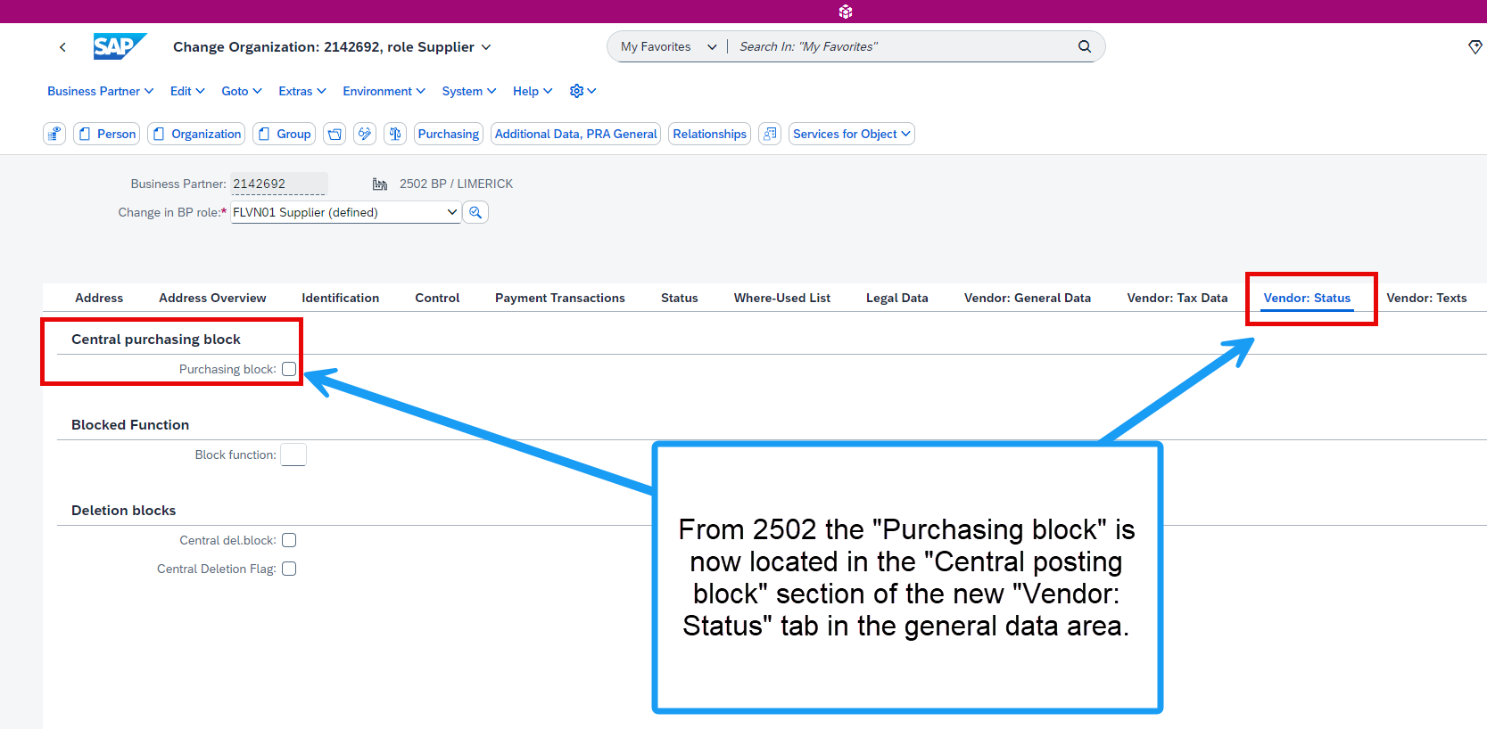

**6. Block function pre-2502 location.**

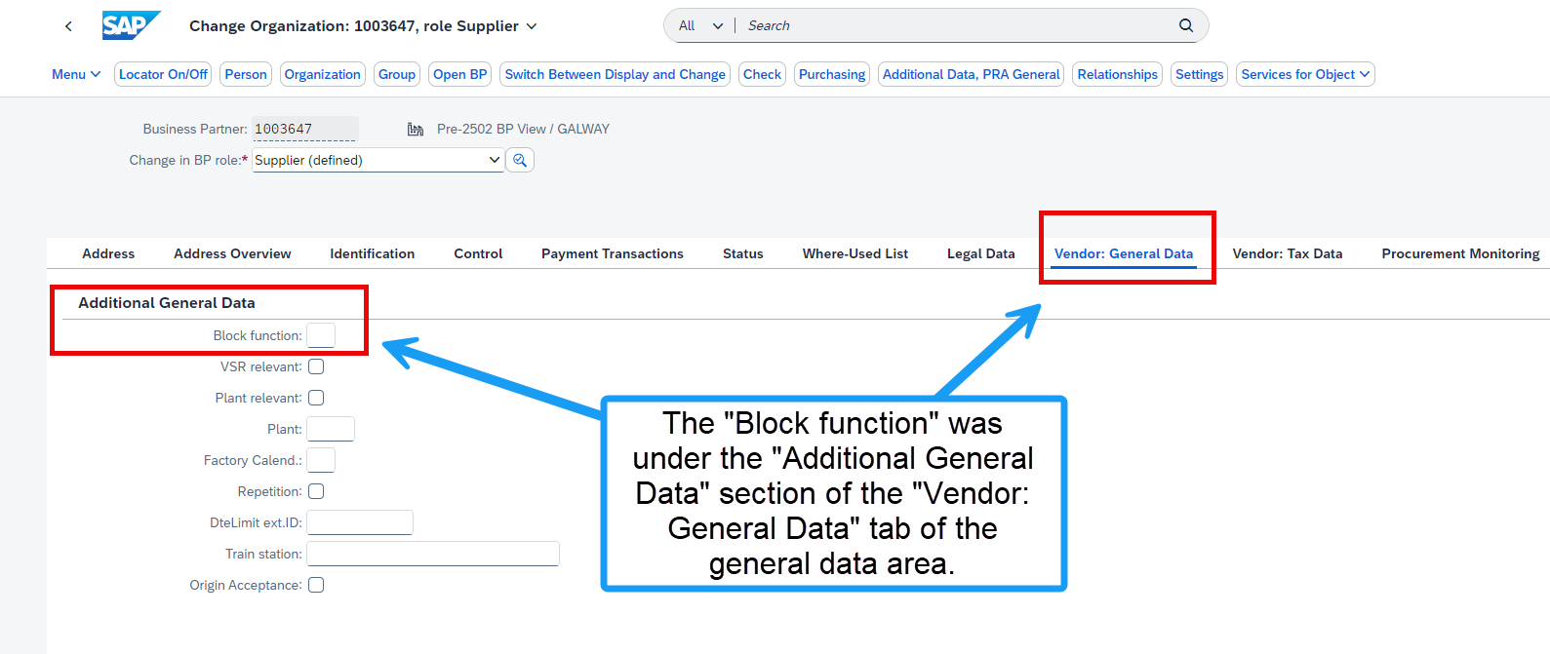

**6. Block function 2502+ location**

