Financial statement version YPS2:
- Under GL account (GL_accountant) , you should be able to find the app: “Maintain Financial statement versions” and in this check FSV YPS2.
  - Here you can see which all GL account are already mapped under cost of good sold
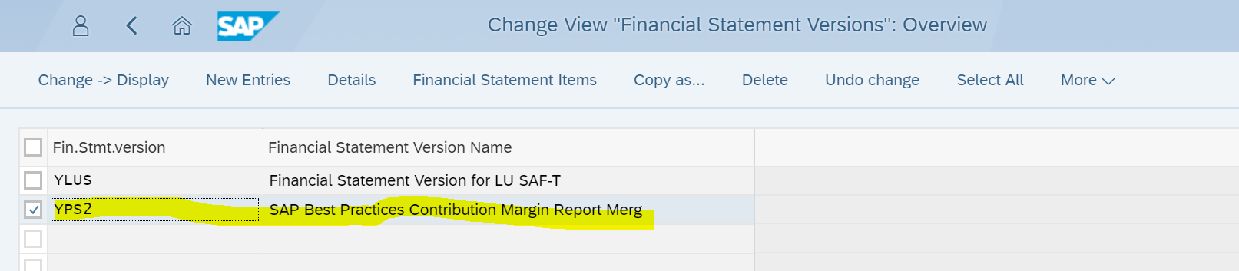

Expand the hierarchy to follow the below path to reach ‘Cost of Goods Sold’:
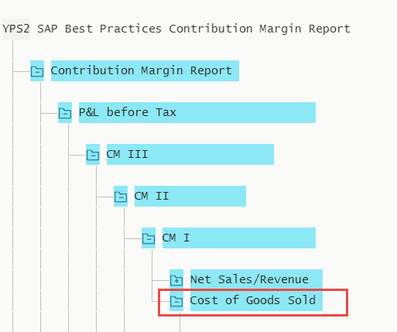

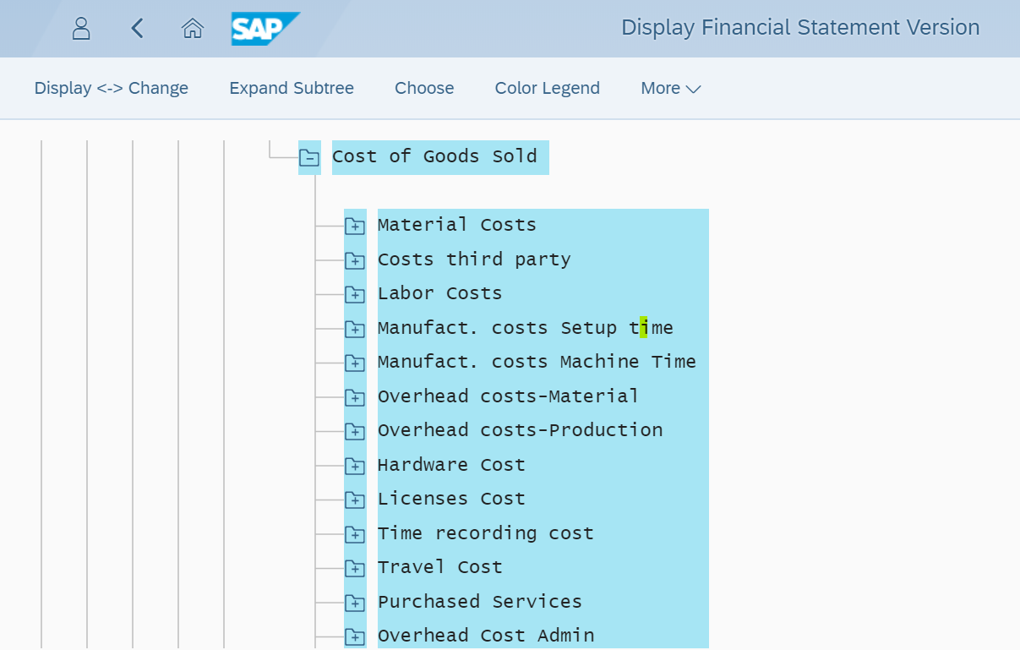
- If you are recording cost on GL which are not yet mapped then you can use the app “ Maintain Financial statement version “ and add the GL account to YPS2.
  - Preferably you should map the GL account to one of the pre-existing node like time, travel etc and when you save the changes make sure you click on activate.
  - If you add new GL to existing node no other action is required
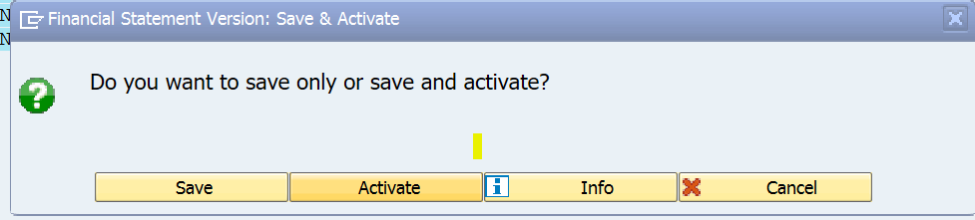
  - If you want to add the new node (like material cost or labor cost) for new type of cost under cost of goods sold then after you do that and add the GL to it, you need to perform additional steps as mentioned only in d and e.
    - First make sure you know the node number, which you can see in FSV (YPS2), via key number as shown below (this is required for only new node that you create yourself)
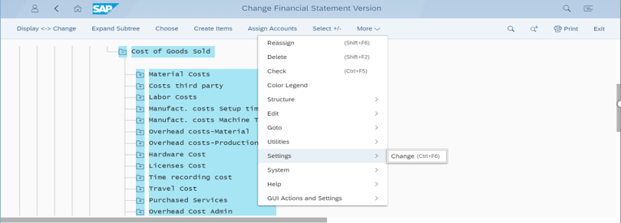
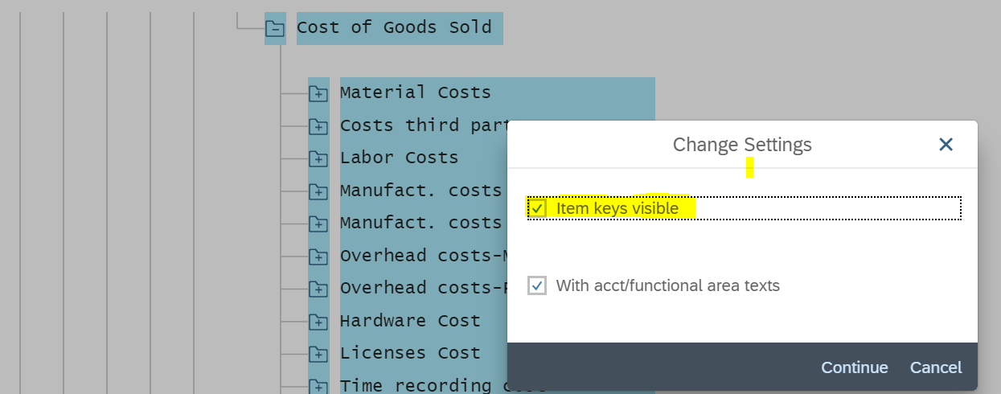
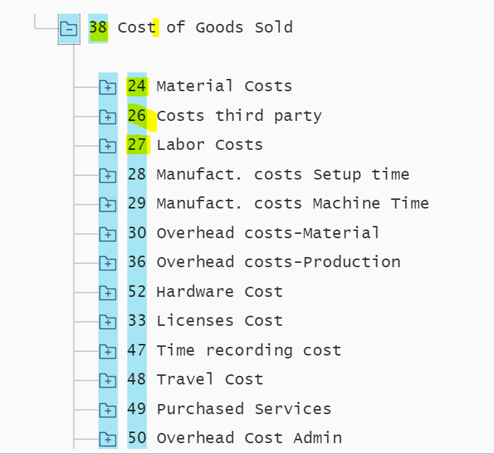
  - Assign Semantic tag to node:
    - Use app “assign Semantic Tag to FSV” and add the new node that you created previously to tag ACT_COST and any other tag you want. All cost node need to be assigned to ACT_COST and respective other tag. Like material cost 24 is mapped to tag like this:
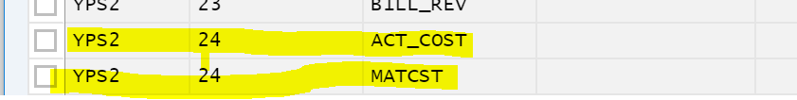
  - Replicate Runtime Hierarchy (this is required so that all the changes are refreshed in Hierarchy for report to work ok)
    - Use app Replicate Runtime Hierarchy and replicate YPS2.

