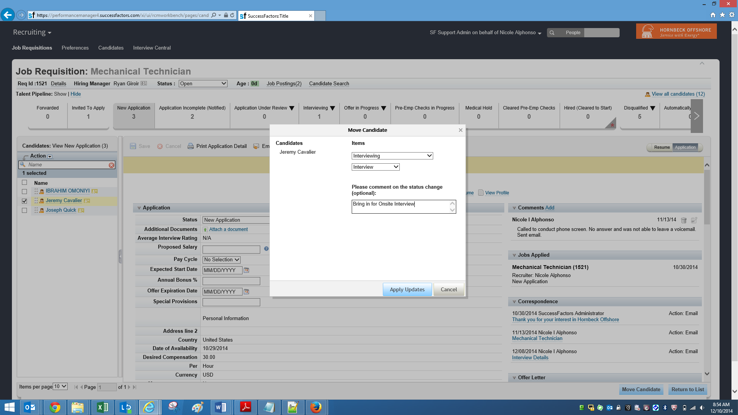

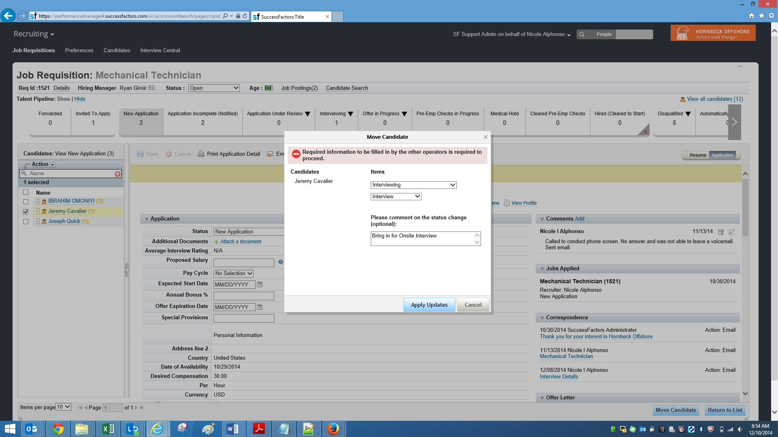

Check in the Splunk for the error with time stamp, and see that the Cellphone id does not have any value.

