System Configuration

Customize Date Rule

SSCUI: Define Date Types, Duration Types and Date Rules for Service Transactions (ID 104300)

Copy Date Rule PPFDEMO to **ZTODAYADD7** and then set the **duration** to 7.

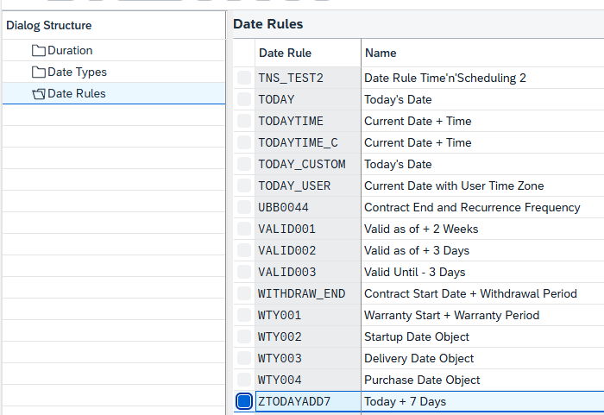

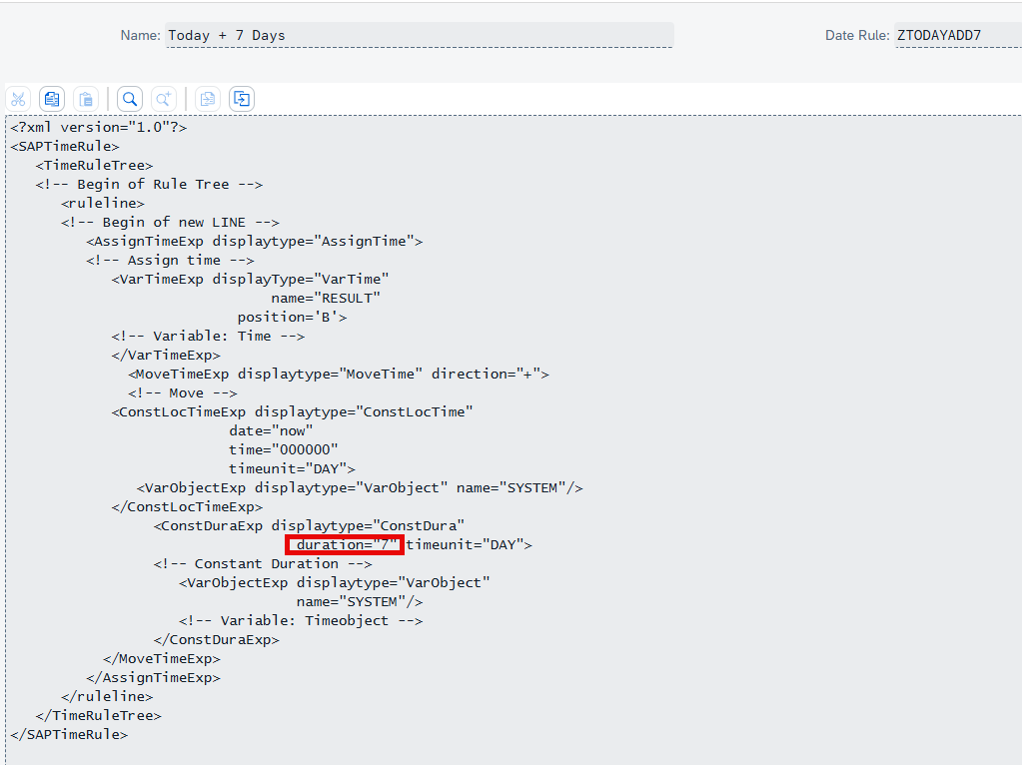

Customize Date Profile

SSCUI: Define Date Profile for Service Transactions (ID 104301)

2.1 **Deep Copy** Date Profile SOLO_SC to **ZSOLO_SC**.

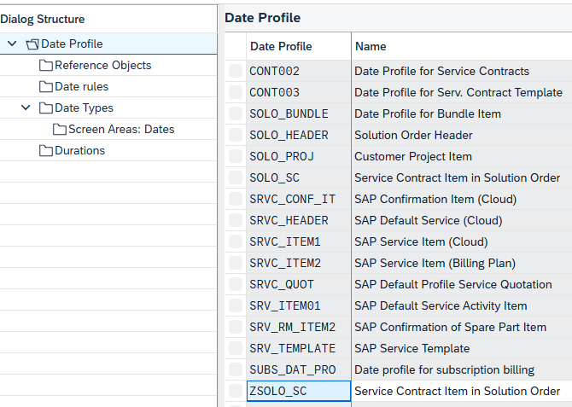

2.2 Add Date Rule **ZTODAYADD7** to Date Profile **ZSOLO_SC**.

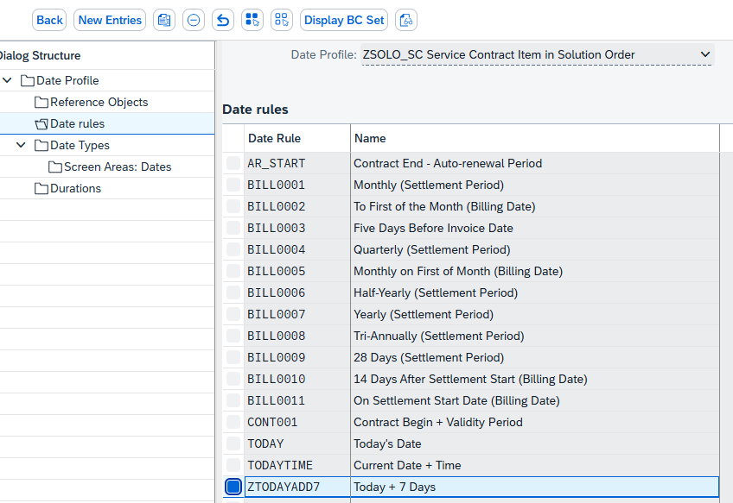

2.3 Change Date Type Contract Start Date **CONSTART** Date Rule to **ZTODAYADD7**.

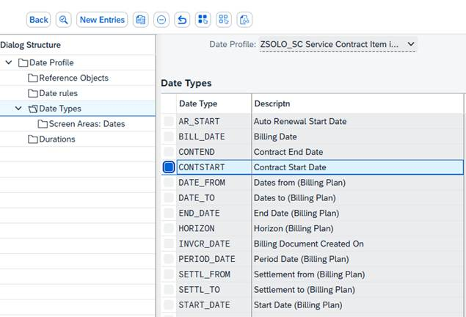

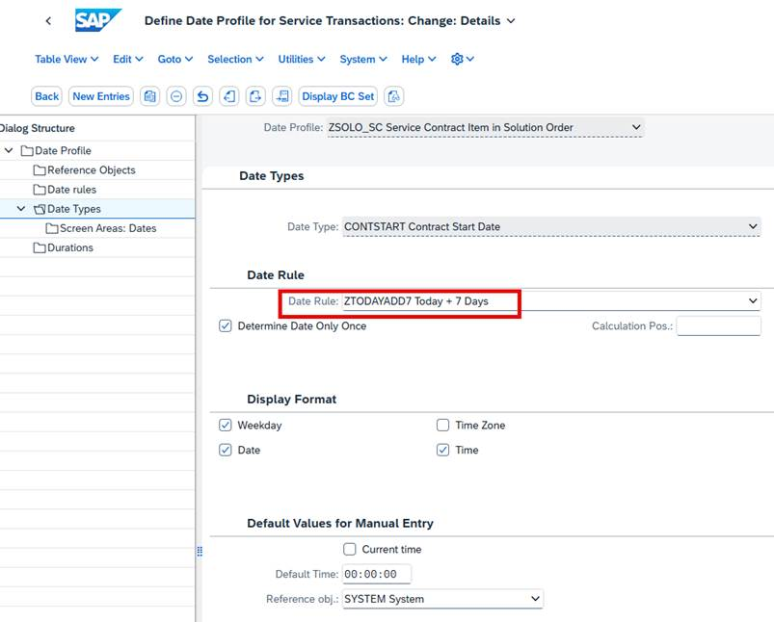

Change Item Category assigned Date Profile

SSCUI: Assign Date Profile to Item Categories in Service (ID 104328)

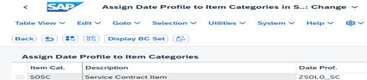

Testing

Manage Solution Orders App

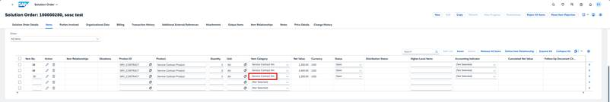

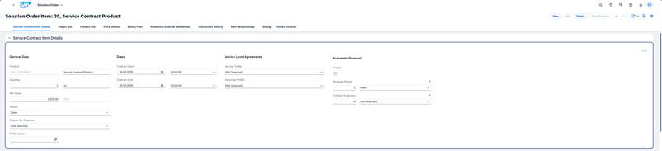

A2X API

Don’t pass field ServiceContrItemStartDateTime in the payload.

