To enable Date rules BILL0013, BILL0014, BILL0015 and BILL0016 in solution order service contract item settlement periods:

You could use business user BPC_EXPERT to use SSCUI to adjust the customizing.

1. Open app Manage Your Solution. Click Configure Your Solution.
2. Find the **Date Management**.

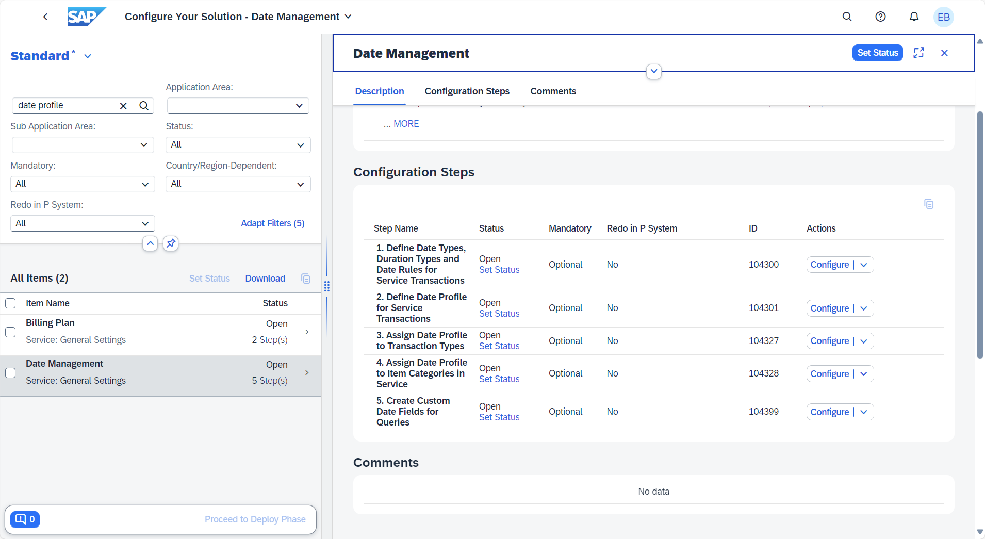

1. Click Define Date Profile for Service Transactions and go into **copy existing date profile SOLO_SC**.

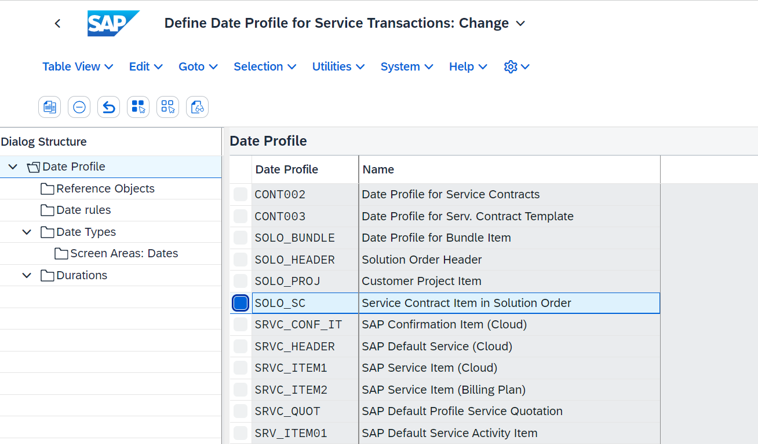

Select copy all. And define new name.

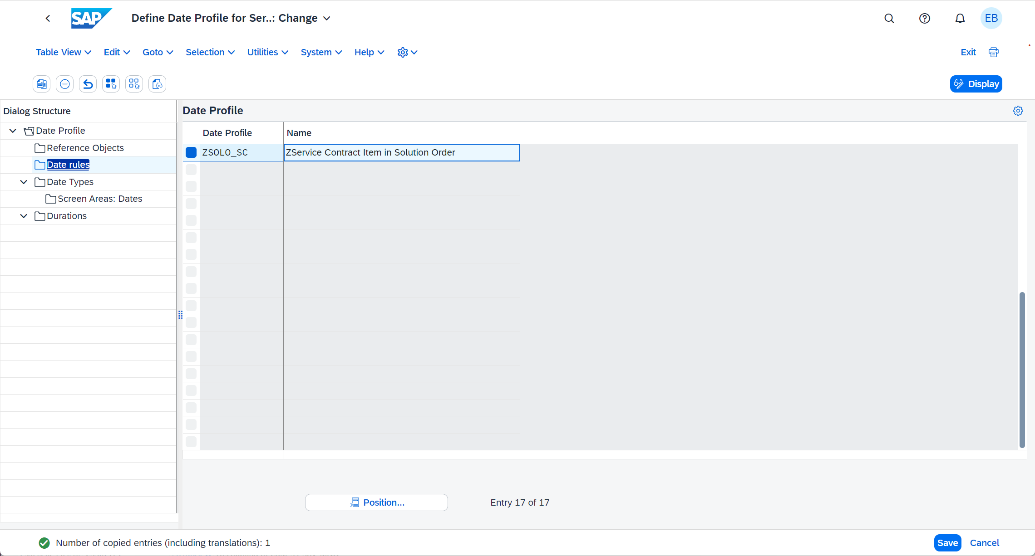

1. Click the Date rules in the new created date profile.

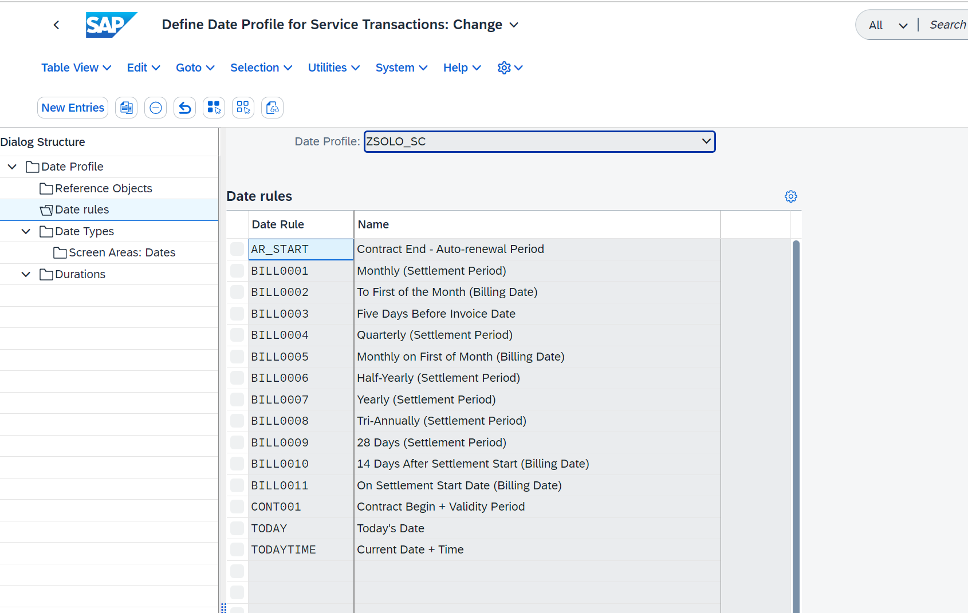

**Add Date rule** you need to there, such as BILL0013, BILL0014, BILL0015, BILL0016.

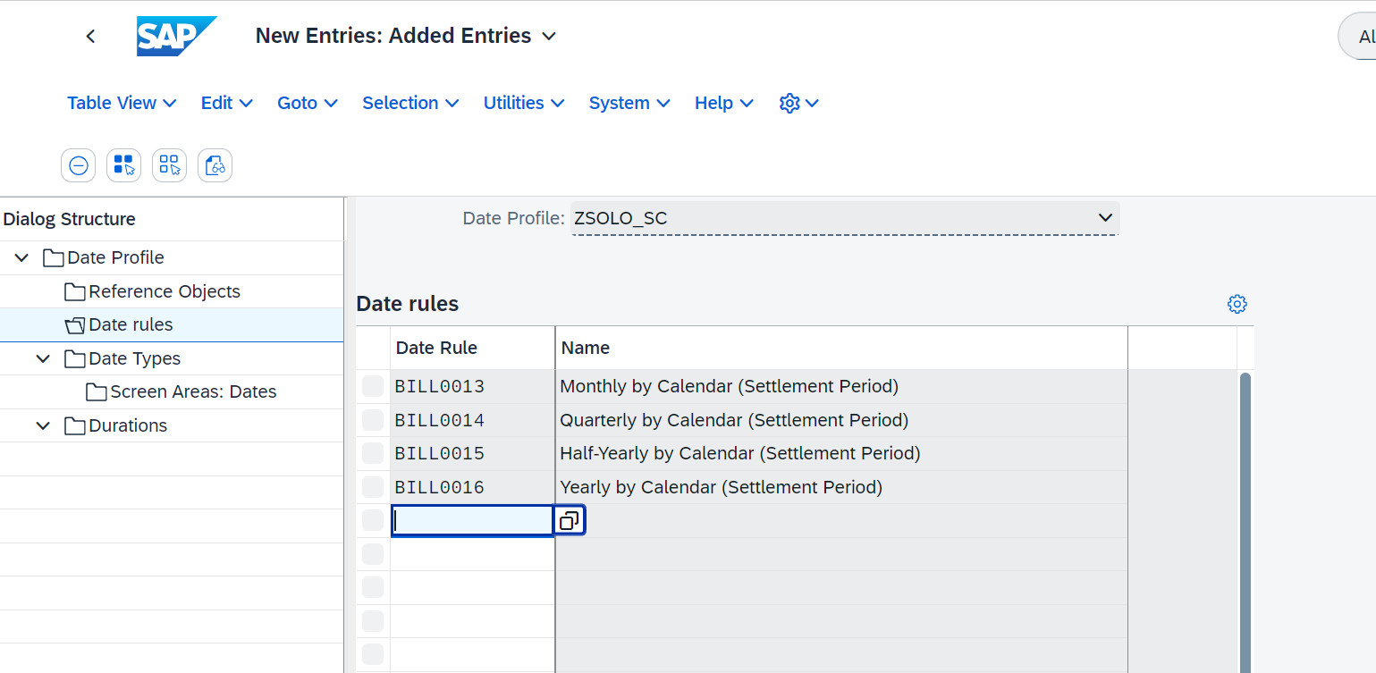

Save it.

1. Back to the Date Management and Click Assign Date Profile to Item Categories in Service

**Assign the new created date profile to the items** which you want to enable the date rules.

