**1. Deletion blocks: Pre-2502 location.**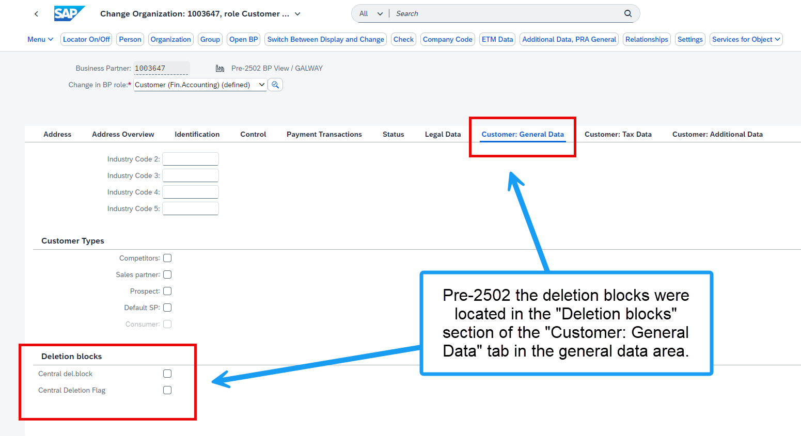

**1. Deletion blocks: 2502+ location.**

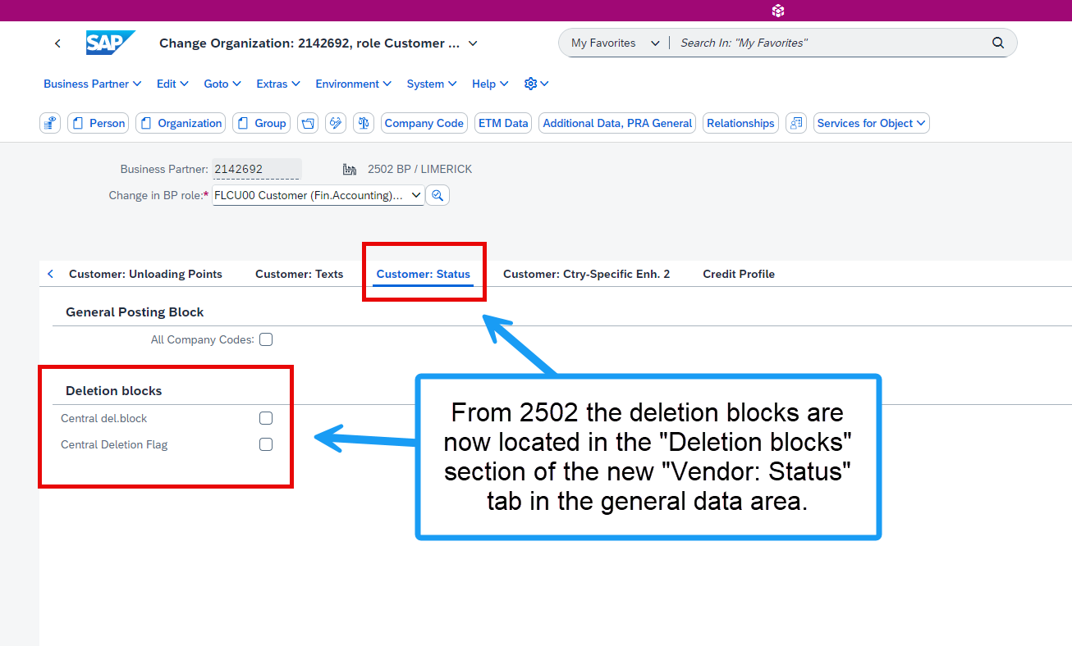

**2. Posting Block for “All Company Codes”: Pre-2502 location.**

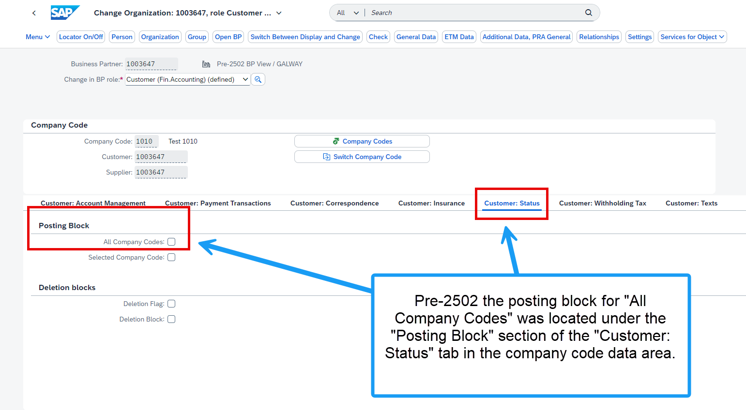

**2. Posting Block for “All Company Codes”: 2502+ location.**

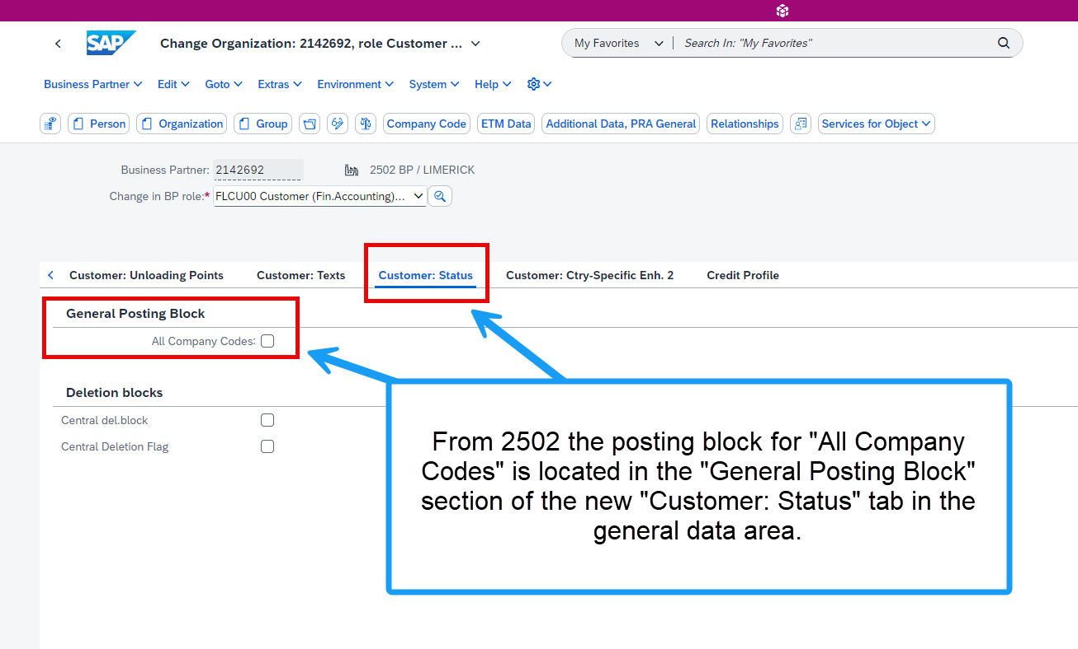

**3. Posting Block for “Selected Company Codes”: 2502+ location.**

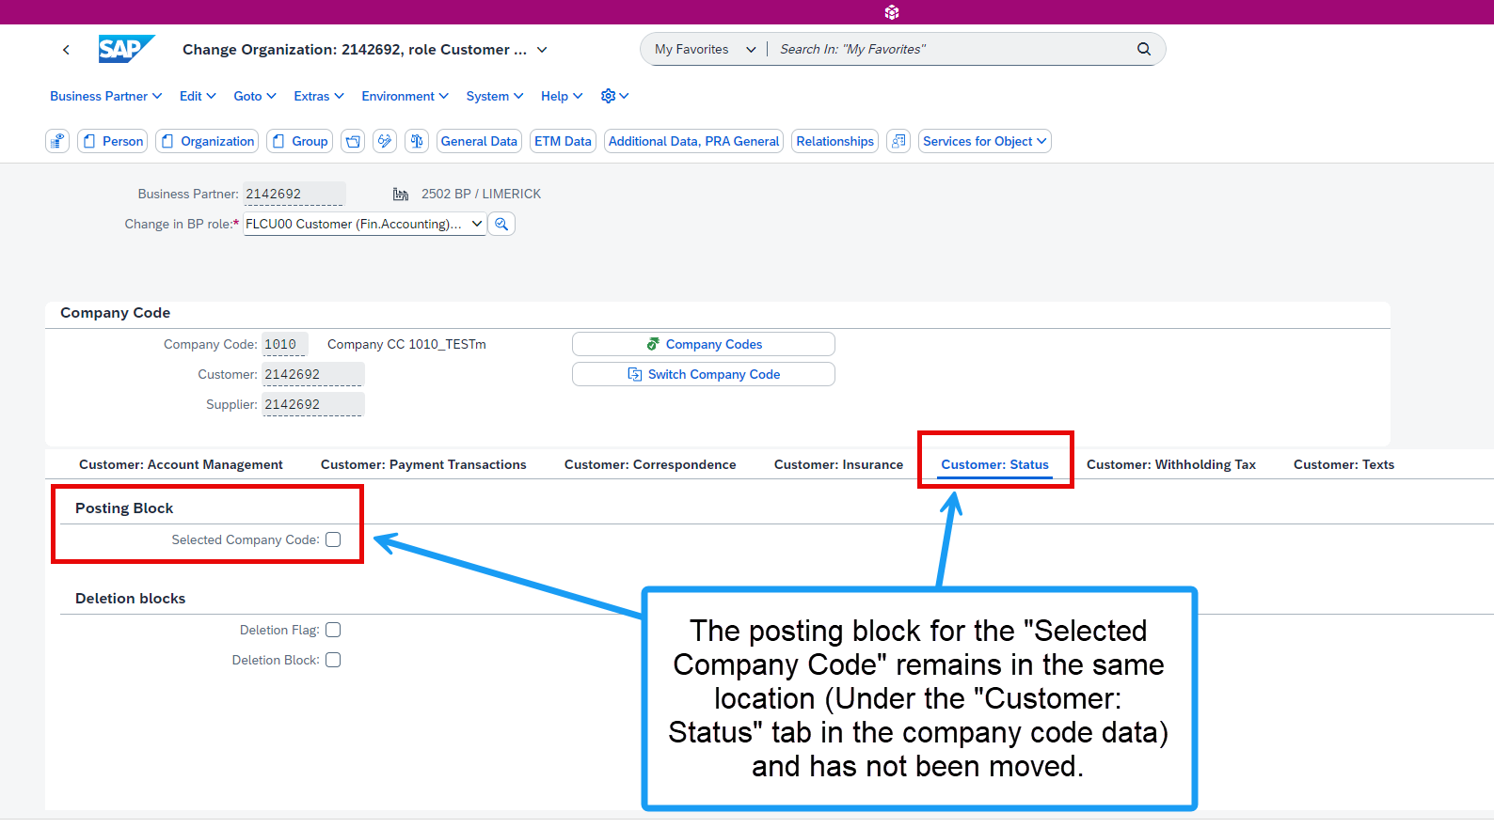

**4. “Sales Order Block”, “Delivery Block”, “Billing Block”, and “Block Sales Support” for "All sales areas"pre-2502 location.** 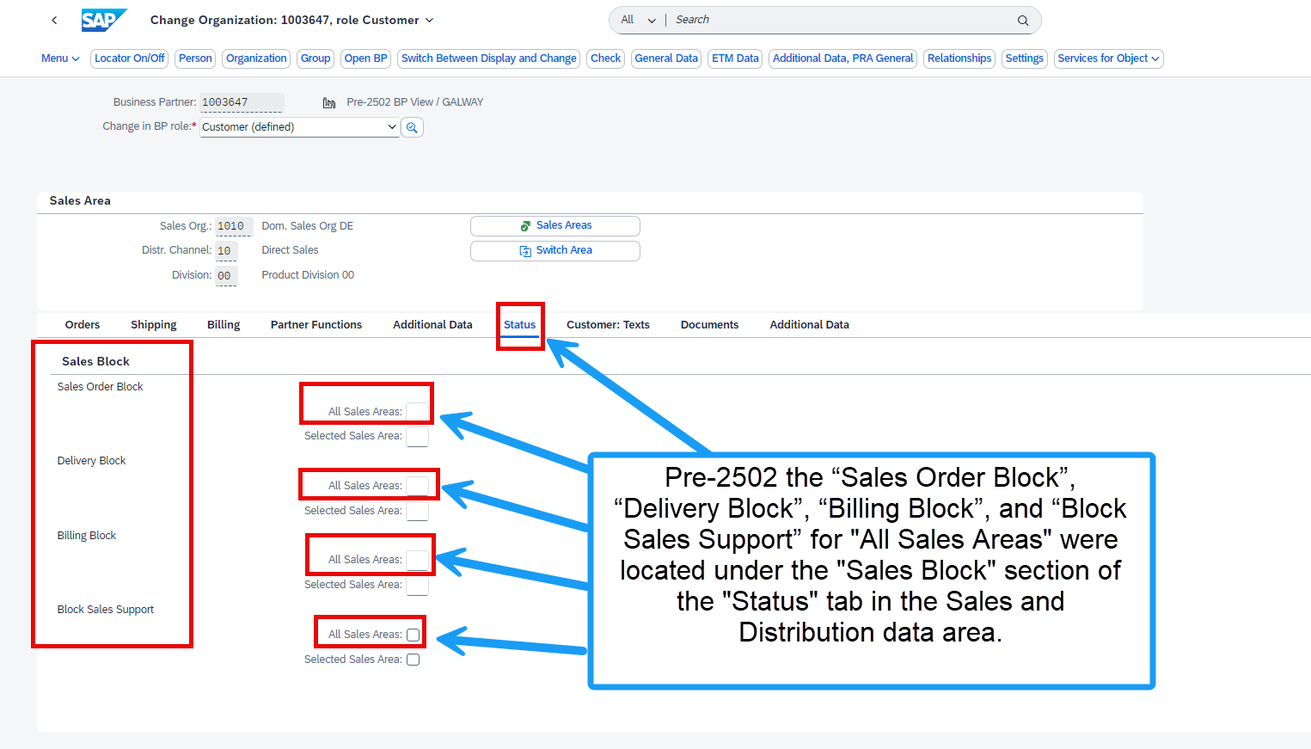

**4. “Sales Order Block”, “Delivery Block”, “Billing Block”, and “Block Sales Support” for "All sales areas” 2502+ location.**

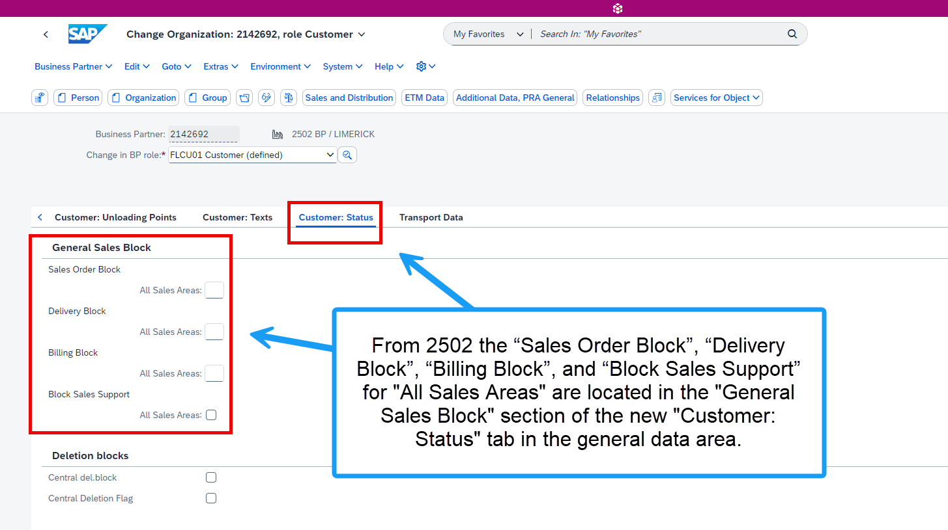

**5. “Sales Order Block”, “Delivery Block”, “Billing Block”, and “Block Sales Support” for "Selected sales areas” 2502+ location**

