**Data correction for Revenue Recognition attribution problem**

**General Remark:**

Once the hotfix correction is contained in the system, the erroneous data can be re-attributed using the Profitability Analysis realignment functionality. This can be found in app “Run Realignment – Profitability Analysis”.

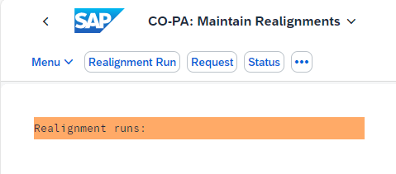

**PLEASE TEST THIS PROCEDURE IN YOUR QUALITY SYSTEM FIRST BEFORE APPLYING IT TO PRODUCTION!**

**Procedure:**

* Create a list of all affected WBS Elements which have inconsistent Profitability Attribution values, e.g. initial Customer, Customer Country, etc. because these are required for selection in app “Run Realignment – Profitability Analysis”.
* Go to the app and click “Realignment Run”, entering a short text for the run:

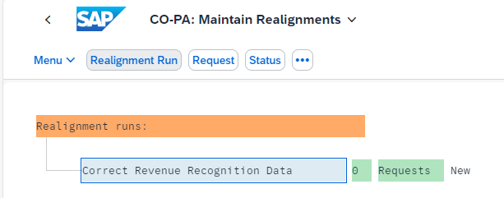

* Place the cursor on the run and press “Request”
* Enter a short text for the request:

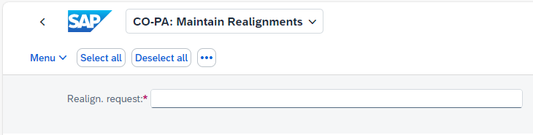

* Under “Selection of CO-PA Characteristics” find “PSPNR – WBS Element”, mark it and choose the arrow-down button named “Move Field”:

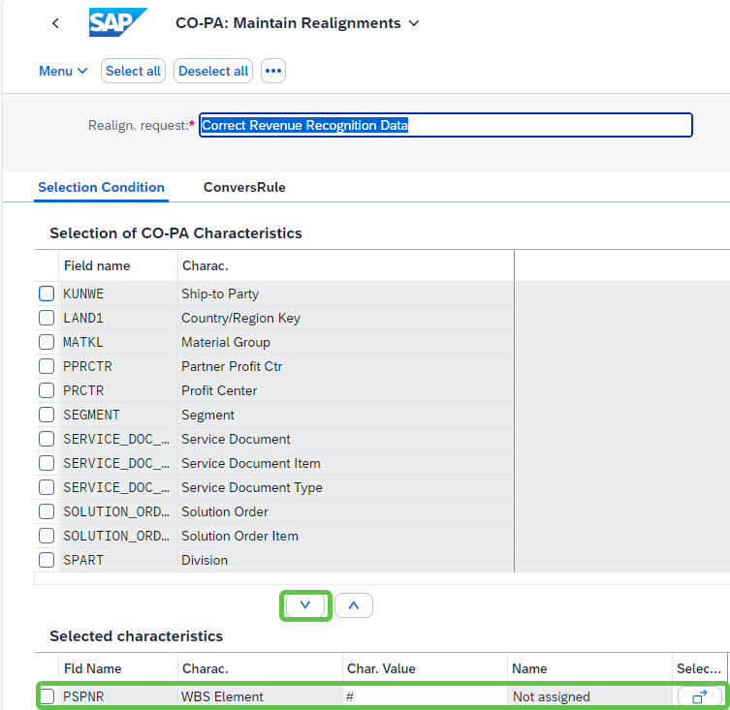

* Choose “Selection….” On the right-hand side and on the upcoming popup enter the WBS Elements from the list you created in the first step:

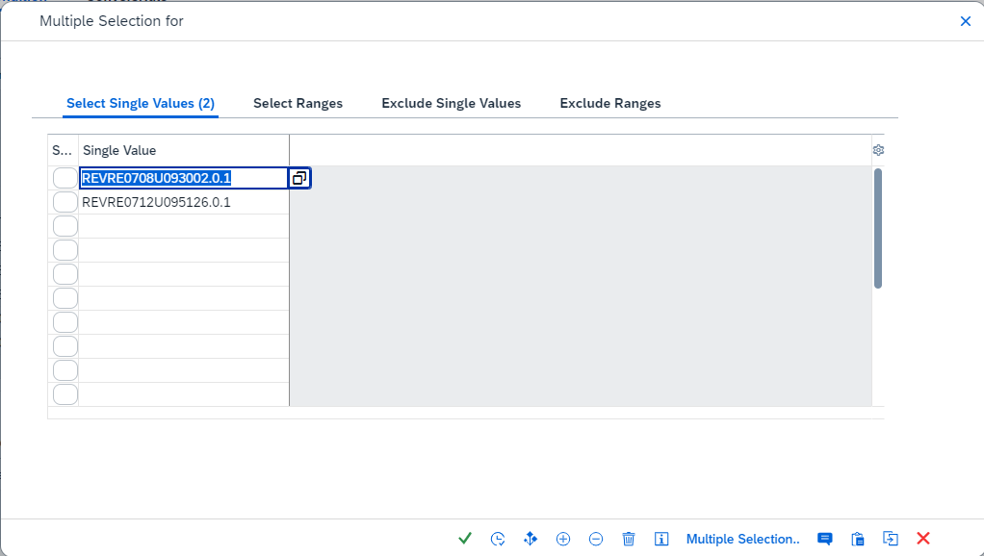

* Confirm and close the screen
* Change to tab “Conversion Rule”, scroll to the bottom and check flag “Rederivation of ACDOCA Chars for Attributed Line Items”:

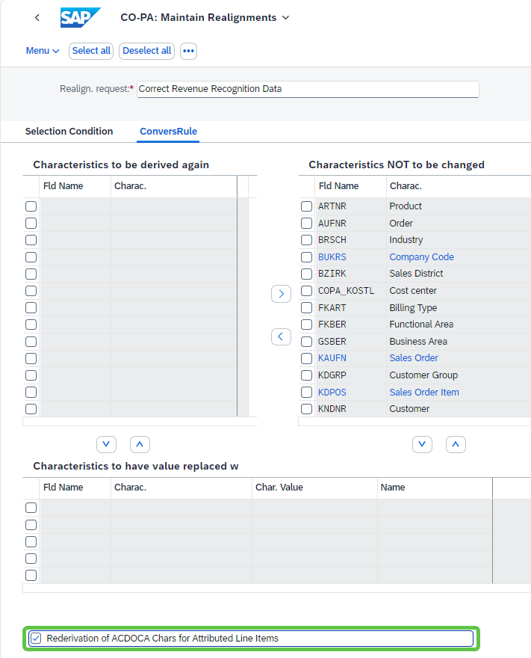

There are NO other selections to be made here.

* Go back and press “Save” at the bottom of the screen to save your entries.
* Again place the mouse on the Realignment Run and choose “Menu” -> “Run / Request” -> “Execute” to start the realignment in background. You can first try a run in “Test Mode”. Unfortunately, there is no app to see the effects the realignment would have, because normally, the changed data volume would be too large for display. The status of the Realignment Run should change to “Running” and to “Successful” finally.
* This should re-run the attribution logic for correct determination of Customer, Customer Country, etc.. The result can be checked, for example, in app “Display Line Items – Margin Analysis”.