***The UI Layout Different With Different Options*  (for manager)**

***behavior-rating-opt="2" - display rating next to all evaluators' comments;***

***behavior-cmt-opt="0" - display comments***

behavior-mode-opt="0"

user-behavior = "true"

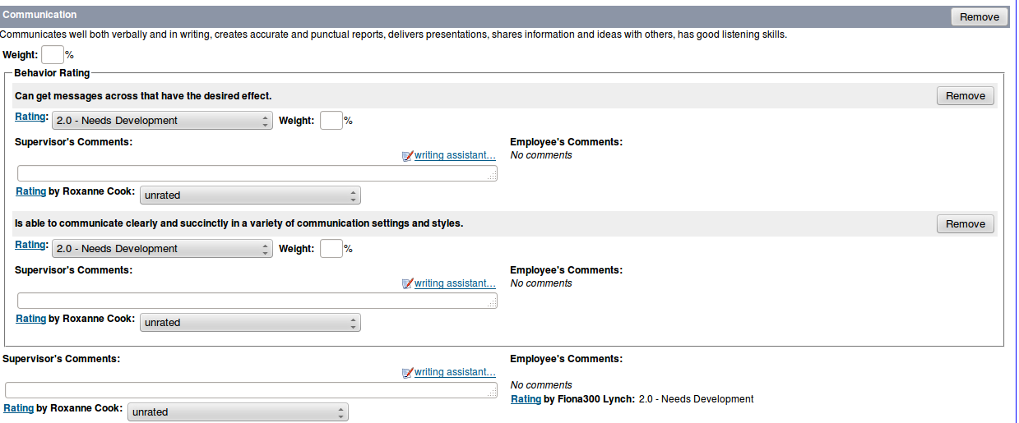

***behavior-rating-opt="2" – no rating next all evaluators’ comments as comments are hidden***

***behavior-cmt-opt="1" - hide comments***

behavior-mode-opt="0"

user-behavior = "true"

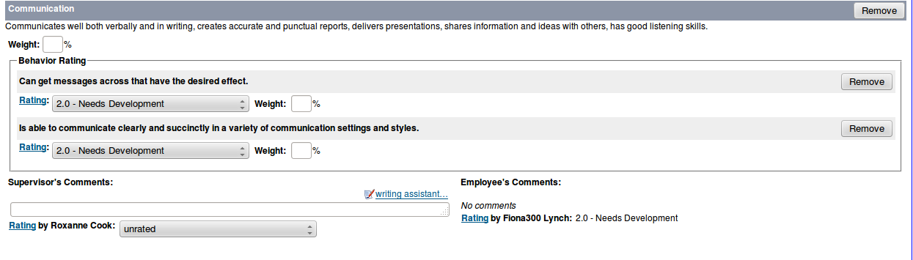

***behavior-rating-opt="1" - no difference with “2” above as comments are hidden***

***behavior-cmt-opt="1" - hide comments***

behavior-mode-opt="0"

user-behavior = "true"

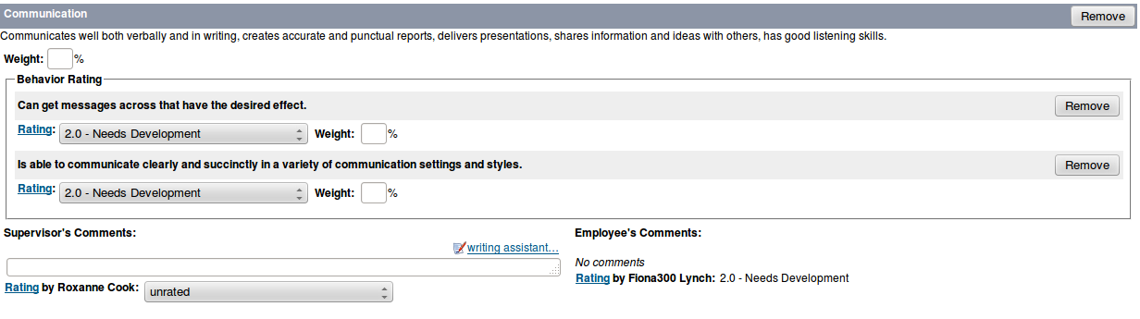

***behavior-rating-opt="1" - only comments box displayed, no rating select box (compare to “2”)***

***behavior-cmt-opt="0" - display comments***

behavior-mode-opt="0"

user-behavior = "true"

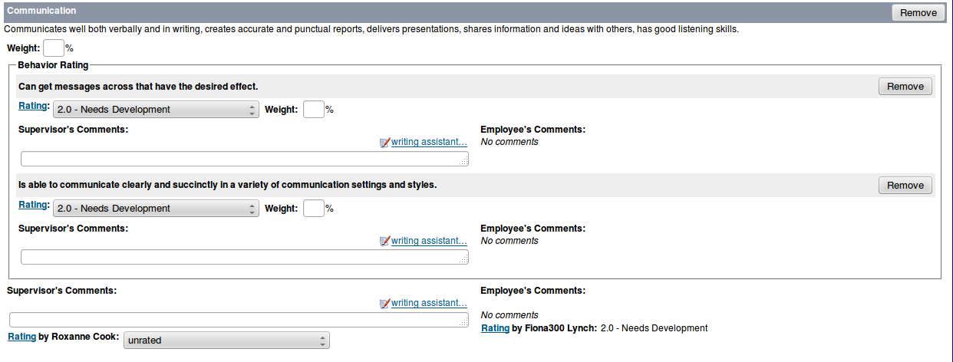

(**for employee**)

***behavior-rating-opt="0" - 0 : DEFAULT. No ratings next to the subject's comment;***

***behavior-cmt-opt="0" - display comments***

behavior-mode-opt="0"

user-behavior = "true"

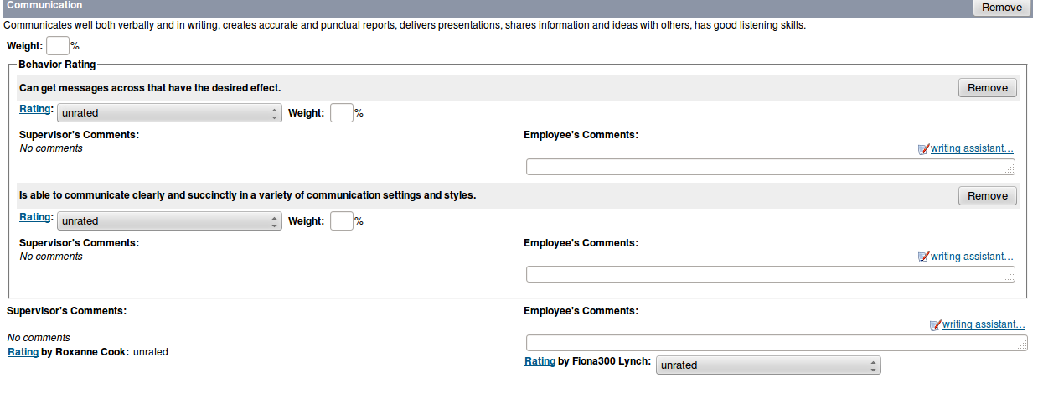

***The UI Layout Different With Different Options*** (**for employee**)

***behavior-rating-opt="1" - Display rating next to subject's comment only.***

***All others, just provide the comment field;***

***behavior-cmt-opt="0" - display comments***

behavior-mode-opt="0"

user-behavior = "true"

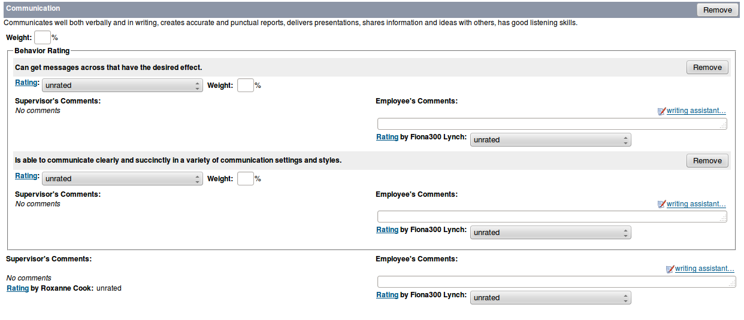

***behavior-rating-opt="1" - Display rating next to subject's comment only.***

***All others, just provide the comment field;***

***behavior-cmt-opt="1" - hide comments***

behavior-mode-opt="0"

user-behavior = "true"

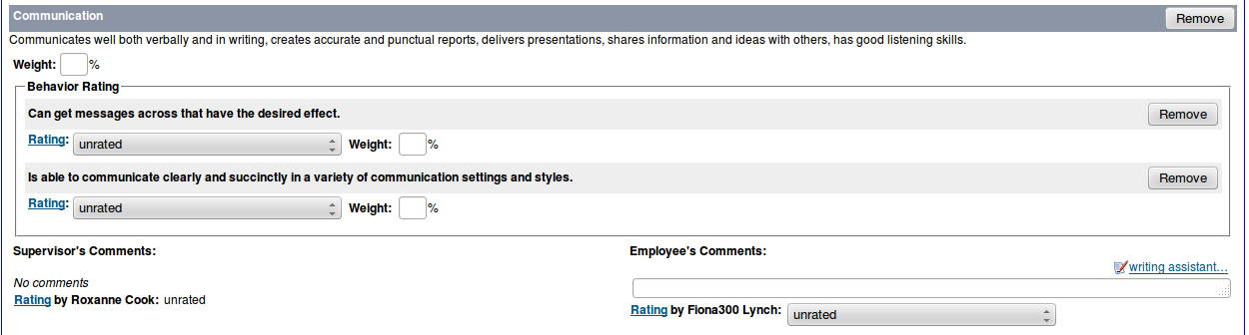

behavior-rating-opt="2"

behavior-cmt-opt="1"

***behavior-mode-opt="1" - can be the value not 0 if use-behavior not “true”***

***user-behavior = "false"***

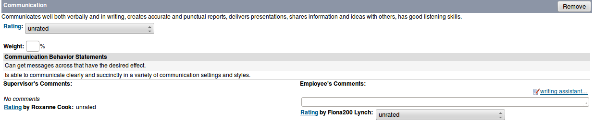

behavior-rating-opt="2"

***behavior-cmt-opt="0" - no difference with above when change from “1” to “0”***

***behavior-mode-opt="1" - can be the value not 0 if use-behavior not “true”***

***user-behavior = "false"***

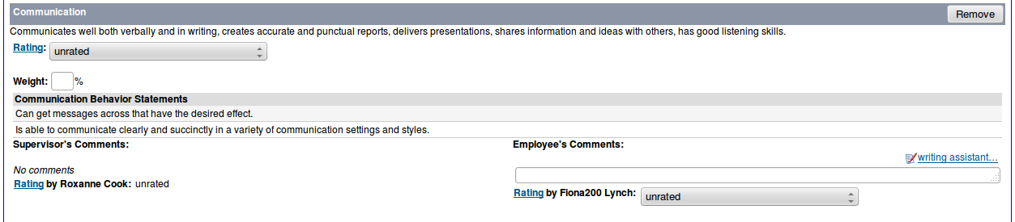

behavior-rating-opt="2"

behavior-cmt-opt="0"

***behavior-mode-opt="2" - can be the value not 0 if use-behavior not “true”***

***user-behavior = "false"***

