**Examples:  
  
  
Configuration Activity Requirements for Negative postings permitted:**

* Company Code General Ledger View (ID 106039)

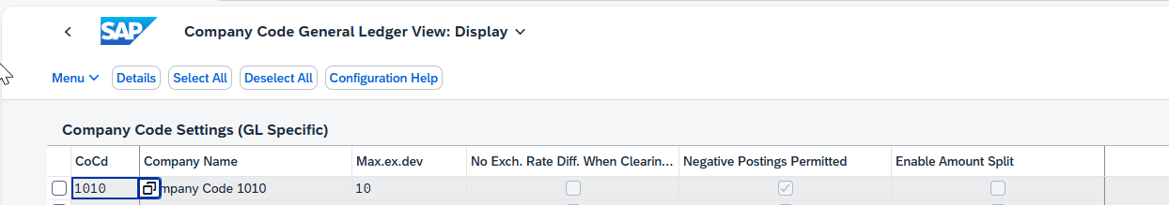

* Define Document Types ID(101522)

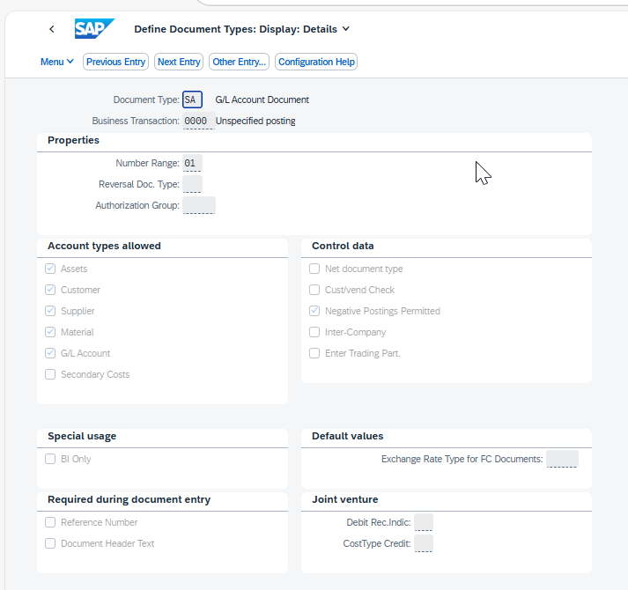

**Test Case Examples:  
  
1. General Ledger Journal Entry Postings without Negative Posting**

* Create Journal Entry with app Post Geneal Journal Entries

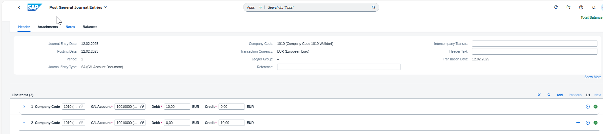

* View Results in app Manage Journal Entries   
    
  Ledger View  
  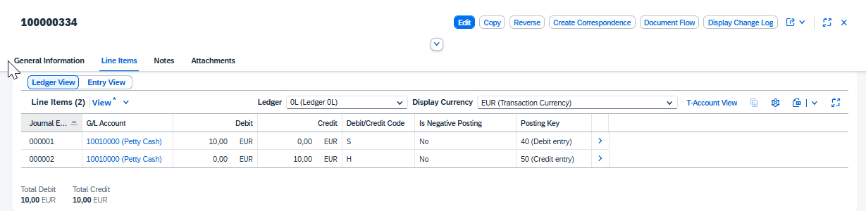  
    
  Entry View  
  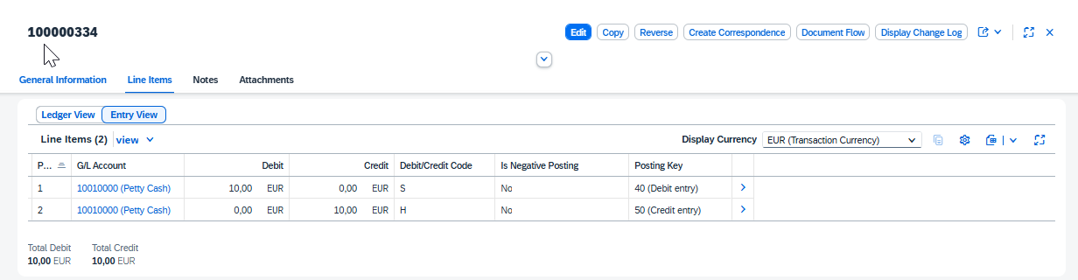
* Create Journal Entry using API Journal Entry - Post (Asynchronous)

**Normal Posting:** no negative posting,  S (Debit) + plus sign amount (100) ;  H (Credit) + minus sign amount (-100)

* Payload (reference to Items)

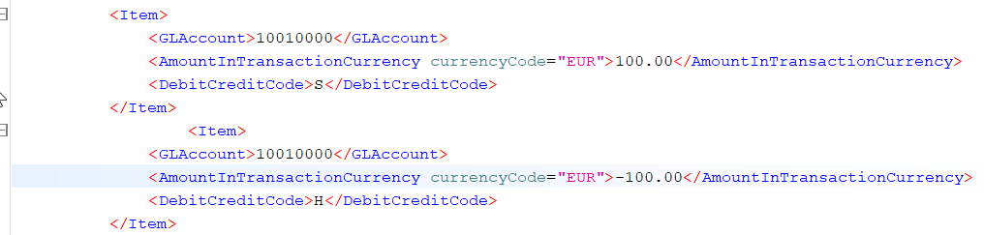

* View Results in app Manage Journal Entries

Ledger View:

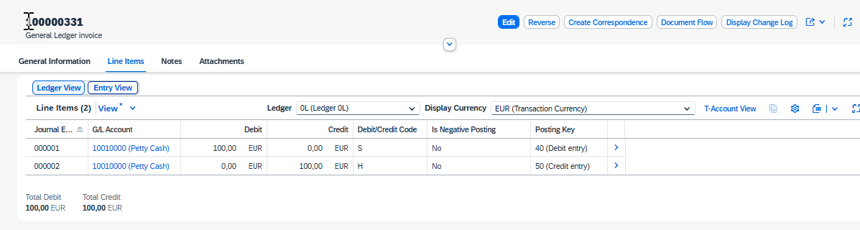

Entry View:

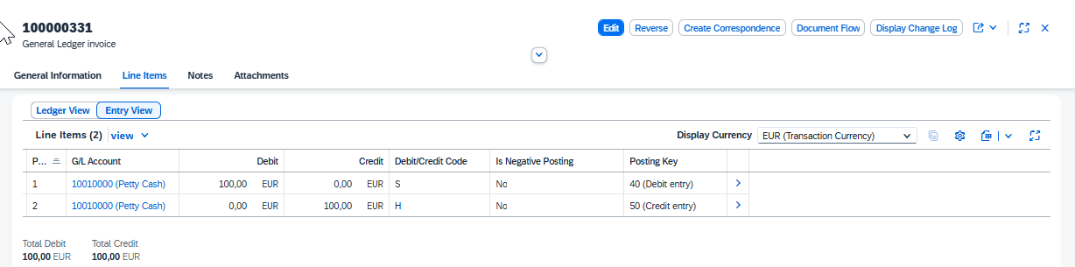

**2. General Ledger Journal Entry Postings Negative Posting**

* Create Journal Entry with app Post Geneal Journal Entries  
    
  When you create a negative posting, enter a minus sign before the transaction amount.

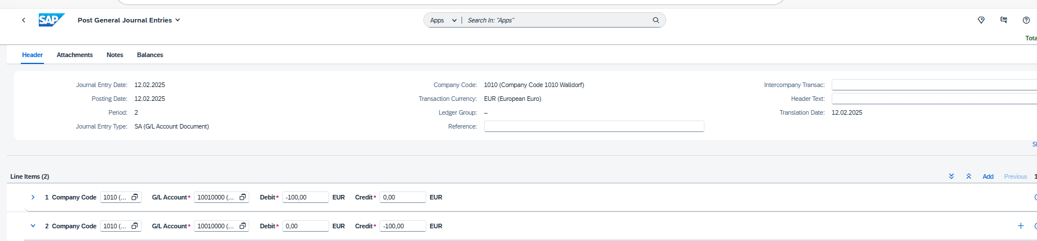

* View Results in app Manage Journal Entries

Ledger View:

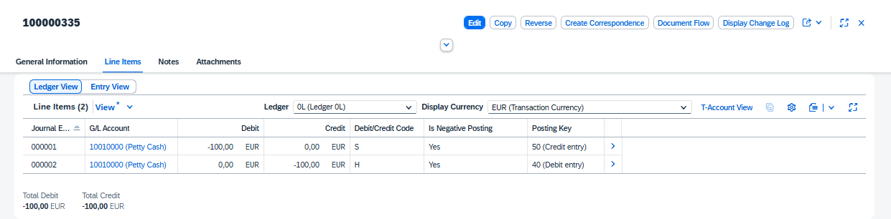

Entry View

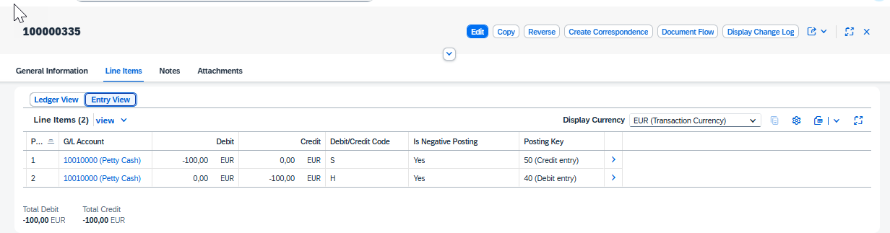

* **Create Journal Entry using API Journal Entry - Post (Asynchronous) Negative Posting:**

Real Negative Posting, S (Debit) + minus sign amount (-100) ;  H (Credit) + plus sign amount (100); negative posting config as allowed

Payload (reference to Items)

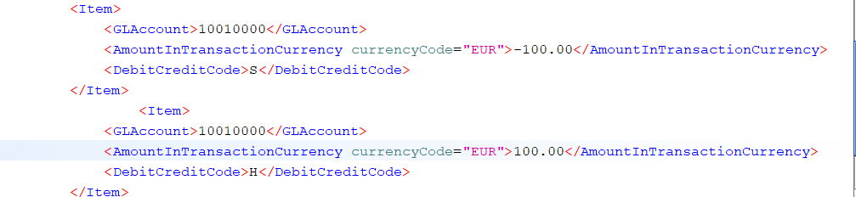

* View Results in app Manage Journal Entries

Ledger View

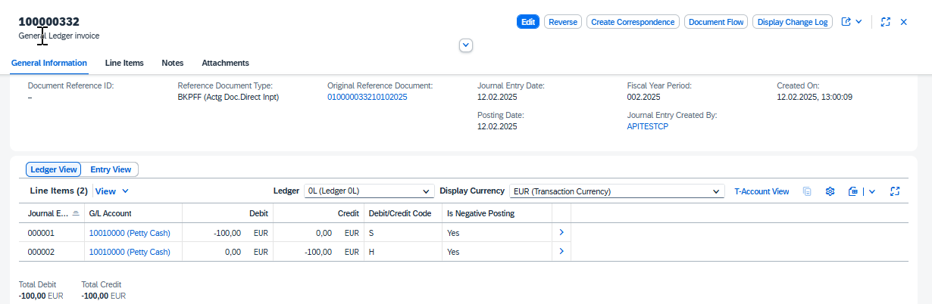

Entry View   
  
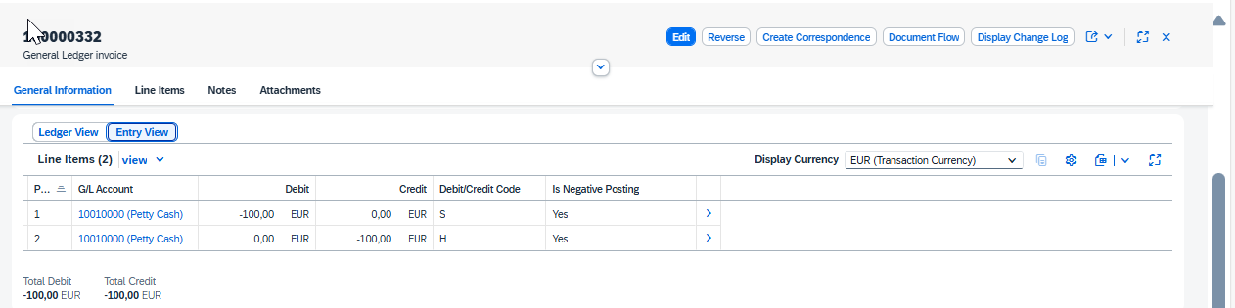

**3. Incorrect Understanding: Negative posting ,S (Debit) + minus sign amount (-100) ;  H (Credit) + plus sign amount (100); negative posting config as not allowed**

* Configuration activity: Company Code General Ledger View (ID 106039)

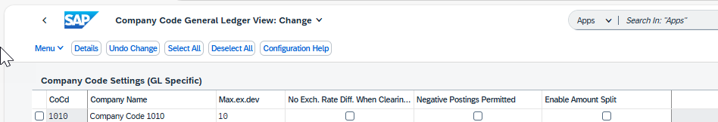

* Create Journal Entry with app Post Geneal Journal Entries

Error: **Negative postings for company code 1010 and document type SA not allowed.**

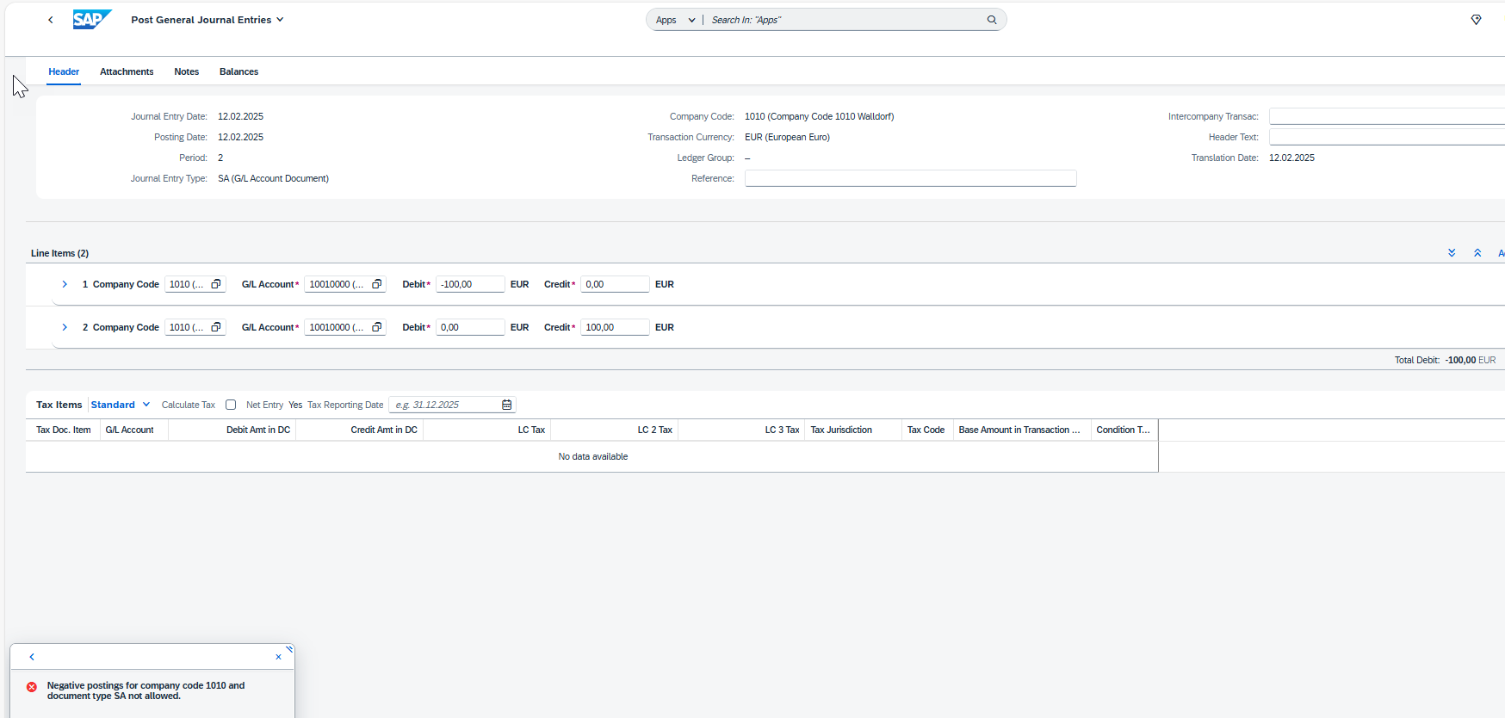

Error: **Negative postings for company code 1010 and document type SA not allowed.**

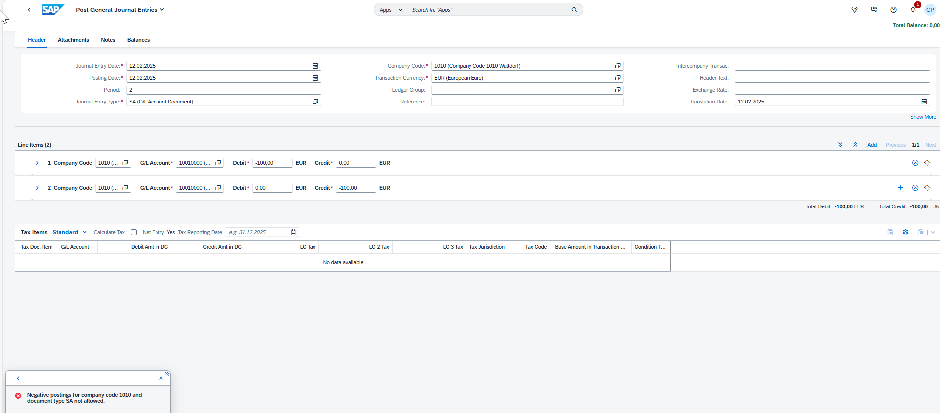

* Create Journal Entry using API Journal Entry - Post (Asynchronous)

Payload (reference to Items)  
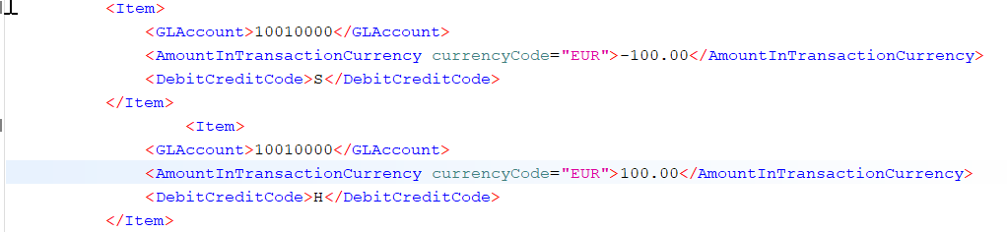 **In future release the following error will occur with API**

**Message Dashboard**  
Error: **Negative postings for company code 1010 and document type SA not allowed.**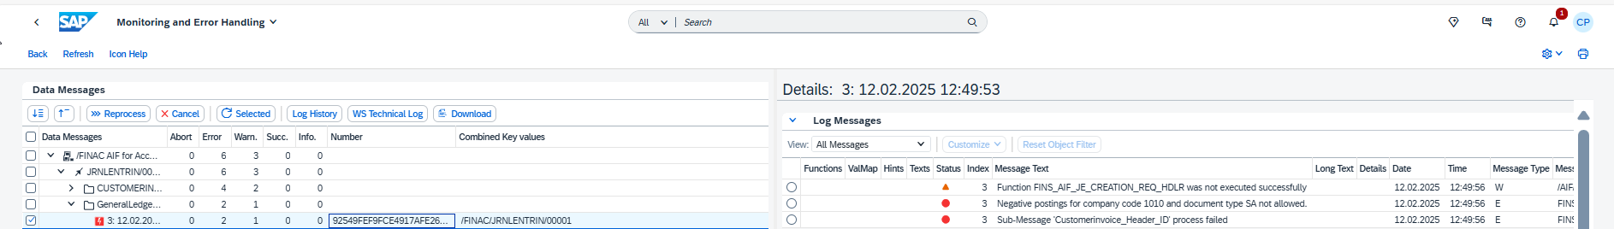

**At present the journal entry can be posted Entry View:**

**Line 1: H ,100, Negative Posting is false**

**Line 2: S, 100, Negative Posting is false**

* Note the payload for examples 2 and 3 are the same.
* The customizing in configuration activity: Company Code General Ledger View (ID 106039) in relation to negative postings Permitted is different.
* The Posting does not have Is Negative Posting selected in Manage Journal Entries at present.
* To Create Normal Posting without Negative Posting Indicator see payload example 1.  
    
  **In future, this case 3 is blocked This ensures Debit/Credit Code is consistent between payload and table/journal entry**