**XSLT PAYMENT FLEXIBILITY**

1. Log on to your Tenant in BC Config makes sure XSLT should be scoped.

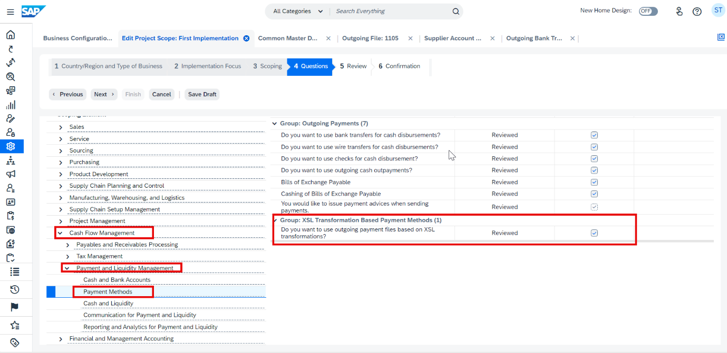

1. Go to Work Center Business Configuration and search for “Common Master Data*”

1. Once the Activity “Common Master Data Configuration” opens, click on “Transformation Repository” and then click “Edit”

The Transformation Repository will open.

1. Once the repository has opened, click on “Add” to add a new transformation entry.

Give the transformation a name and a description.

Maintain the attributes for

* Transformation Type: PAYFO – XSL Transformation for Payment Flexibility Outgoing Files
* Transformation Subtype – FODT or FOCT (Debit and Credit Transfer respectively)
* Country field is optional.
* Usage Type: Select Custom Default Transformation for the first Transformation, and Custom Transformation for subsequent transformations and variations.

**NB.** *You can only have 1 Custom Default Transformation and multiple Custom Transformations per country/Region.*

Click on Add Row:

Add a description and a validity Date. Then Click on Add to upload the transformation.

1. Once successfully uploaded, change the status to “Active”.

Upon setting the Transformation Version to Active, the file will be deployed and a deployment log will be created.

It will either show a successfully deployment or an error log.

Transformation is now successfully deployed and ready for usage,

1. Go to My Bank in the Liquidity Management Work Center.

Select the Payment Formats.

Now click on your user Icon at the top right corner of the screen to get into the “Personalization Mode”

Once in the Personalization Mode, select the “Unnamed Table”

Select the Checkboxes for:

-Transformation Name

-Transformation ID

This will unhide the two respective columns.

Save and then Quite the Personalization Mode

Now select the Payment Medium Format Code:

* XSLT Bank Transfer
* XSLT Direct Debit
* XSLT SEPA Bank Transfer (for SEPA Payments)
* XSLT SEPA Direct Debit (for SEPA Payments)

And then select your transformation ID from list.

The transformation selection is Optional. The Default Transformation will get picked as a fall back.

Save. You transformation is now ready for usage.