Steps to change the validity for GSTR1 Activities:

1. Open SSCUI: 101071 – “Setting Up Your Statutory Reporting “ and select the reporting entity

Example: IN_BUPL_GJ

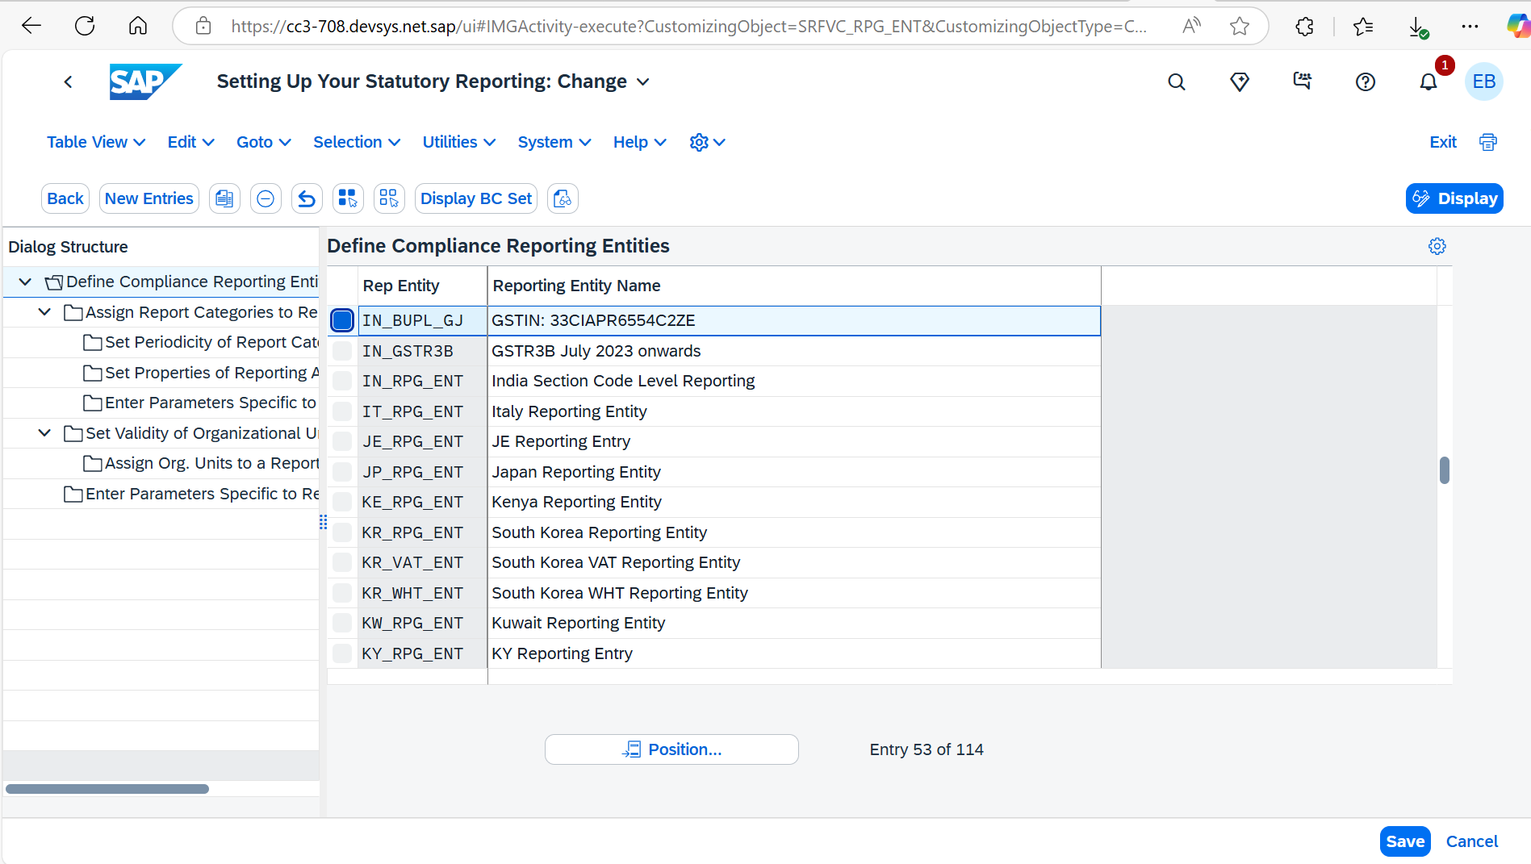

2. Select Reporting category for India GSTR1 Report - IN_GSTR1_DCL

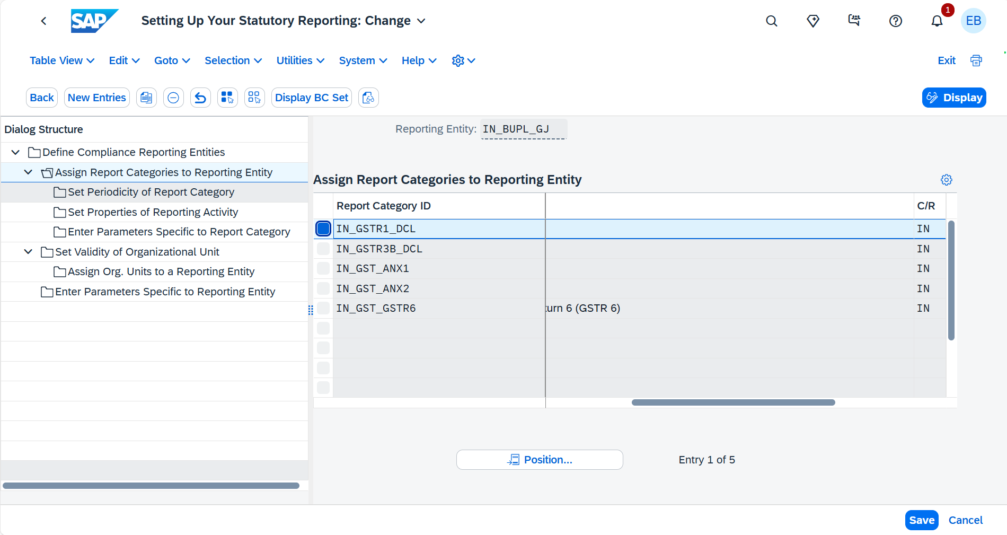

3. Select the “Set Properties of Reporting Activity“ and set the “ Use until date“ for IN_GSTR1_DCL_V1_S activity as 30th June 2025 and “ Use as of“ date for IN_GSTR1_DCL_V2_S as 30th June 2025 and “Save“.  
   
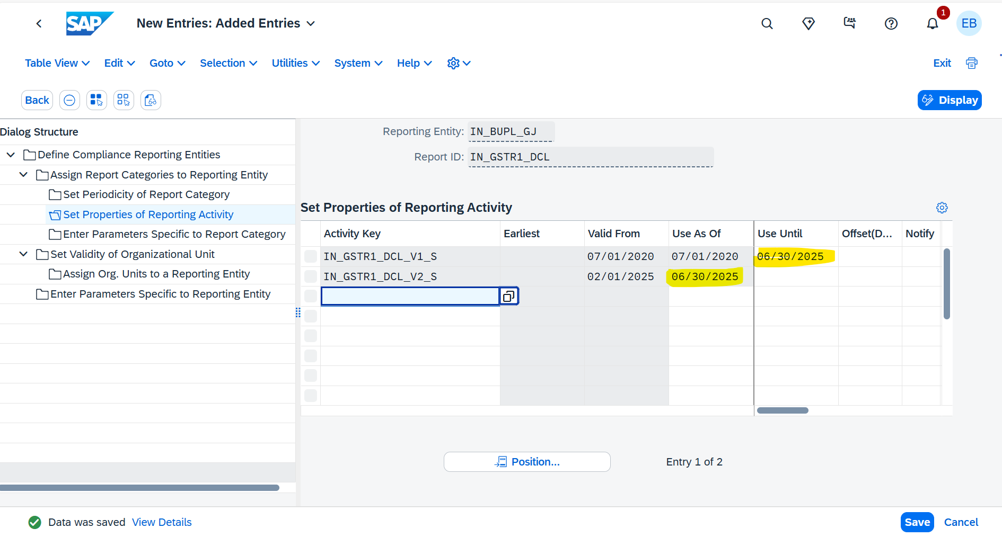

4. Refresh “Run Statutory Reports“ App and continue to use    "GSTR1 Reporting India July'20 Onwards" activity for GSTR1 filing.

