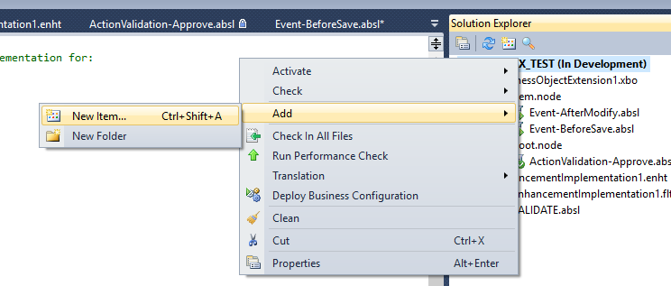

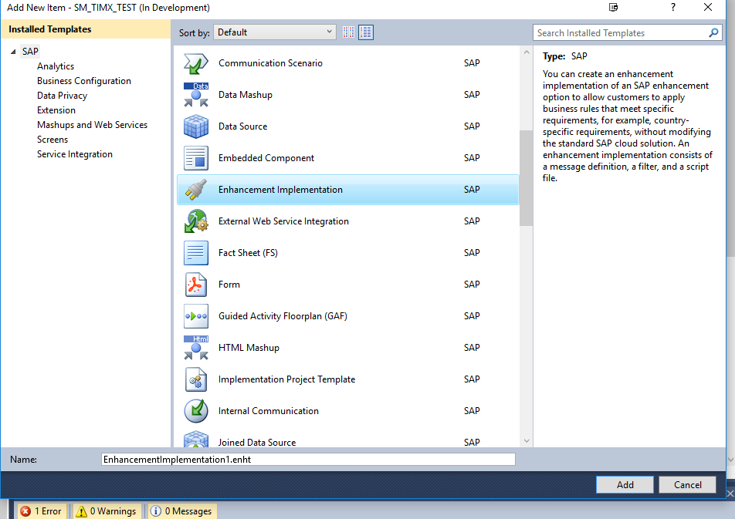

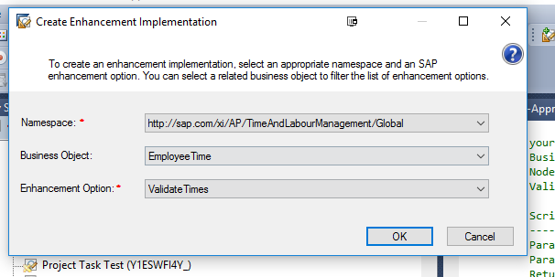

**The above option will create option like the below.**

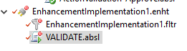

In the VALIDATE.absl you can write the logic and raise the error messages as required.

Here you can specify all your messages that must be raised from the BADI.

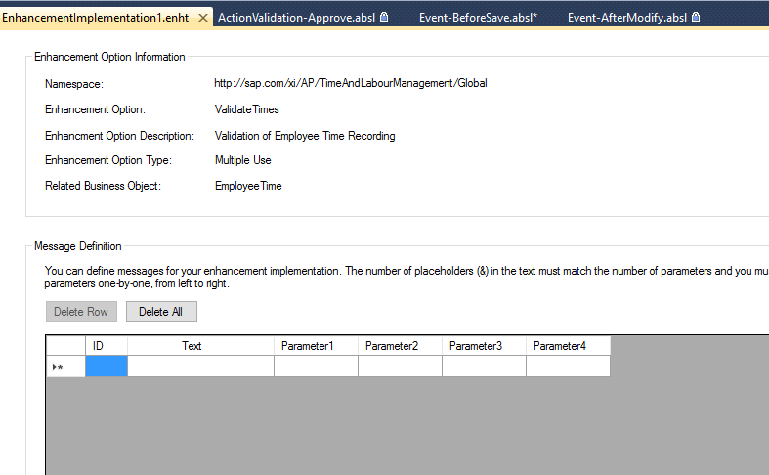

In the below screenshot, you can use the input parameters that are passed to this BADI for the conditions. (Action Name, RecViewTypeCode, UUID). The UUID received is of the Employee Time Root and you need to retrieve the data of root and item node of the Employee Time Business object to write the logic based on the duration or time recording date or as required.

