1. Find app “Set Report Relevancy”

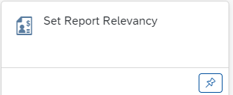

1. Open app “Set Report Relevancy”, and select cost center group (“0101”), such as choosing cost center group (“0101”) as below:

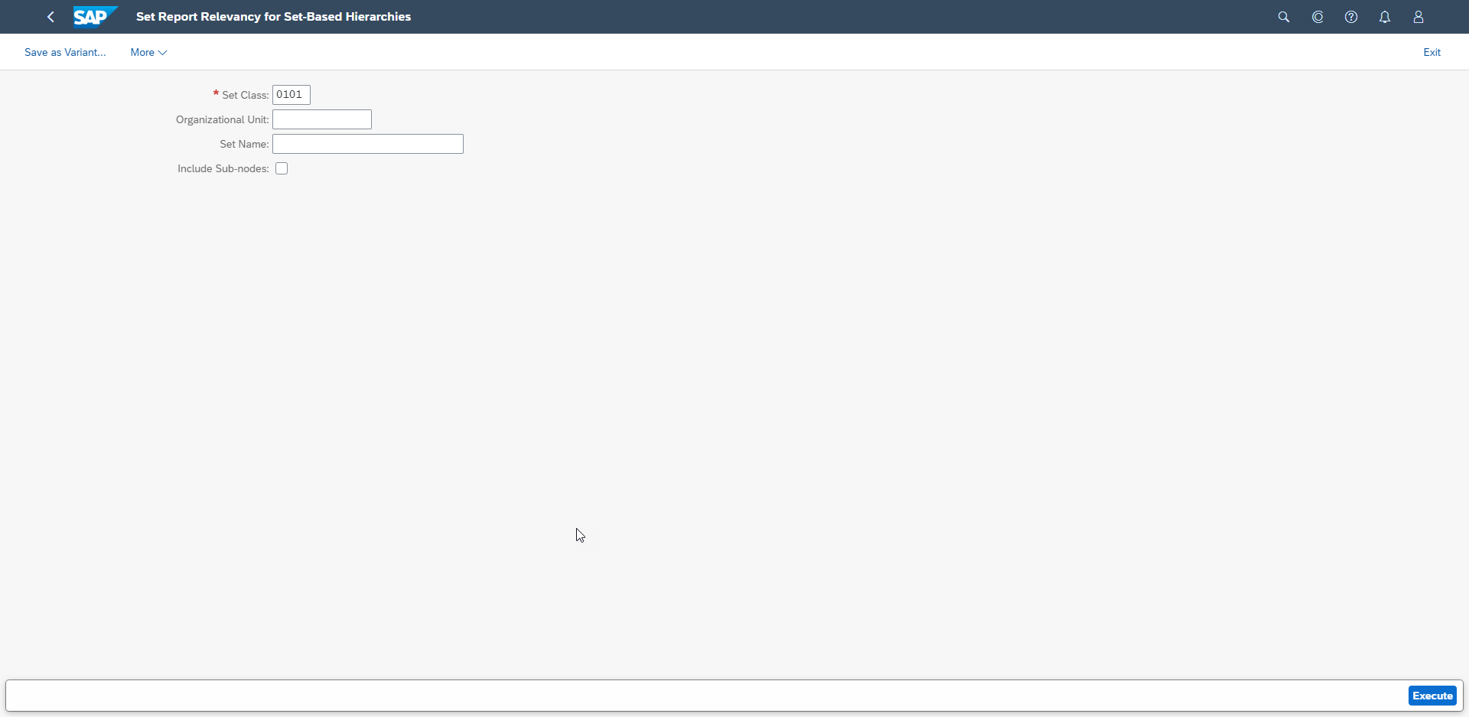

1. Select the cost center group which you want to use in report, check it to “Report Relevant”, or click the “Auto Replicate” button then save it,

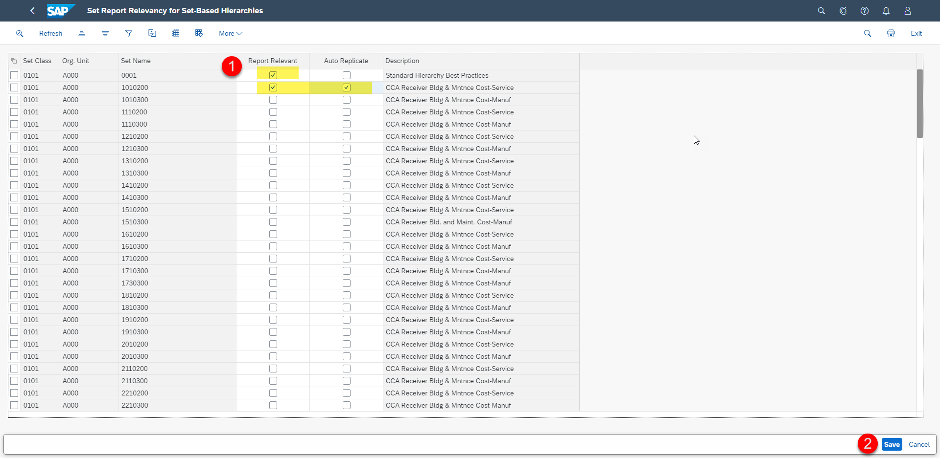

1. Find app “Replicate Runtime Hierarchy”:

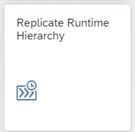

1. Open app and click create button “+” to create a new job to replicate the cost center that you have set report relevancy in last step.

