Workforce Planning and Analytics - Changing Measures between ‘Actual’ to ‘Annualized’
Users have the ability to change how the measure data is reported for selected measures.
Environment – Preview and Production instances
Tool – Query Workspace WFA only
- Select desired measure and enter the design view of the query. Measures will be highlighted in blue.
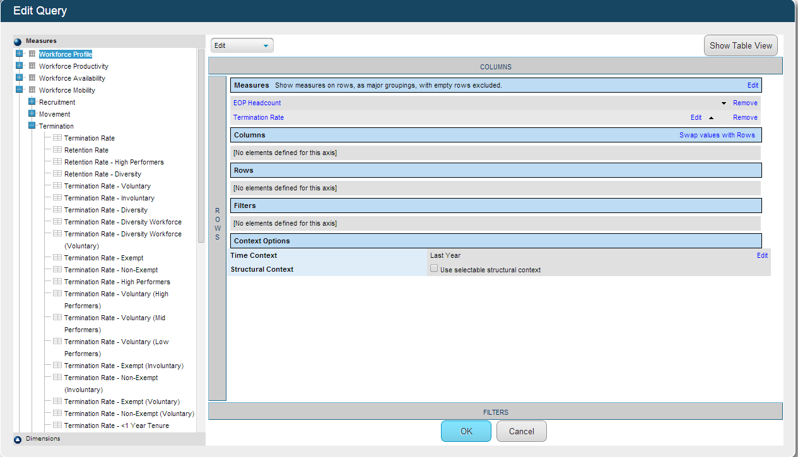

- Select the measure and drop down will appear. Select ‘Edit’
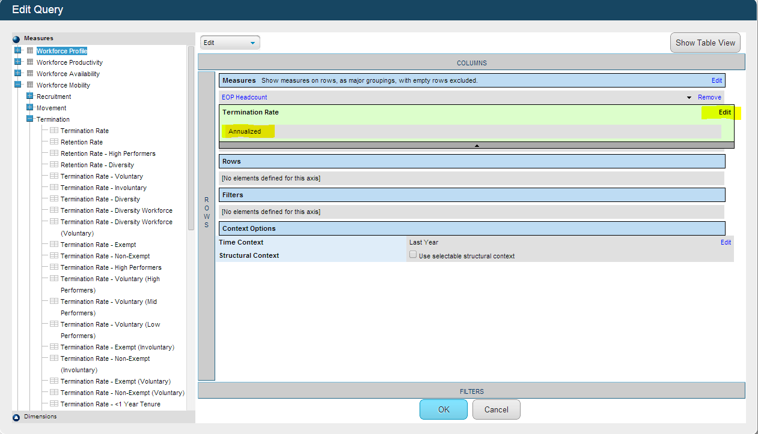
- Now able to choose between ‘Actual’ and ‘Annualized’. The black arrow on gray bar should be clicked on to save changes.
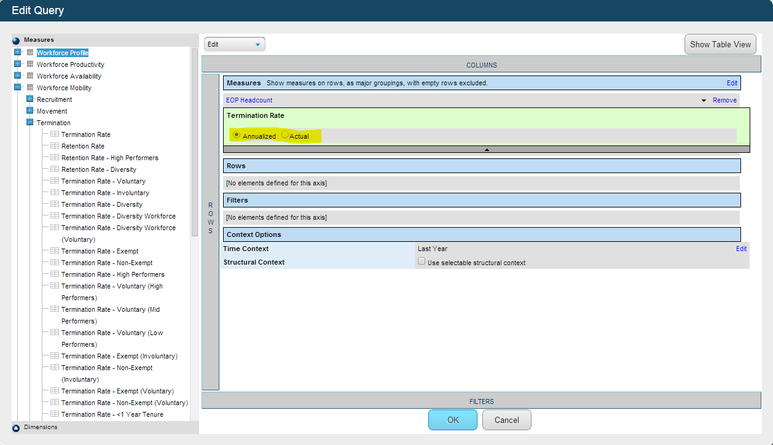

- All measures can’t be changed. If unable to change, the tool will inform user.
