To check Report Assignment status and change report assignments.

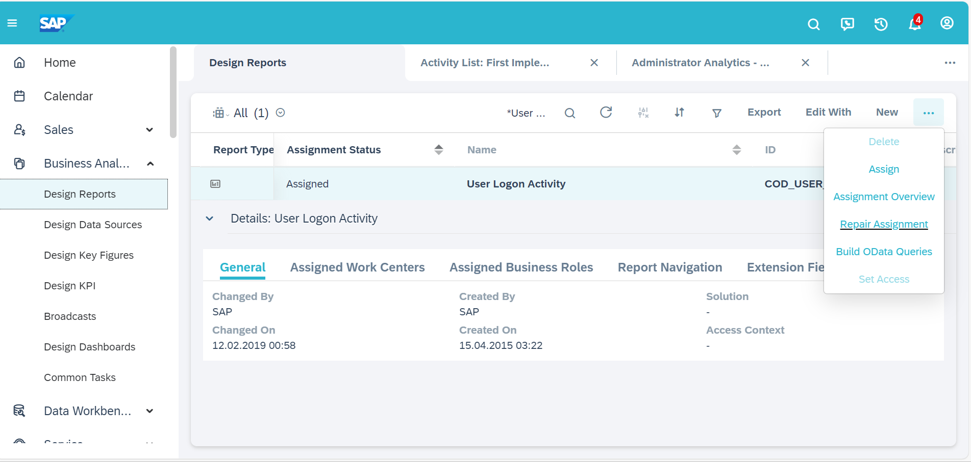

You can assign the required Work center views and Business Roles in the respective tabs.

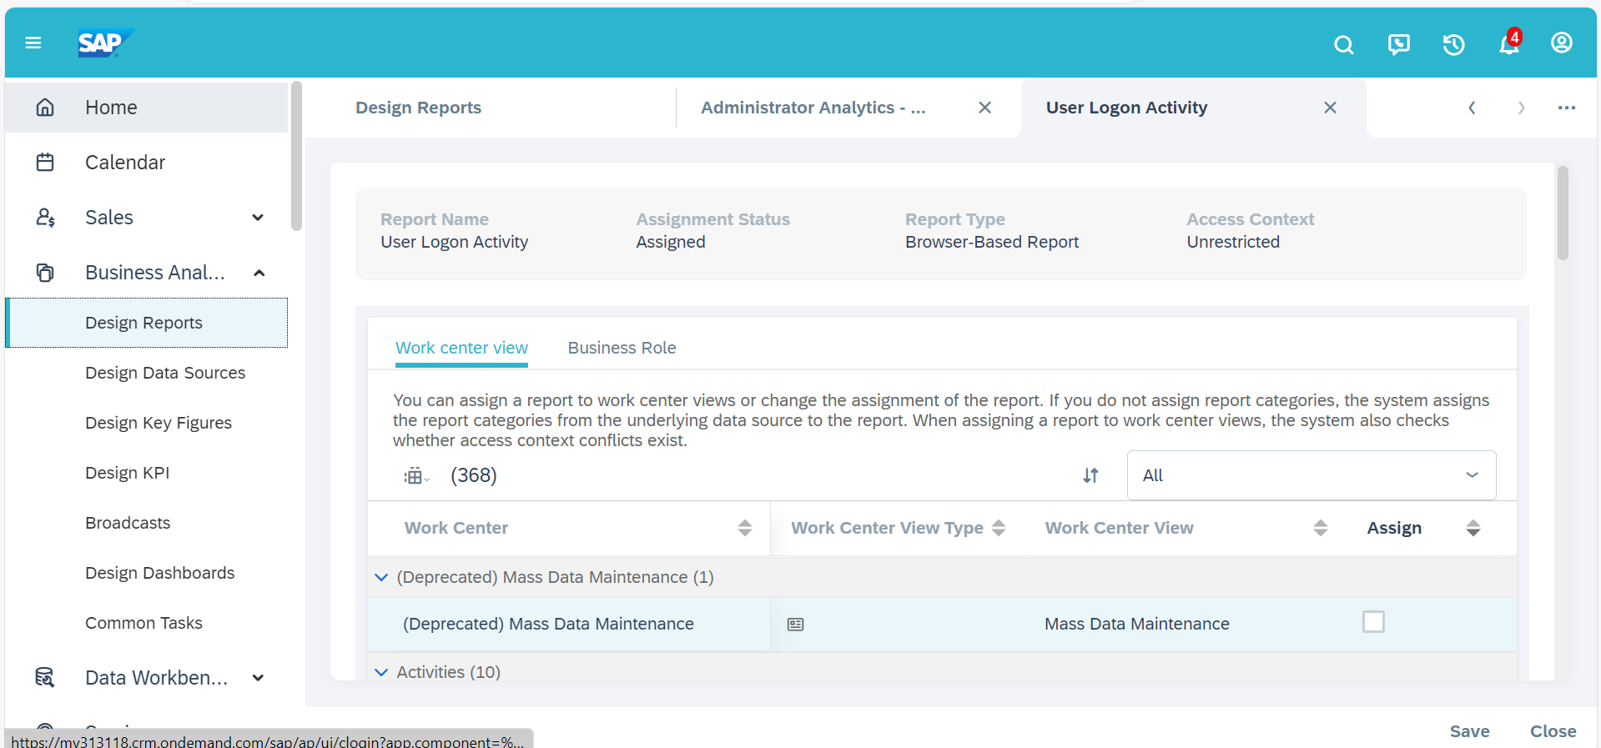

If you would prefer to not assign reports to business role, you can change the setting as follows: Business Configuration -> Implementation Projects -> Choose required Project ->Open Activity List.

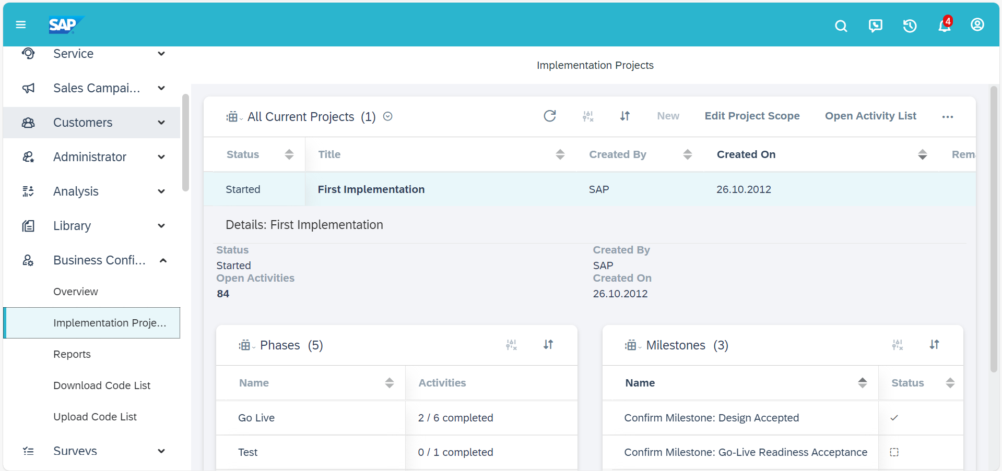

Go to Fine-Tune step and Open Administrator Analytics -Settings

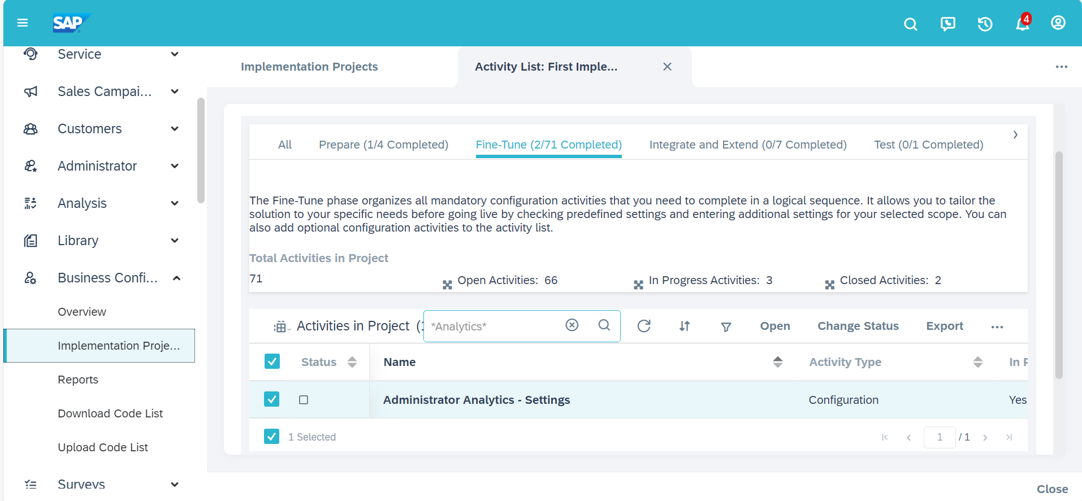

Disable the toggle button for Allow Assignment under Assignment of Business Roles to Analytical Objects.

